**Course Description**In the real world, data sets typically come split across many tables while most data analysis functions in R are designed to work with single tables of data. In this course, you'll learn how to effectively combine data sets into single tables using data.table. You'll learn how to add columns from one table to another table, how to filter a table based on observations in another table, and how to identify records across multiple tables matching complex criteria. Along the way, you'll learn how to troubleshoot failed join operations and best practices for working with complex data sets. After completing this course you'll be well on your way to be a data.table master!

**Joining Multiple data.tables**This chapter will show you how to perform simple joins that will enable you to combine information spread across multiple tables.

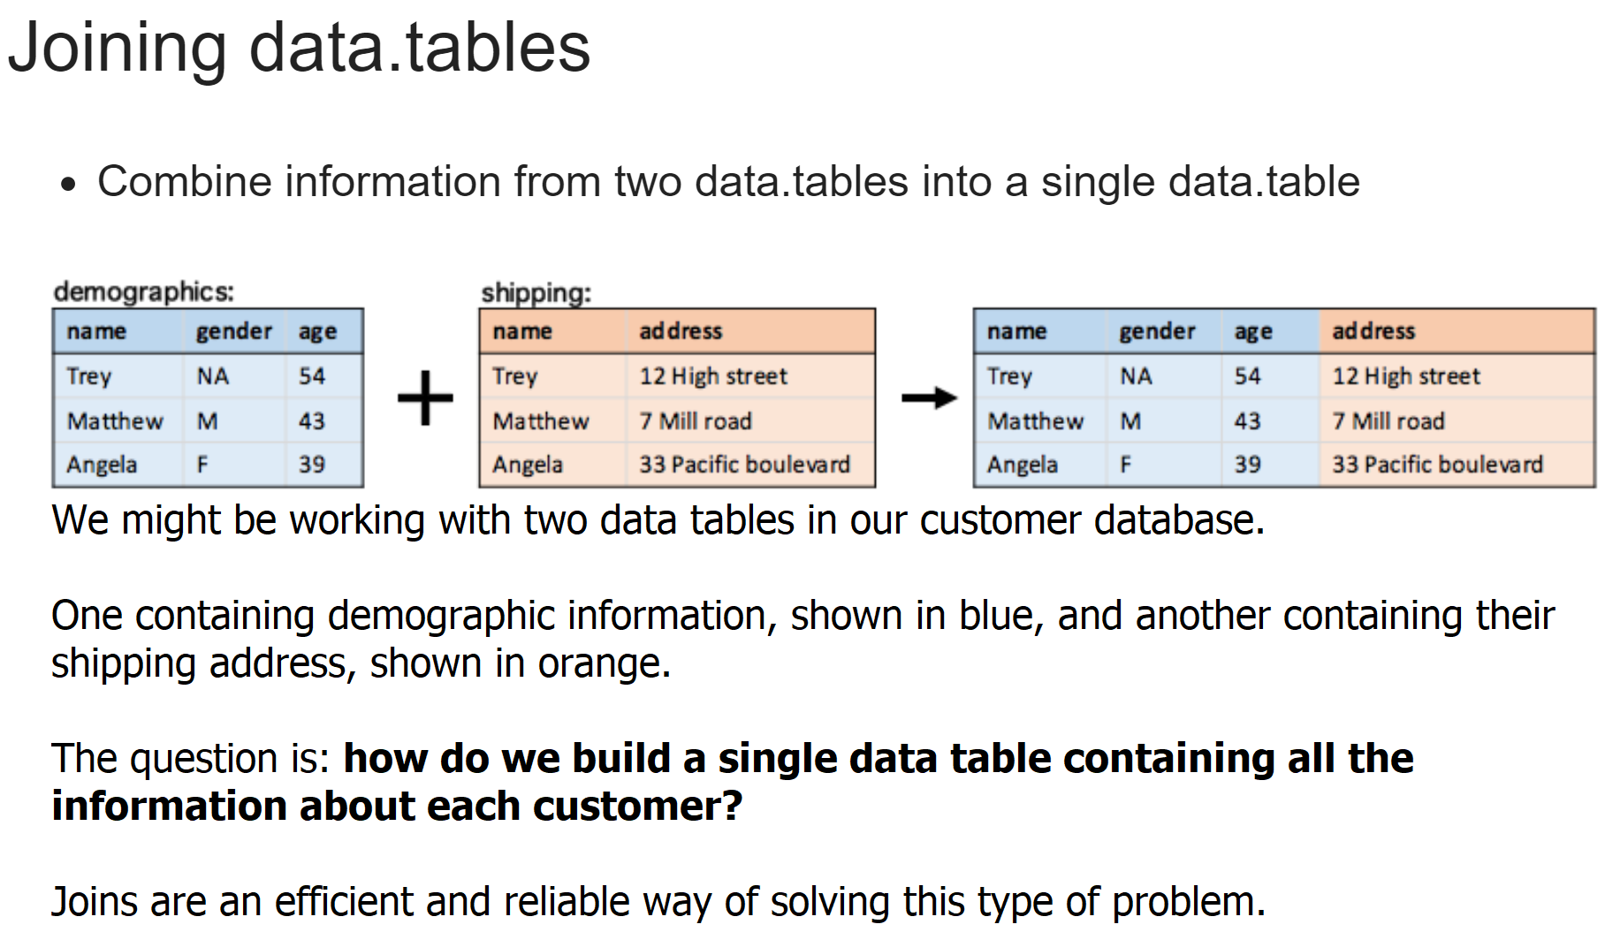

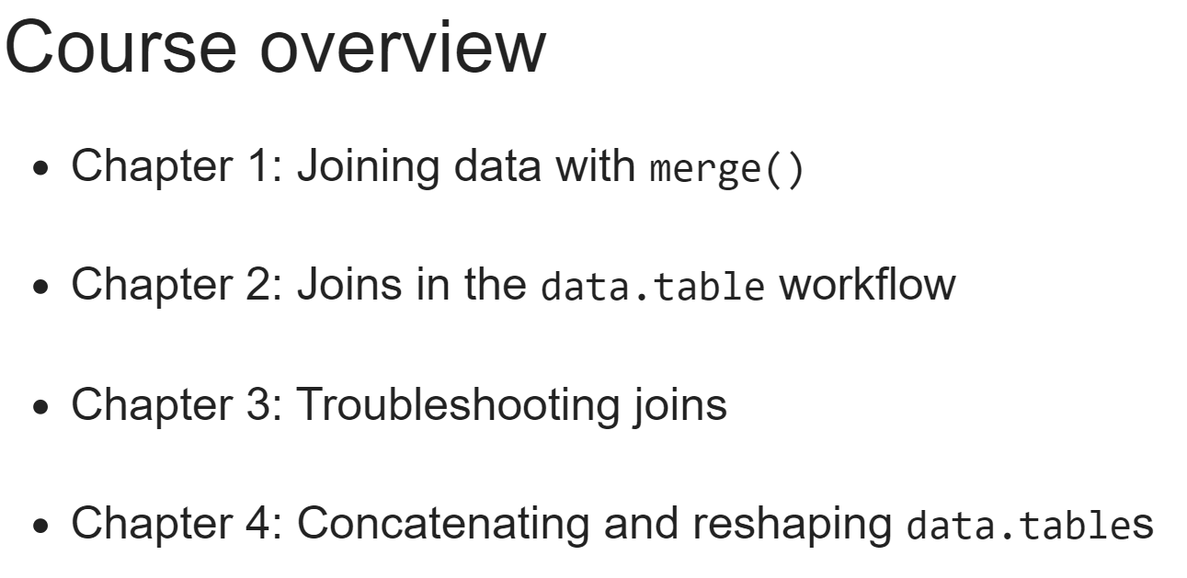

The first skill we need to learn is to **identify the join key columns**.

These are the columns we need in each data table to match the rows between them for a join. No matter what type of join we want to do, we will always need to know which columns to use as join keys.

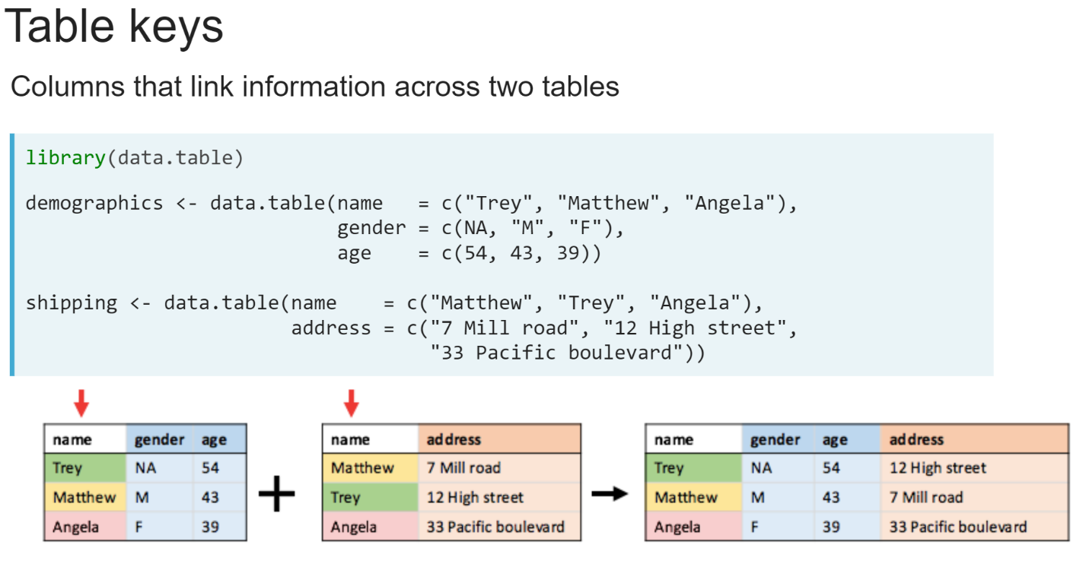

Returning to the customer database example, to match the rows between the two data tables, we would need to use the values stored in the name column, as we can see from their highlighted matching values.

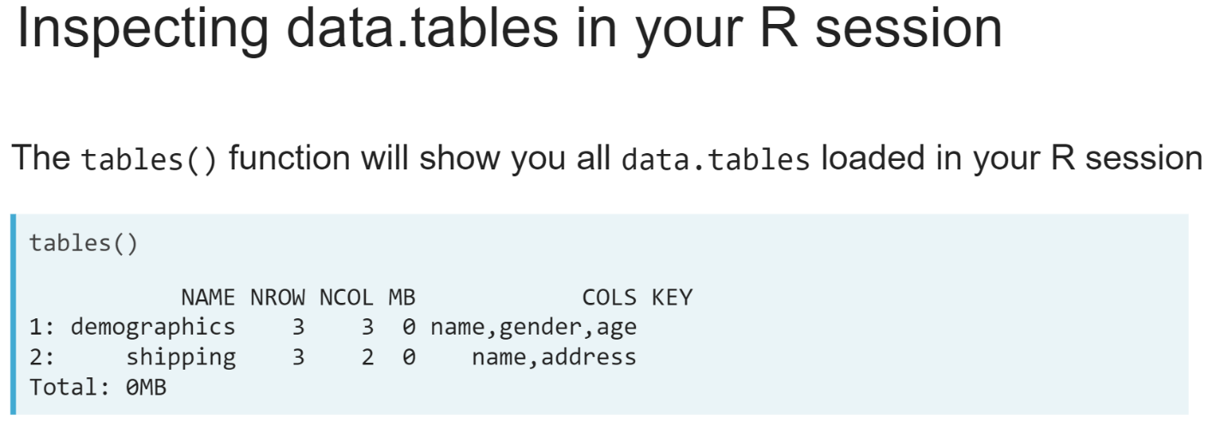

To identify join keys, we will need to learn about the contents of the data tables we are working with. There are a few different ways we can do this. The first way is using the ***tables()*** function.

It will show you all data tables in our R session, along with their number of rows, their number and names of their columns, and how much space they occupy in terms of memory. It will also tell us any columns we have set as their keys, which we'll learn in the next exercises.

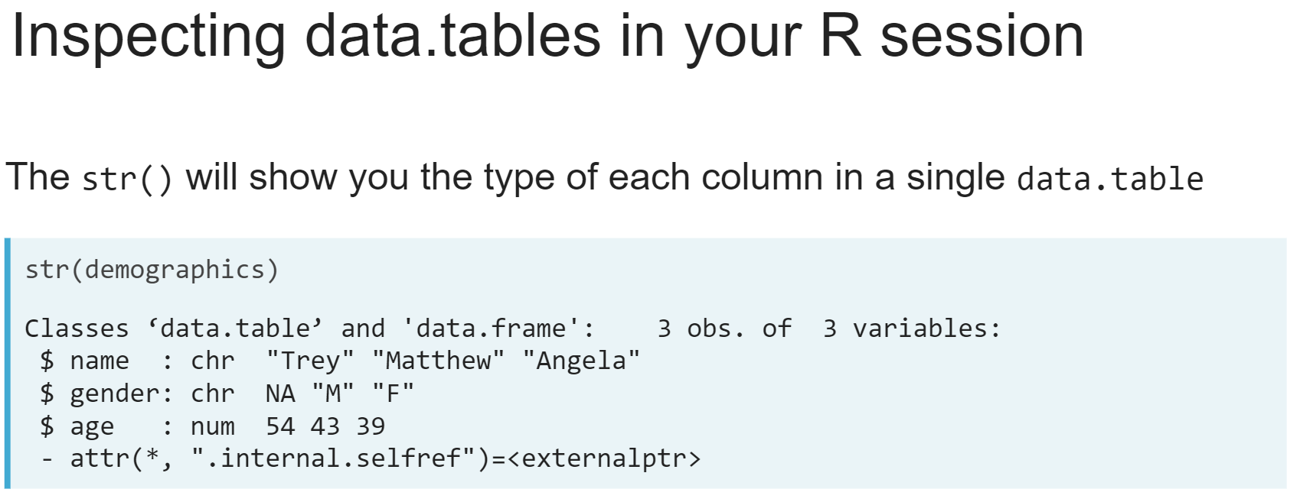

Another way is using the ***str()*** function. This is a general-purpose function that will show us the type of data stored in any R object, in this case, a data table along with the types and first few entries of each column.

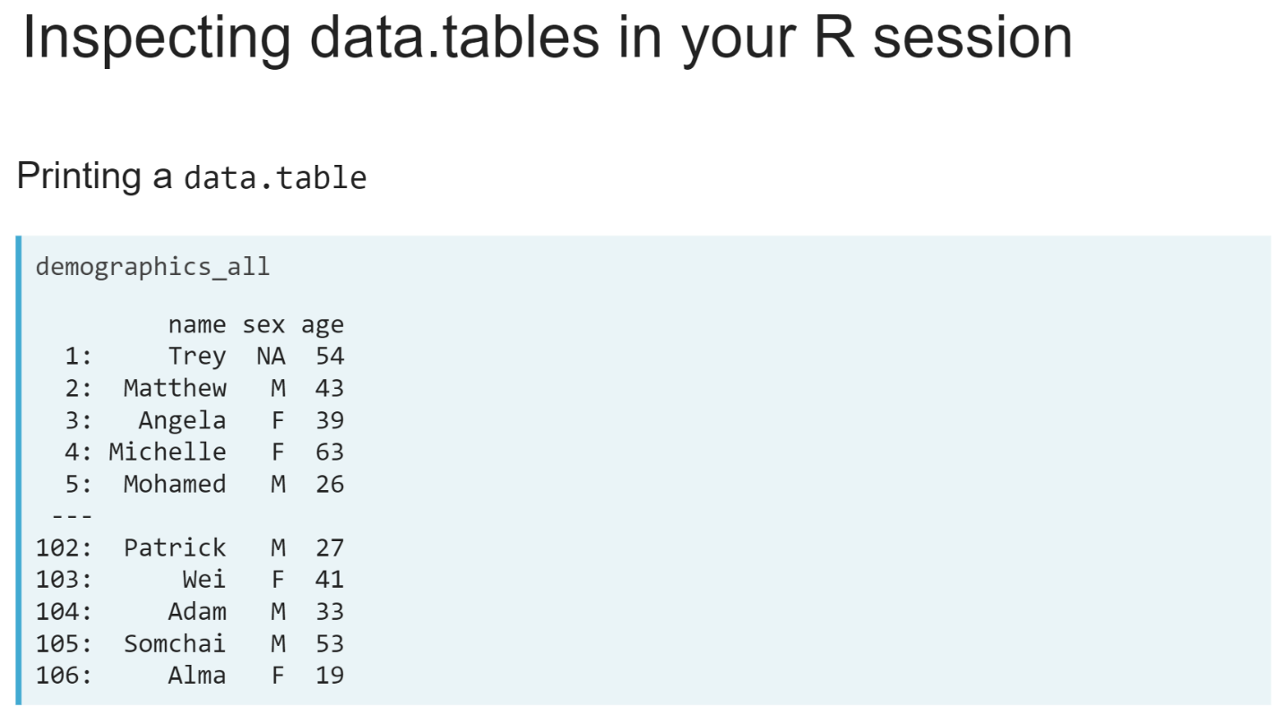

Finally, typing in the variable name and hitting enter in the console will show us the values stored in a data table. If it has more than 100 rows, only the first and last five rows are displayed by default.

# Exploring data.tables

In this exercise, you will explore two data.tables:

* netflix: contains information about some of the [**Netflix**](https://www.netflix.com/) original series released in 2017
* imdb: contains ratings for some TV shows and movies obtained from [**IMDB**](https://www.imdb.com/)

This course touches on a lot of concepts you may have forgotten, so if you ever need a quick refresher, download the [***data.table Cheat Sheet***](https://datacamp-community-prod.s3.amazonaws.com/6fdf799f-76ba-45b1-b8d8-39c4d4211c31) and keep it handy!

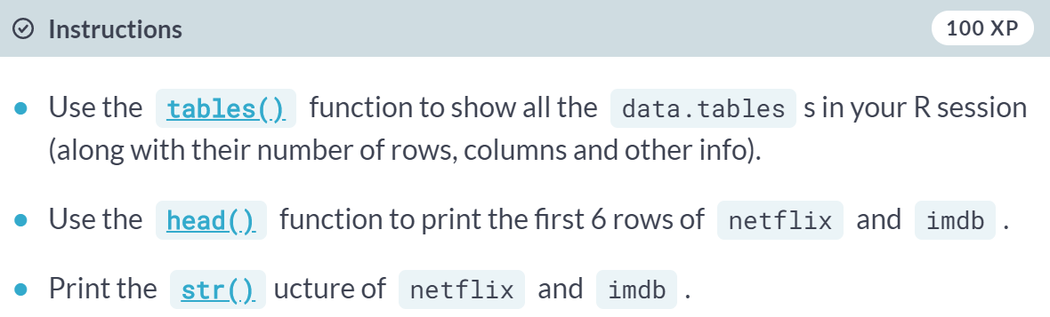  
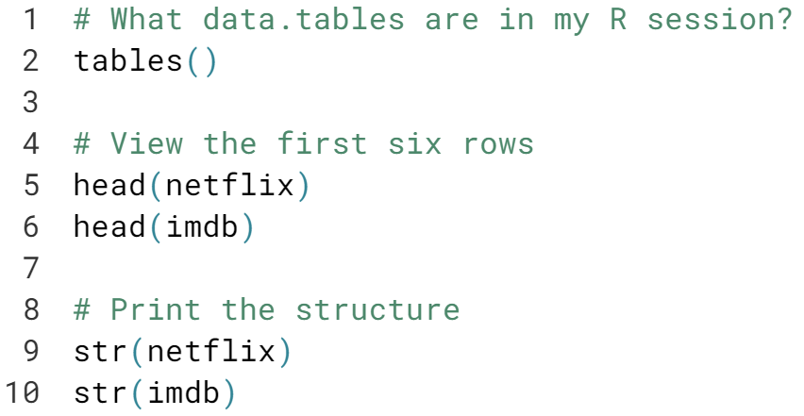  
Nice work! Let's take a closer look at these data.tables in the result next page!

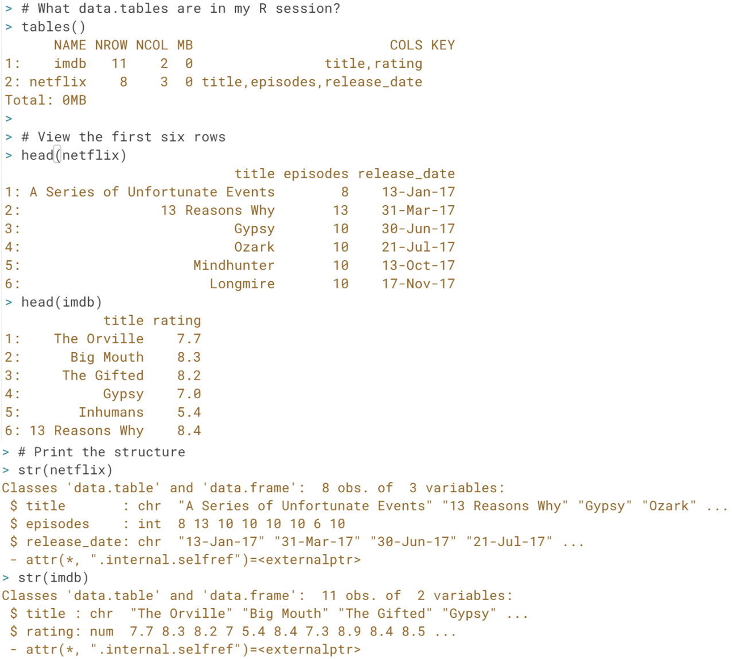

# Identifying join keys

The netflix and imdb data.tables from the previous exercise have been loaded into your workspace. Which columns can be used to match the rows across these two data.tables?

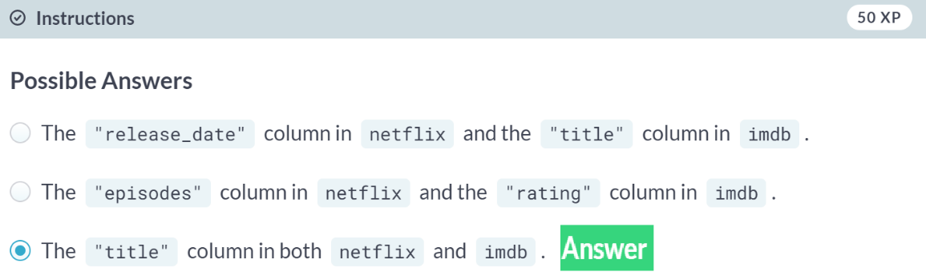  
Well done! Remember that columns that link observations across data.tables are known as “*join keys*”.

# Multiple data.tables, multiple keys

Three new data.tables are available in your workspace: area, capitals, and population, containing basic statistics about the geography and demographics of Australia.

Which columns can be used to match rows across these three data.tables?

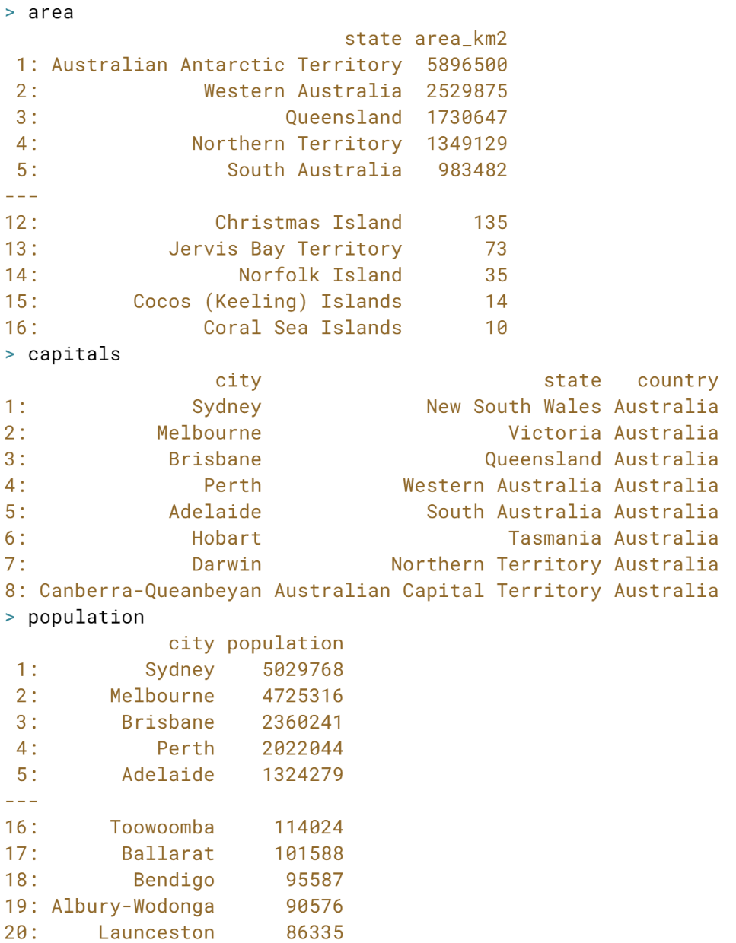  
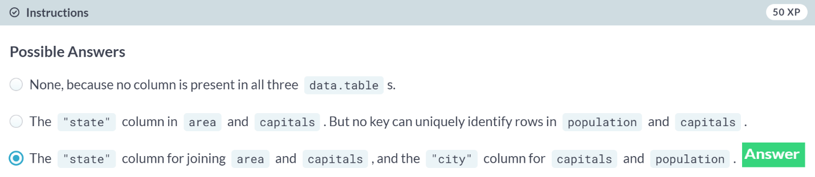  
Excellent! A data.table may have different join key columns depending on the other data.table it is joined to.



Now that we can successfully identify join keys, it's time to learn how to perform joins using the ***merge()*** function.

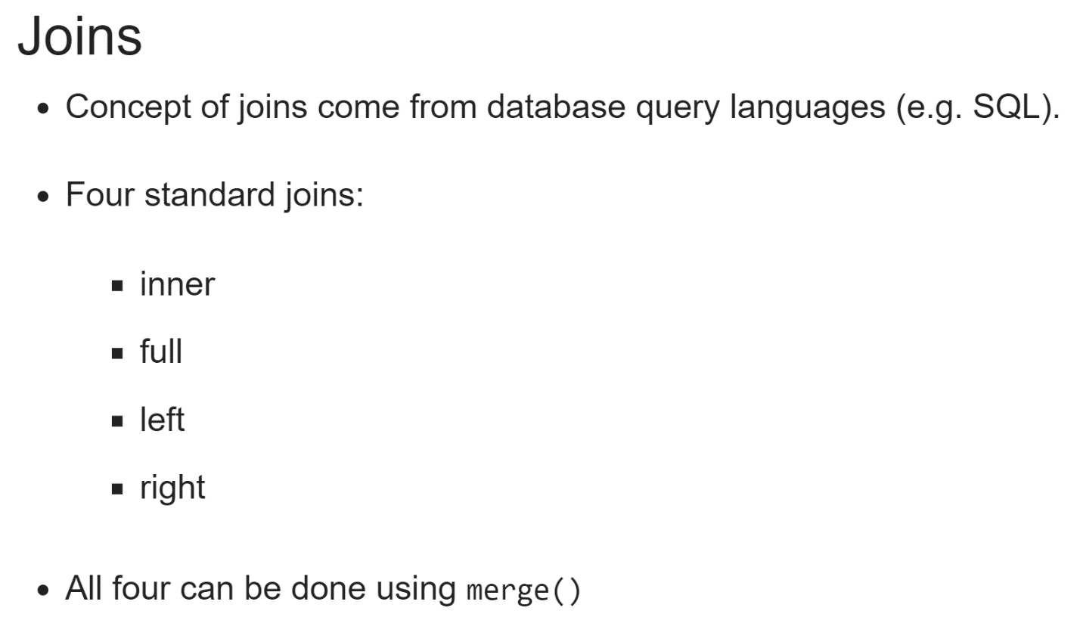

Each of these joins give a different result, based on what observations are present in one data table but not in the other.

All four are standard joins that originally come from database query languages, such as SQL. So, the concepts we will learn in this chapter are widely applicable, not just for the data table package in R.

In this chapter, we will learn how to do these joins using the merge() function. This function comes from base R but is extended in the data table package to work efficiently with data tables.

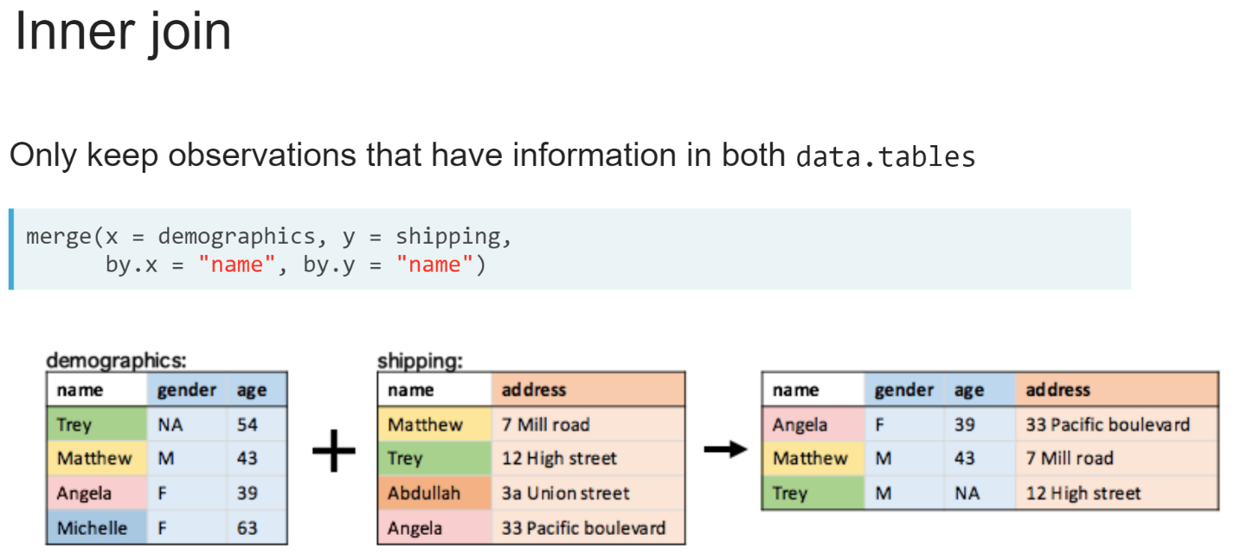  
An inner join combines the columns of two data tables, keeping only the observations present in both tables, that is, rows whose value in the join key column can be found in both data tables. Returning to our example customer database, an inner join of the demographics data table, shown in blue, to the shipping address data table, shown in orange, creates a new data table containing all the columns from both data tables, containing just the people with entries in both; those highlighted in pink, yellow, and green. An inner join is the default behavior of the merge() function. It takes two data tables as inputs, one to its x and one to its y arguments, along with the name of the key column in each table to the *by.x* and *by.y* arguments respectively.

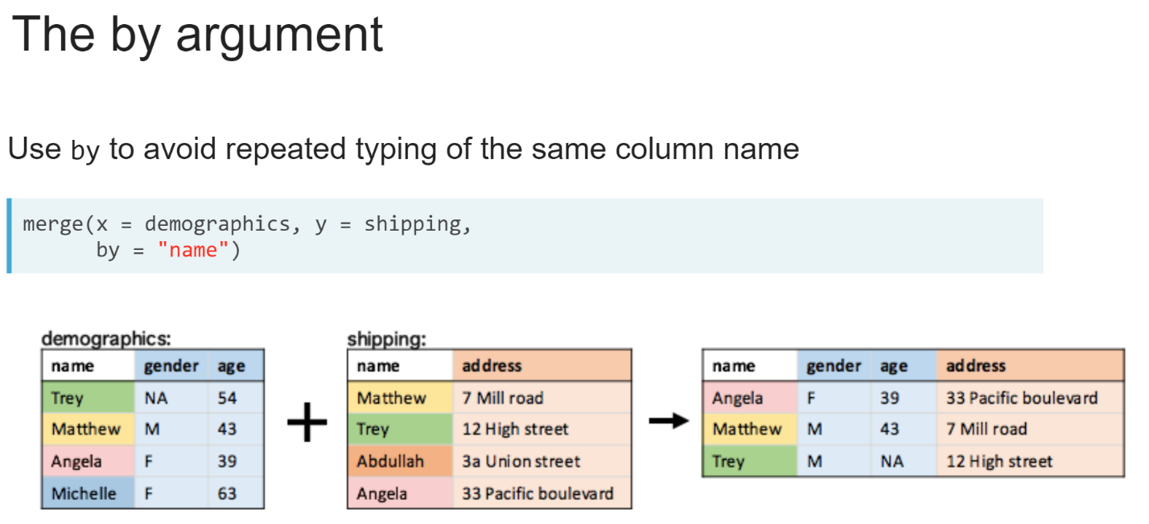  
When the key columns have the same name in both data tables, we can use the *by* argument instead to avoid typing the column name twice.

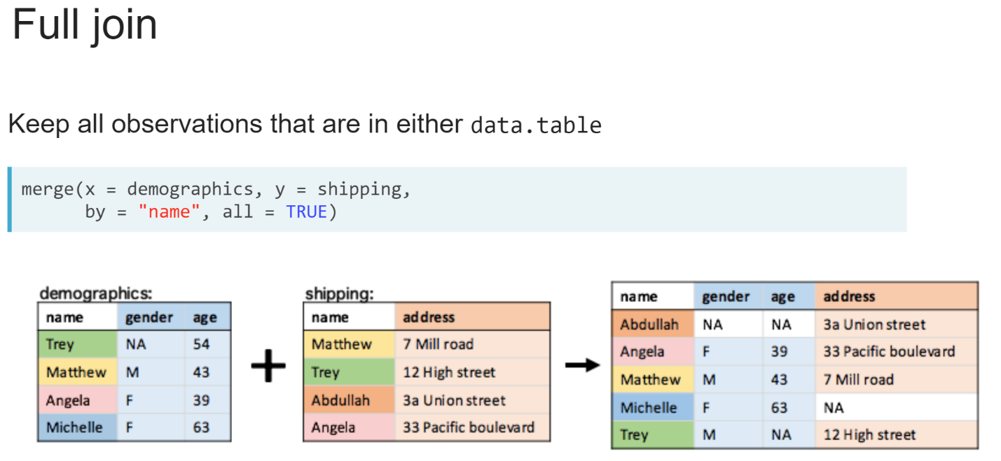  
If you want to keep all observations that are present in either data table, you can supply an additional argument to the ***merge()*** function; setting the all argument to be equal to **TRUE**.

This is known as a full join or a full outer join. Observations which were present in only one data table will have missing values in the columns from the other data table, as shown in the white cells in the result.

# Inner join

Two data.tables are available in your workspace:

* netflix: contains a selection of original series released by [**Netflix**](https://www.netflix.com/) in 2017
* imdb: contains average user ratings for a selection of TV shows and movies from [**IMDB**](https://www.imdb.com/).

Your goal is use the [**merge()**](https://www.rdocumentation.org/packages/data.table/topics/merge) function to perform an inner join to build a new data.table containing all series from netflix that have a rating in imdb.

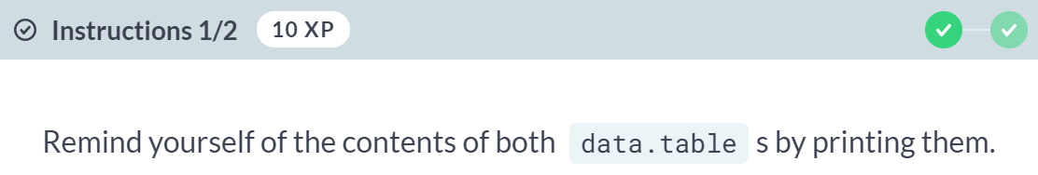

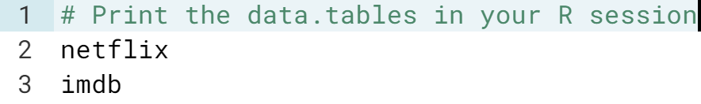  
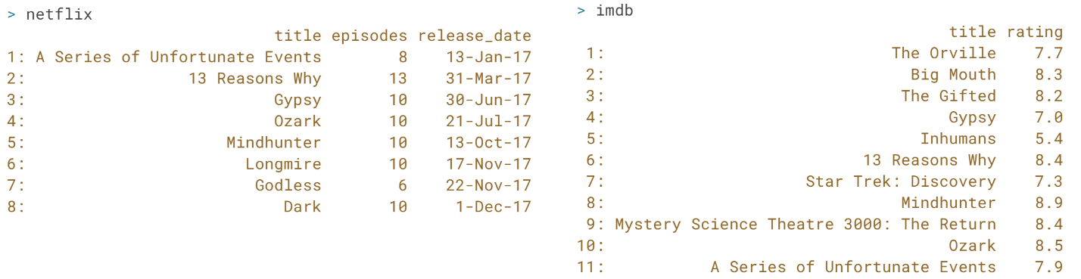  
  
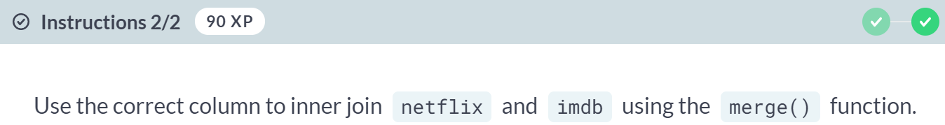  
  
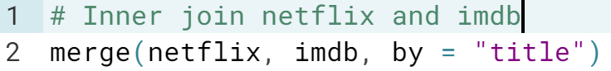  
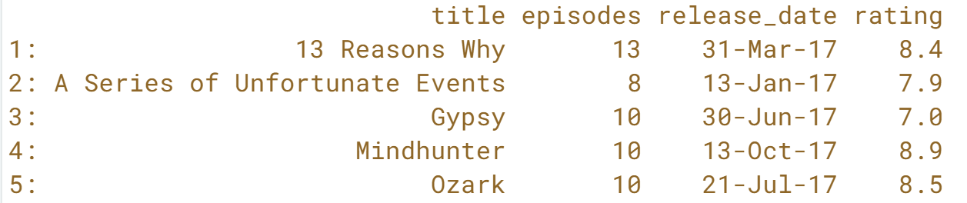  
Great job! *Inner joins* are useful when you want to build a complete set of information for observations that are present in both *data.tables*.

# Full join

Using the same data.tables as the previous exercise, this time use merge() to perform a full join to build a new data.table containing all rows present in either netflix or imdb.

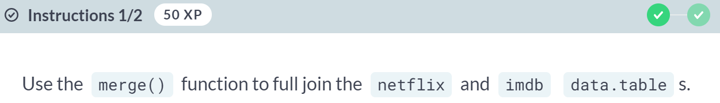  
  
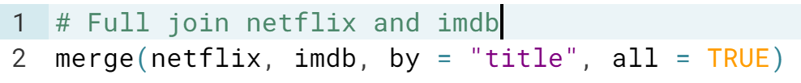  
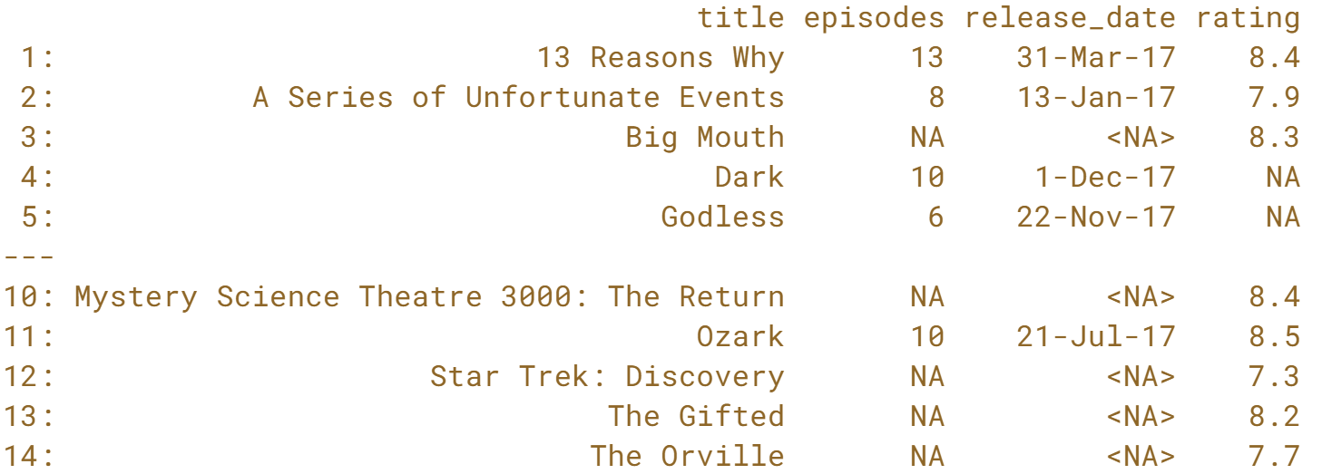  
  
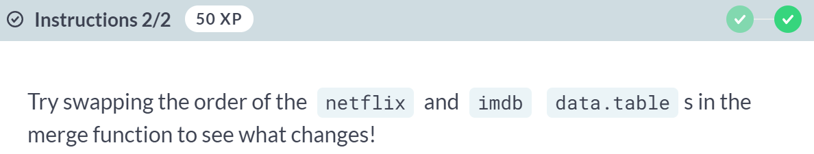  
  
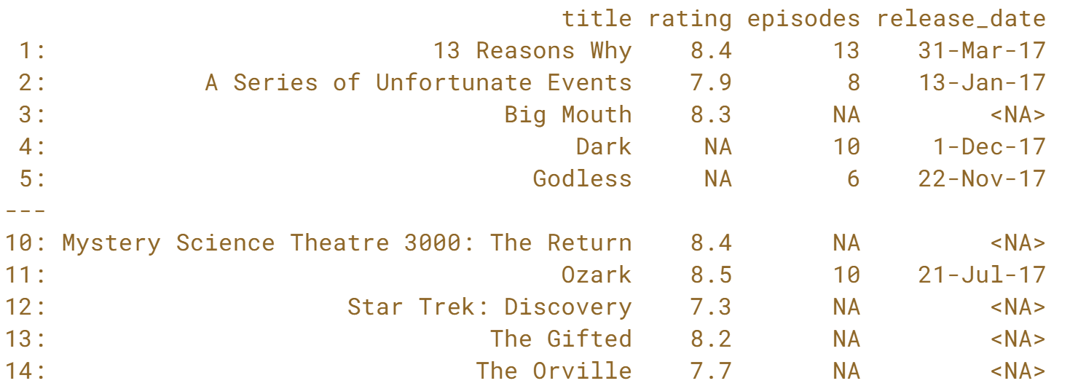

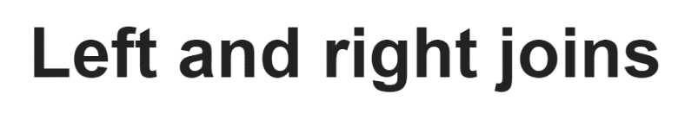

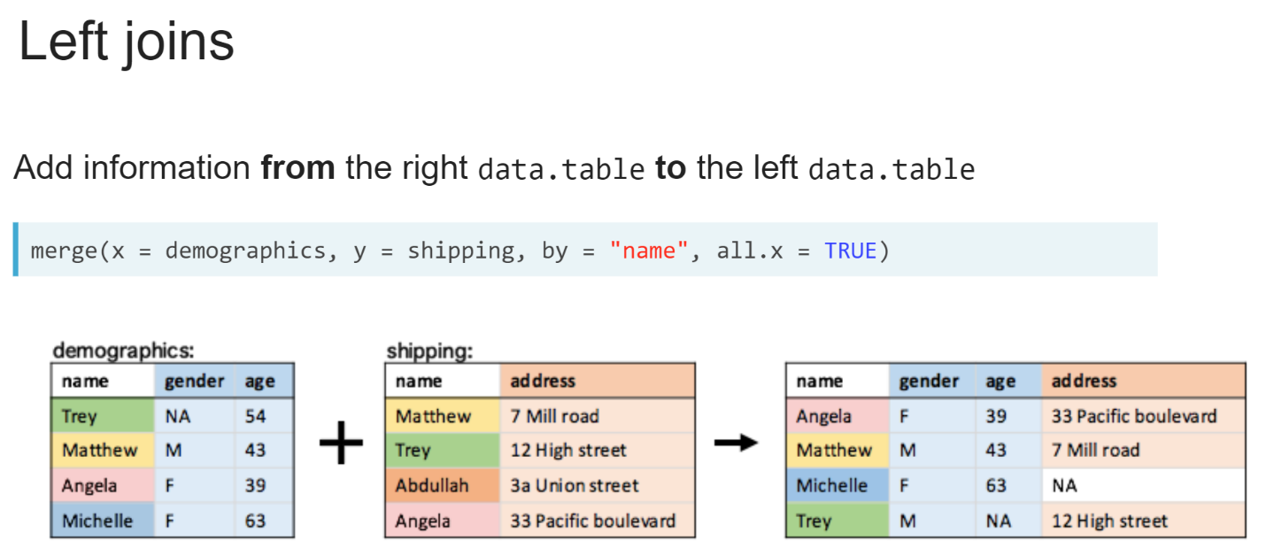  
A left join keeps only the observation that are present in the data table on the left side of the join. In other words, a left join will add information from the data table on the right to the data table on the left. This is useful when there are two data table from different sources, but we are only interested in the observation from one.

The data table on the left side of the join is the data table given to the x argument of the ***merge()*** function. To perform a left join with the merge() function, we set the argument **all.x** to be **TRUE**.

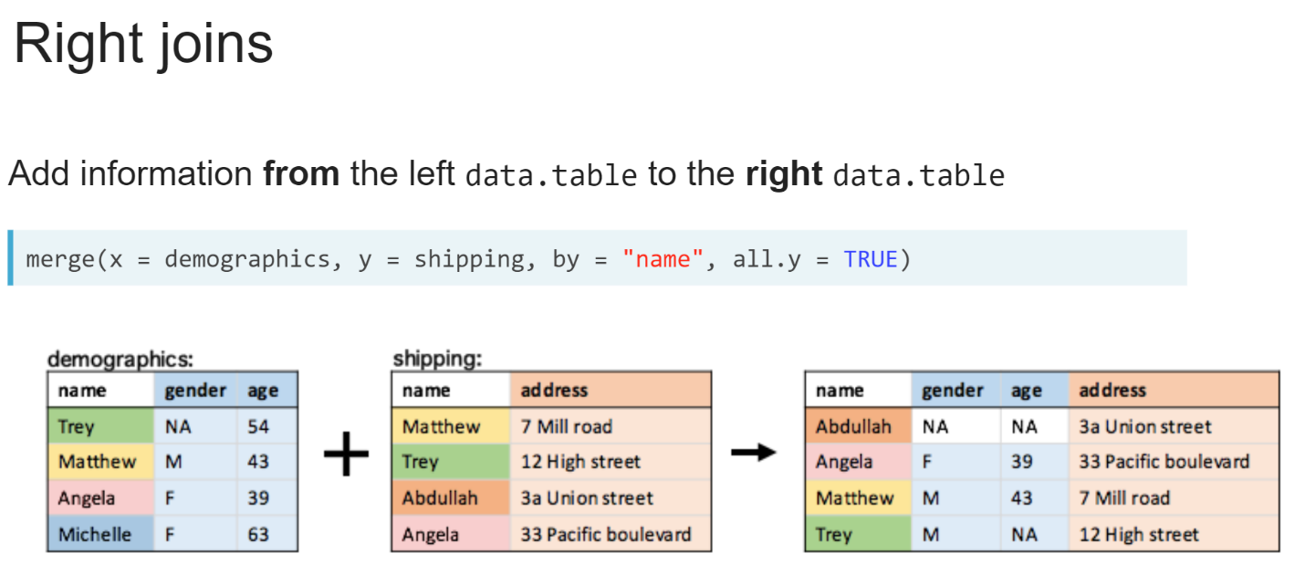  
Conversely, a right join keeps only the observation that are present in the data table on the right side of the join. The data table on the right side of the join is the data table given to the y argument of the ***merge()*** function. To perform a right join with the merge() function, we set the argument **all.y** to be **TRUE**.

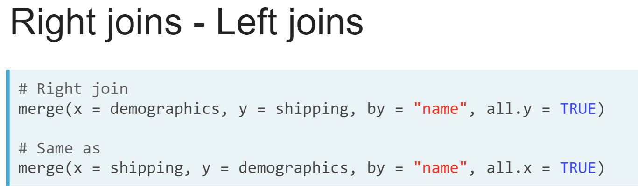

The outcome is the same as swapping the order of the data tables in the ***merge()*** function and performing a left join. Most people find one or the other to fit more naturally when thinking about data and stick to that. It's only in rare cases when joining multiple data tables in a sequence of joins where we might need to use both left and right joins.

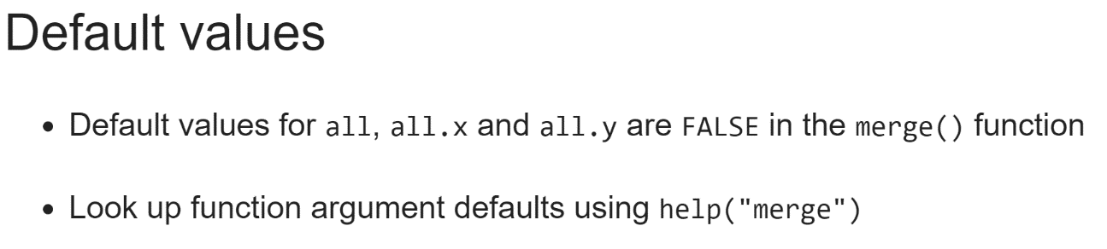  
Any arguments we don't specify in a function call in R take on their default values. For example, the arguments *all*, *all.x*, *all.y* for the ***merge()*** function have a default value of **FALSE**. We can look up the default values for any function's argument by using the ***help()*** function.

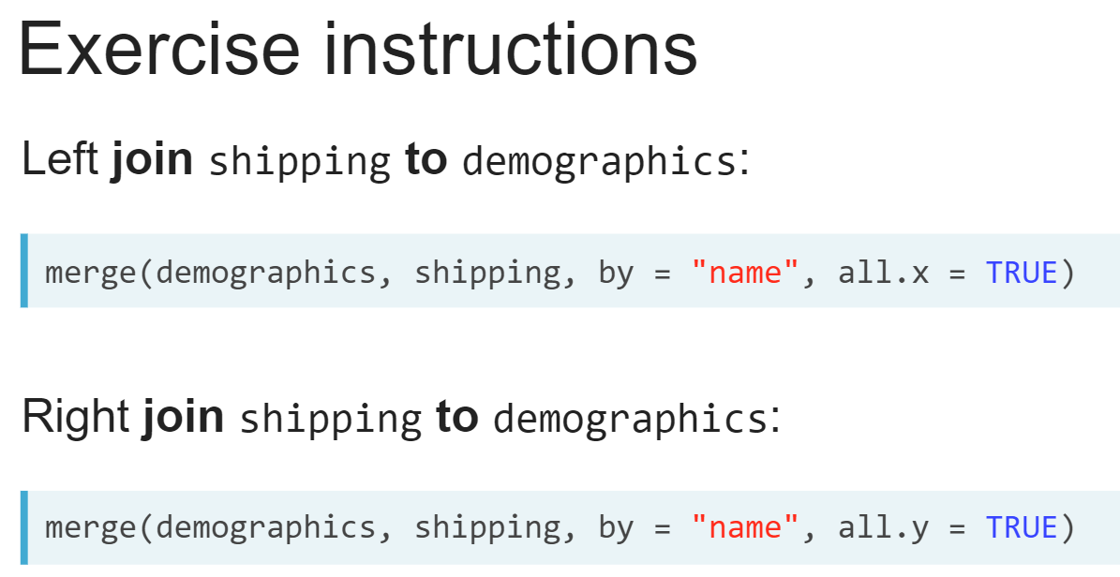  
In the code exercises throughout the rest of the course, we will be instructed to join one data table to another using the wording we see on the slide. Regardless of the type of join, the data table that we see after the word "*to*" should always be placed on the **left side** of the join in the code. So, if we ask you to join the shipping data table to demographics data table, the demographics data table should always be on the left side of the join: the first argument to the ***merge()*** function.

# Left join

In this exercise, you will practice left joins! In a left join, rows from only the left (or the first) data.table will be retained.

Both netflix and imdb are available in your workspace.

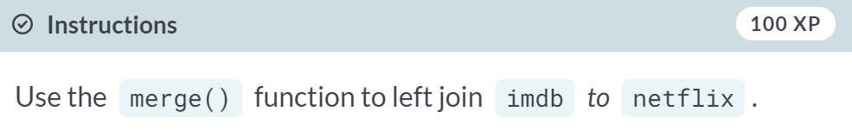

  
  
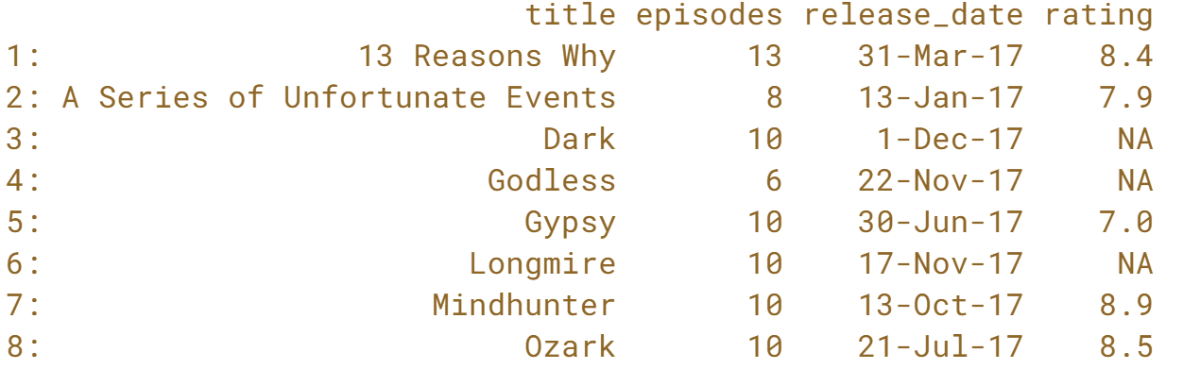  
Fantastic! Did you notice that missing information for observations that are not present in the right table of the join contain NAs for the right data.table's columns?

# Right join

In this exercise, you will right join imdb to netflix. The resulting data.table should contain all entries from imdb with the release date and the number of episodes added for titles that are also listed in the netflix data.table.

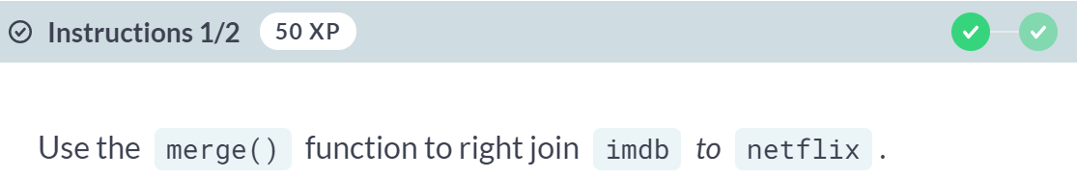  
  
  
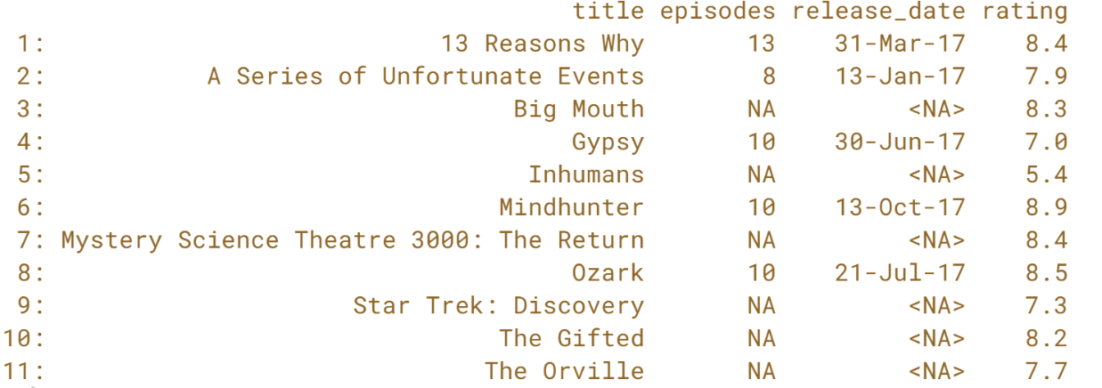

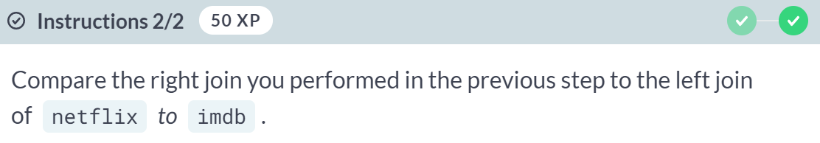  
  
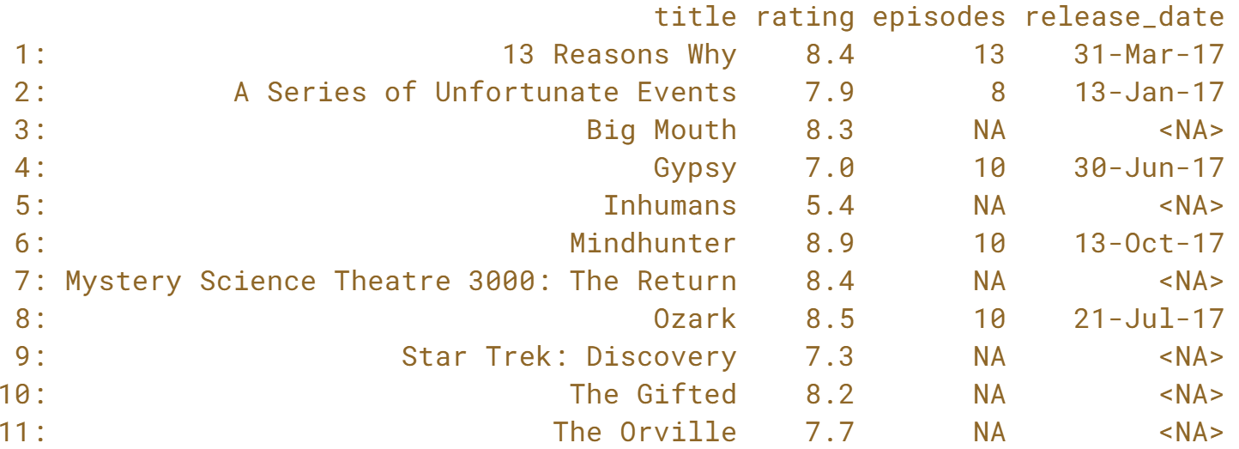  
Nicely done! Right joins and left joins are essentially the same, with the order of input data.tables swapped in the join.

# Mastering simple joins

Three new data.tables have been loaded into your R session containing information about the geography and population of Australia: area, capitals, and population. Your goal is to perform a sequence of joins to build a single data.table containing information about the geographical area of each Australian state and the population of its capital city, storing the final result in a new variable: australia_stats.

There are three data.tables so you will need to perform two joins. First, you will join capitals and population, and then you will join the resulting data.table to the area.

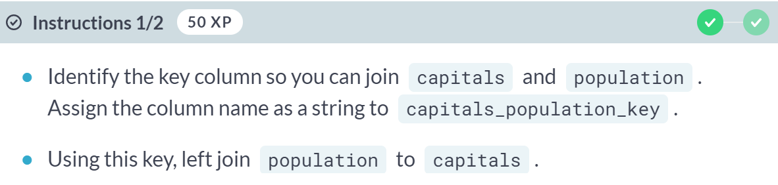  
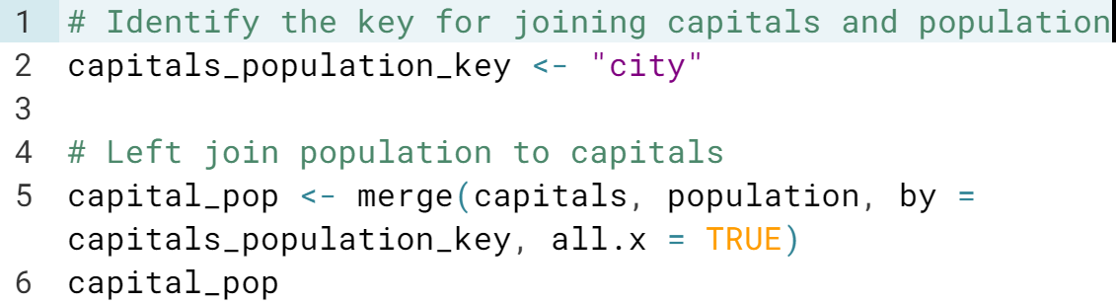

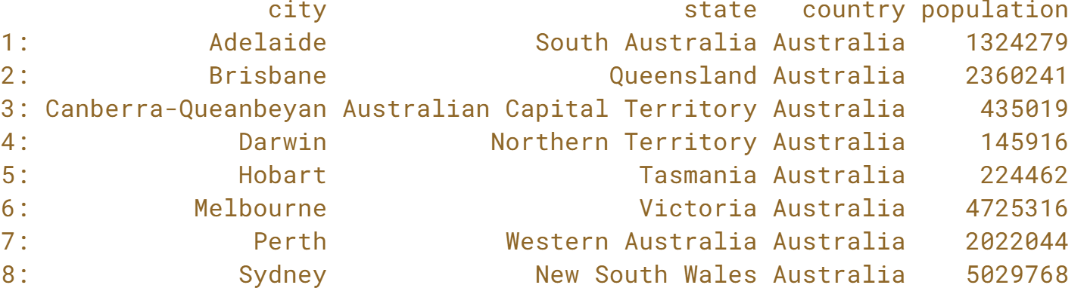

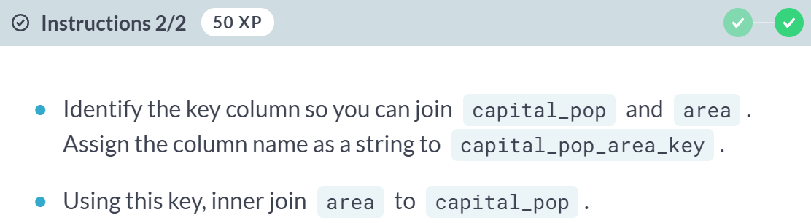

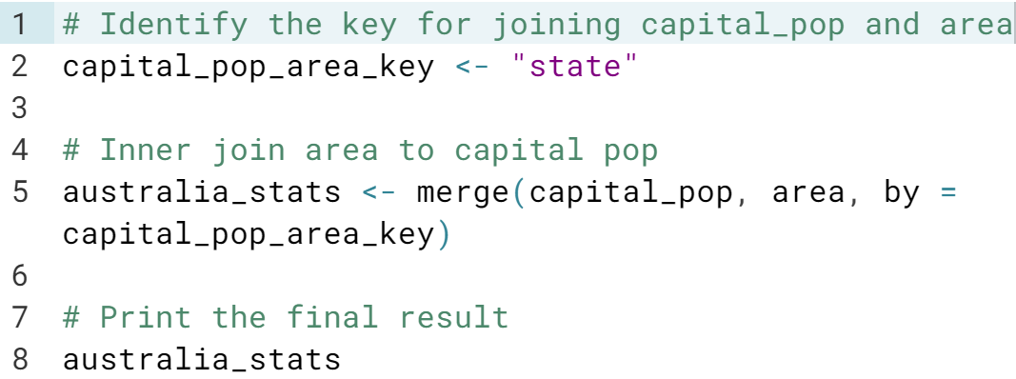

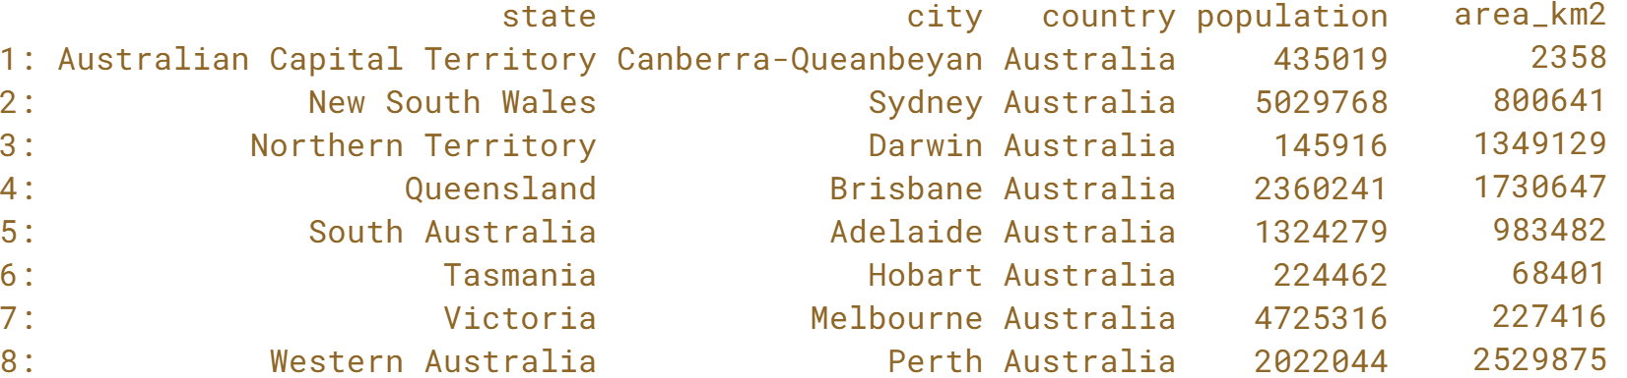

Well done! Mastering these joins enables you to combine information in many different ways to build the right *data.table* to ask your data science questions of interest.

**Joins Using data.table Syntax**In this chapter you will perform joins using the data.table syntax, set and view data.table keys, and perform anti-joins.

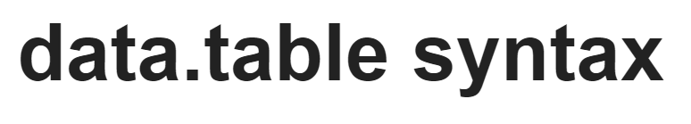

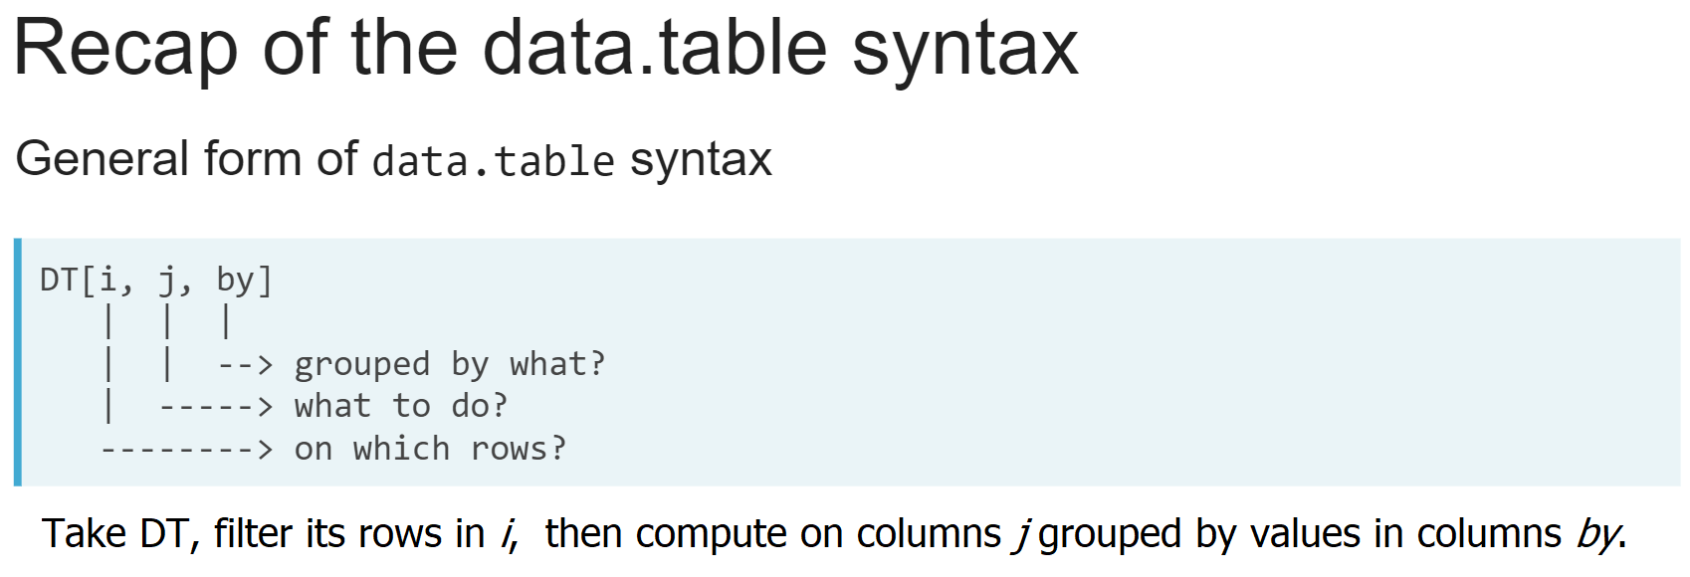

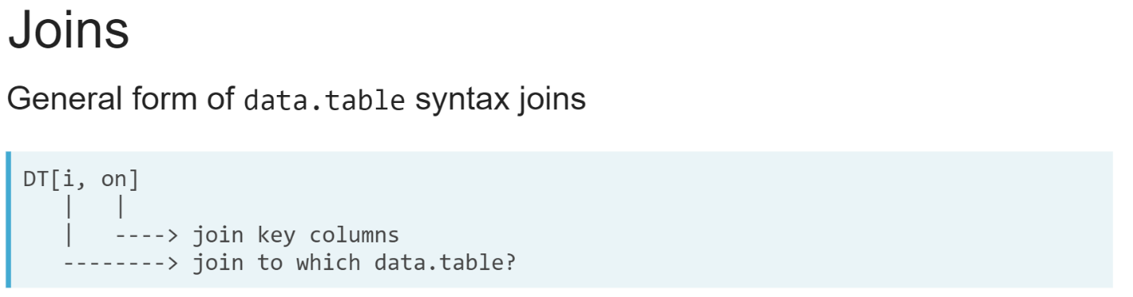  
To perform a join using this syntax, we pass another data table to the i argument. This can be read out loud as "Join DT to *i* using the column in on as the join key".

We can think of it as just any other filter operation in *i*, except here we are filtering the rows in DT based on those that have matches to rows in *i*.

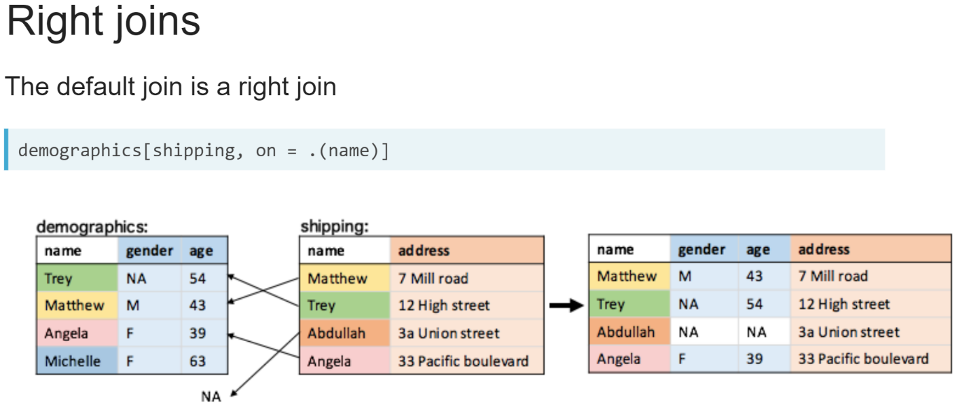  
This naturally leads to the definition of a right join. Like any other subset operation in R, values that have no match return missing values.

So here, rows from the data table we are subsetting on in the *i* argument are kept in the result, with missing values where there was no match in the main data table.

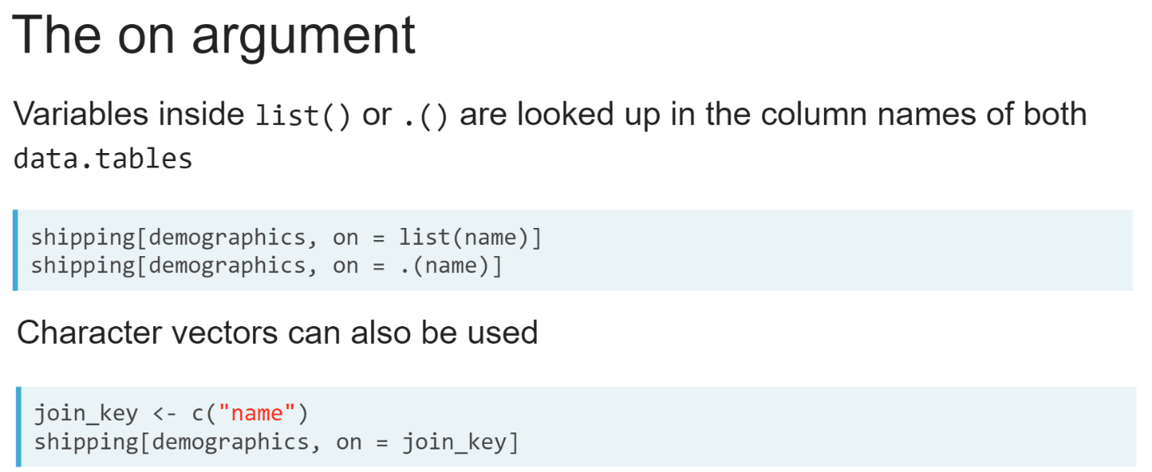  
Join key columns are supplied to the on argument. This follows similar rules to the j and by arguments in the data table syntax. If we use the list function or its alias, we can enter the join key column name as if it was a variable.

We can also use a character vector to specify the join key. This also allows us to store the join key in a variable that we pass to the on argument. Note that we haven't used the list function or its alias, so data table syntax looks for the *join_key* variable, not for a column with the same name.

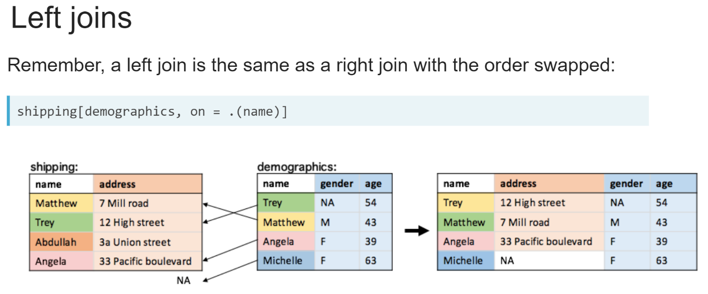  
To perform a left join, we can swap the order of the data tables, so that the data table on the left side of the join is passed to the *i* argument. To left join the demographics data table shown in blue to the shipping data table shown in orange, we swap the order of data tables from the previous slides and perform a right join on the *demographics* data table.

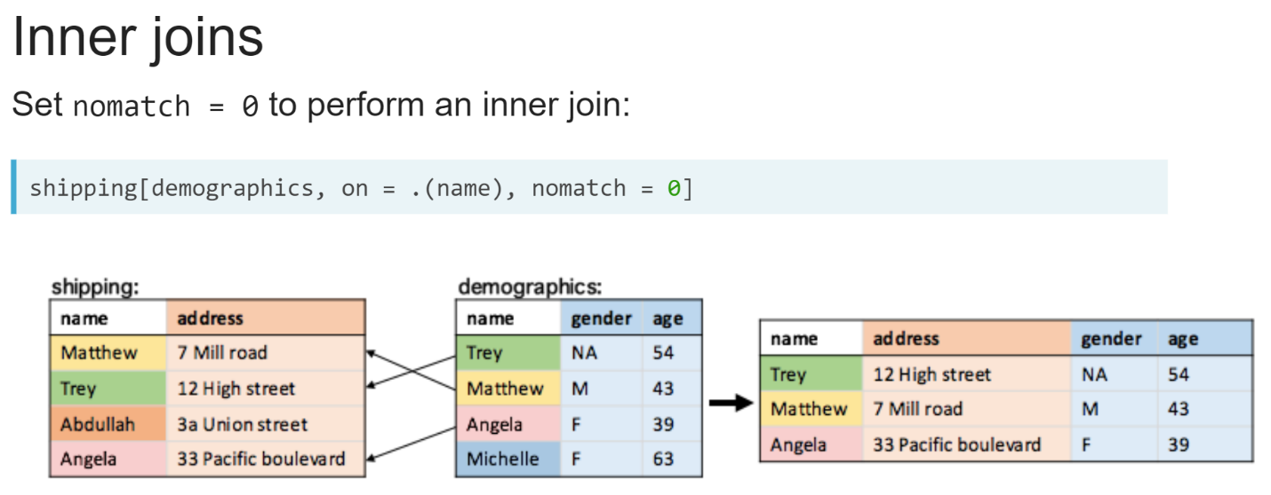  
To perform an inner join, we supply an additional argument, '*nomatch = 0'*, which tells the data table syntax to ignore rows that cannot be matched between the two data tables, giving you an inner join.

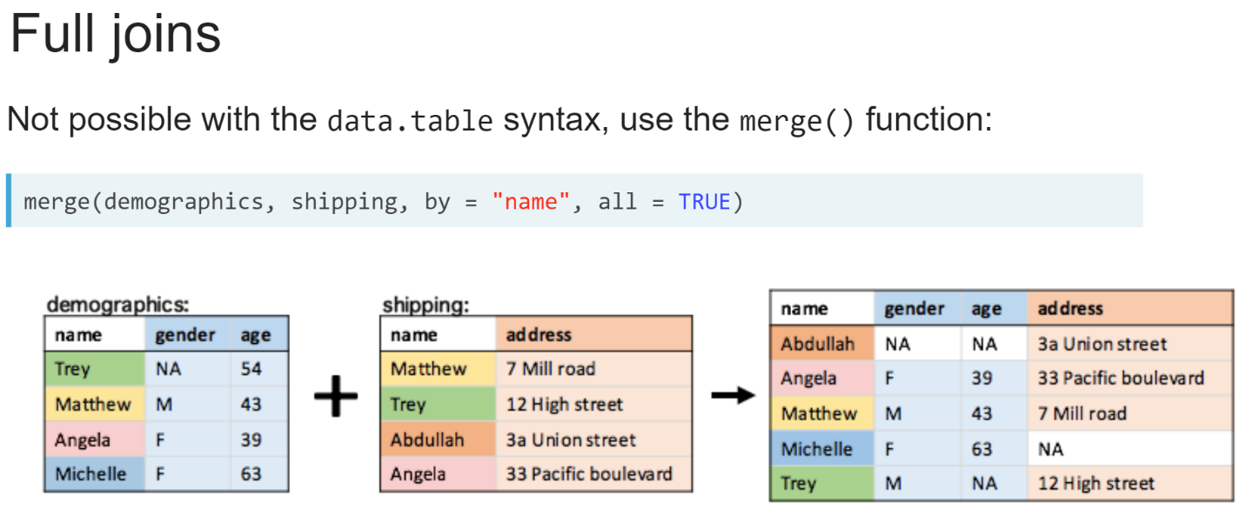  
It is not possible to perform a full join with the data table syntax, so we will need to rely on the merge function we learned in the previous chapter. Remember to set '**all = TRUE**' to perform a full join.  
  
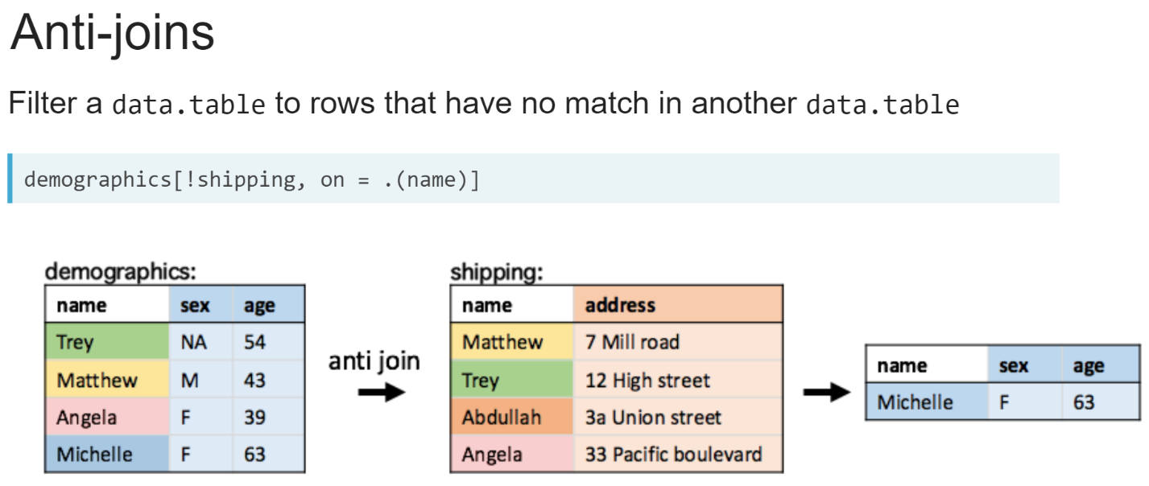  
Finally, another type of join we can perform using the data table syntax is an anti-join; this filters the main data table on the left so that it contains only rows that have no match in the data table on the right. Anti-joins are performed by adding an exclamation mark(**!**), known as "**not**" operator, before the data table we want to filter on in the *i* argument.

# Right join with the data.table syntax

capitals and population, the two data.tables containing information about the geography and population of Australia are available in your workspace. Your goal is to add the state of each city to the population by performing a right join using the data.table syntax.

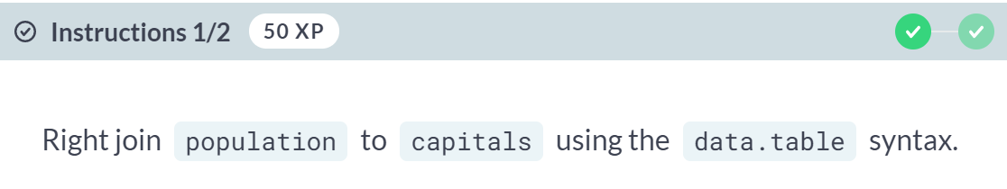  
  
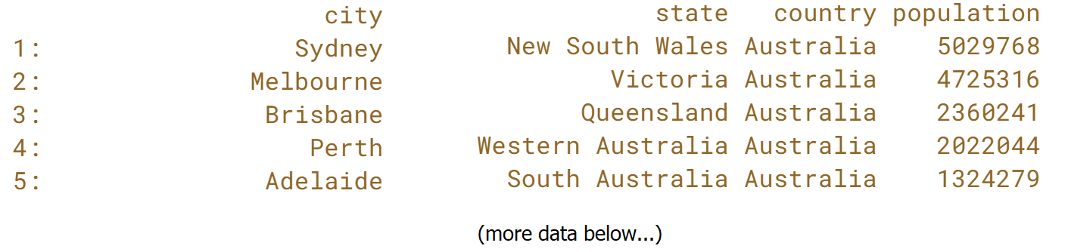  
  
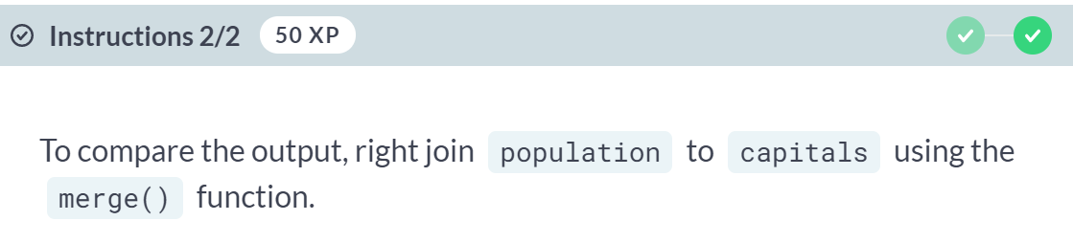  
  
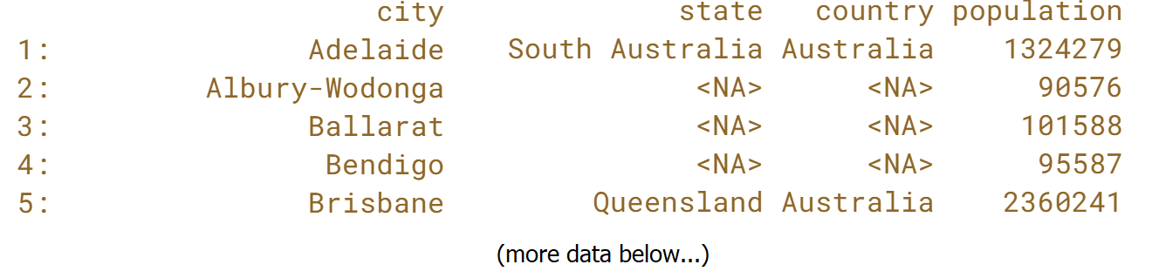  
Nice work! Did you notice the difference in row ordering in the result? This is because joins using the *data.table* syntax treat the *i* argument like a subset operation, so it returns rows in the order they appear in the data.table given to the *i* argument, while the ***merge()*** function sorts rows based on the values in the key column.

# Inner join with the data.table syntax

In the last exercise, you right joined population to capitals. The result contained all rows from population and had some NAs. In this exercise, you will perform an inner join instead, retaining rows only from both the tables.

  
  
  
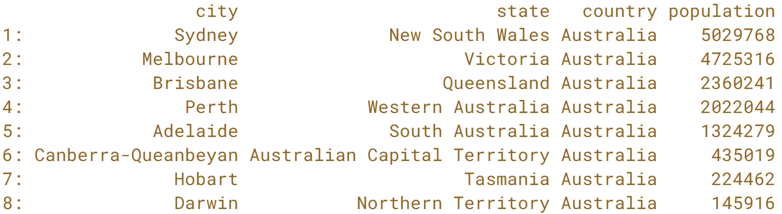  
Great job! If you are performing many inner joins, you can change the default behavior of nomatch by setting options(*datatable.nomatch = 0* ) in the R session.

# Anti-joins

Anti-joins are useful when you want to filter rows in one table not found in the other. Your goal is to filter the population so that it does not contain the state capitals, and filter the area so that it only contains administrative areas, not the major Australian states.

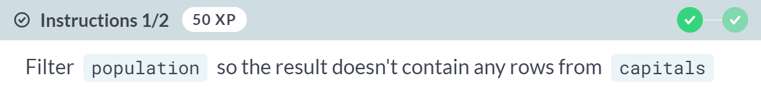  
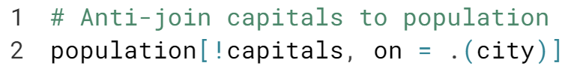  
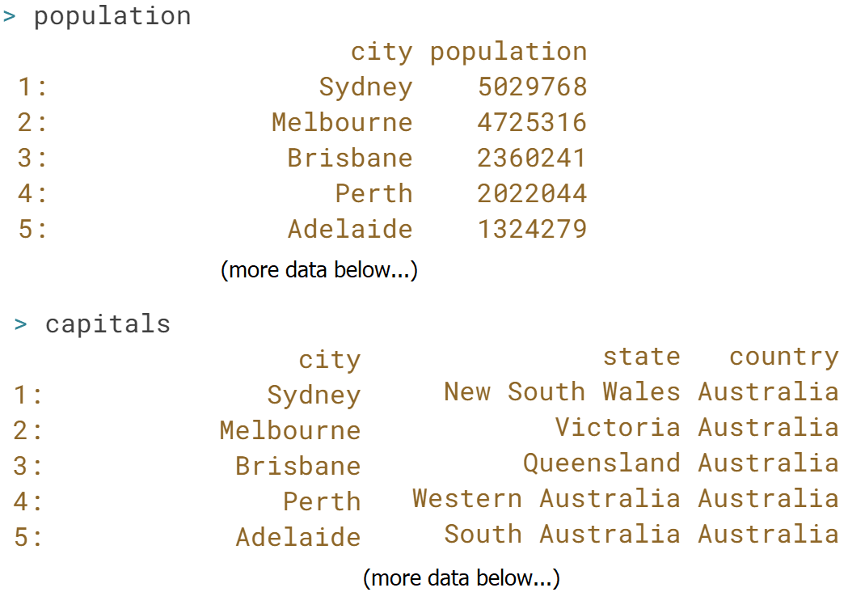  
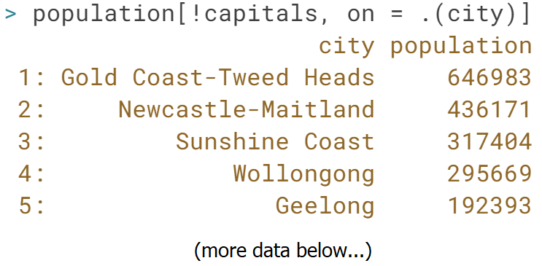

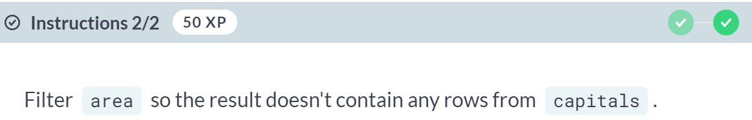  
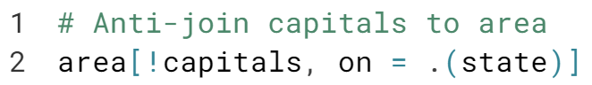

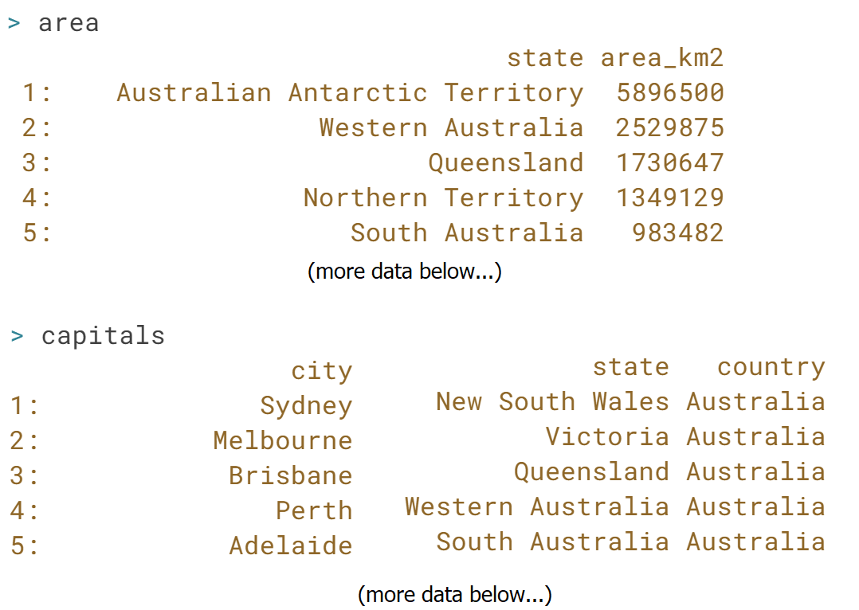  
  
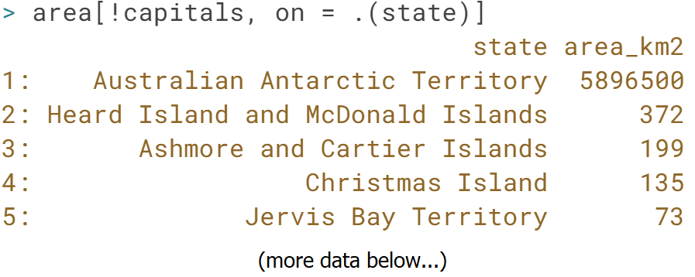  
Nicely done! *Anti-joins* are a useful way of identifying rows that have no match in another data.table.



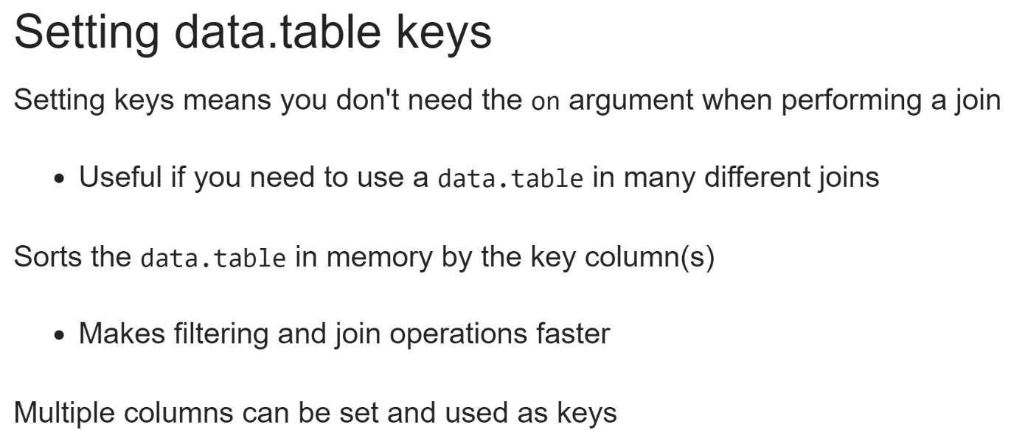  
In the previous lesson, we learned how to perform joins using the data table syntax. In each case, we had to use the on argument to specify how to match rows between the two data tables. However, it is possible to tell R which columns are keys for each data table **in advance of a join**, removing the need for the on argument.

This is useful if we find ourselves performing several different joins with a single data table. Setting a key will also sort a data table by that column in memory, which makes joining and filtering operations on that columns much faster for large data tables. With that in mind, it's useful to know that we can set multiple key columns for a single data table. We will learn more about joins that require multiple keys in the next chapter.  
  
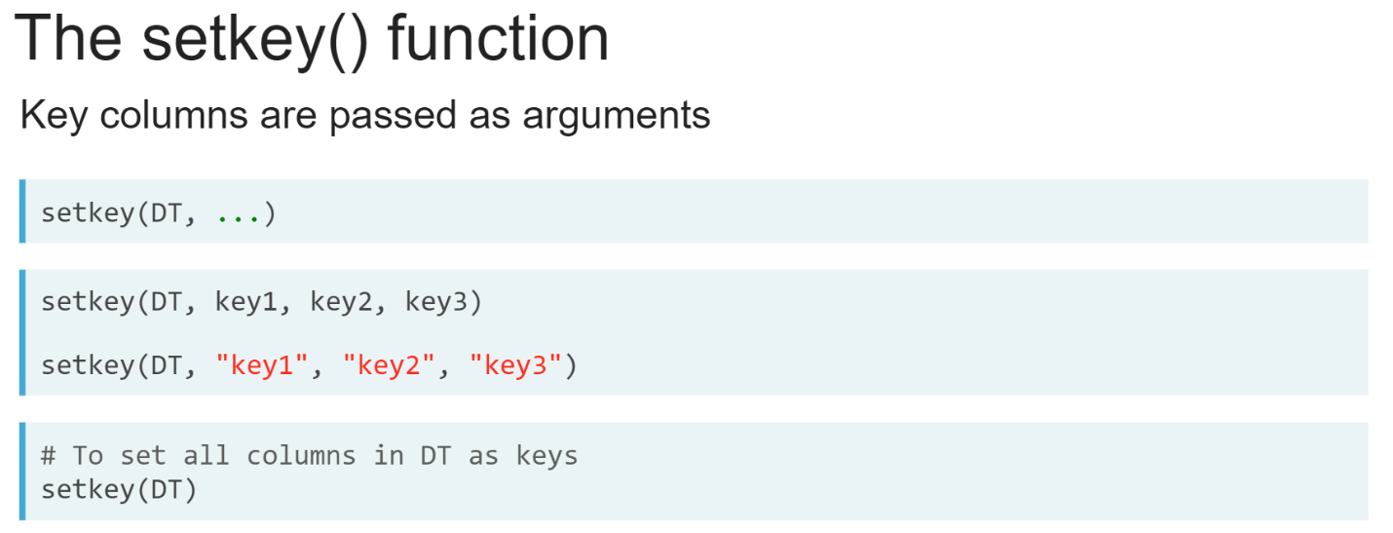  
The ***setkey()*** function is used for this purpose. It takes a single data table as its first argument, then any number of key column names as its remaining arguments. These can be entered as if they were variables or can be wrapped inside quotes; either will work. If you don't provide any column names to the ***setkey()*** function, it will use all columns of the data tale as its keys.

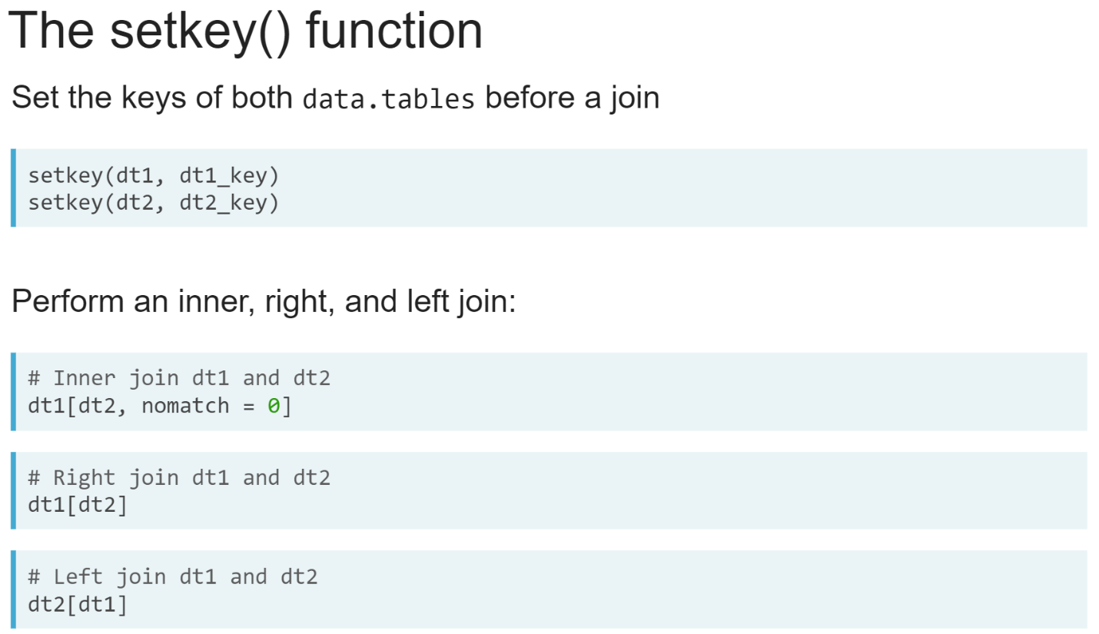  
When keys are set for two data tables, we can use the data table syntax without the on argument for performing joins.

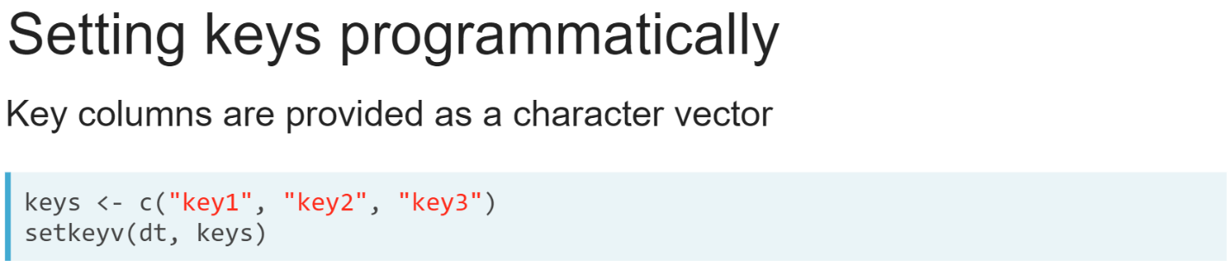  
We can also use the ***setkeyv()*** function to set the keys of a data table by passing in a character vector of the key column names. This is useful if we want to set the keys of a data table programmatically, where our key column names are stored in another variable.

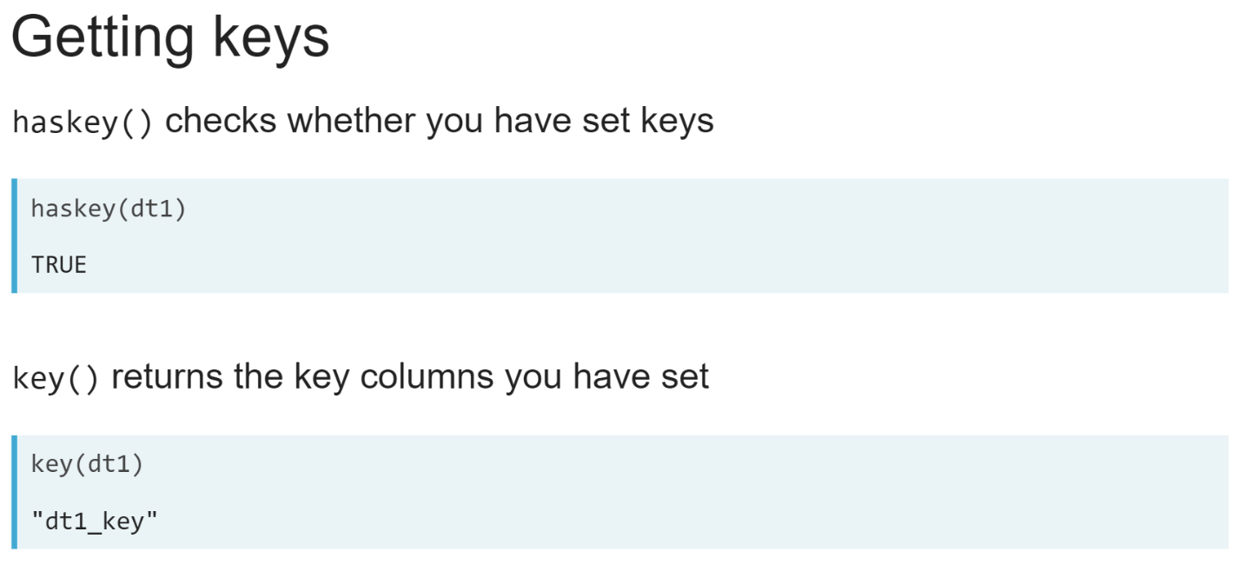  
We can check whether a data table has any key columns set by using the ***haskey()*** function and get the key we've set by using the ***key()*** function.

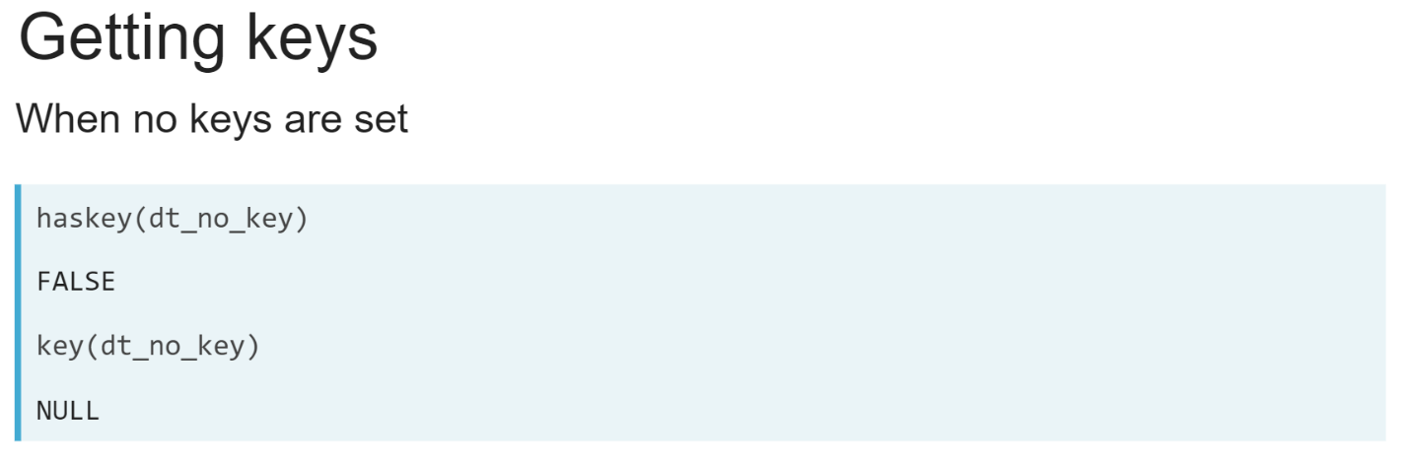  
If we haven't set the key for a data table, then the ***haskey()*** function will return **FALSE** and the *key()* function will return **NULL**.  
  
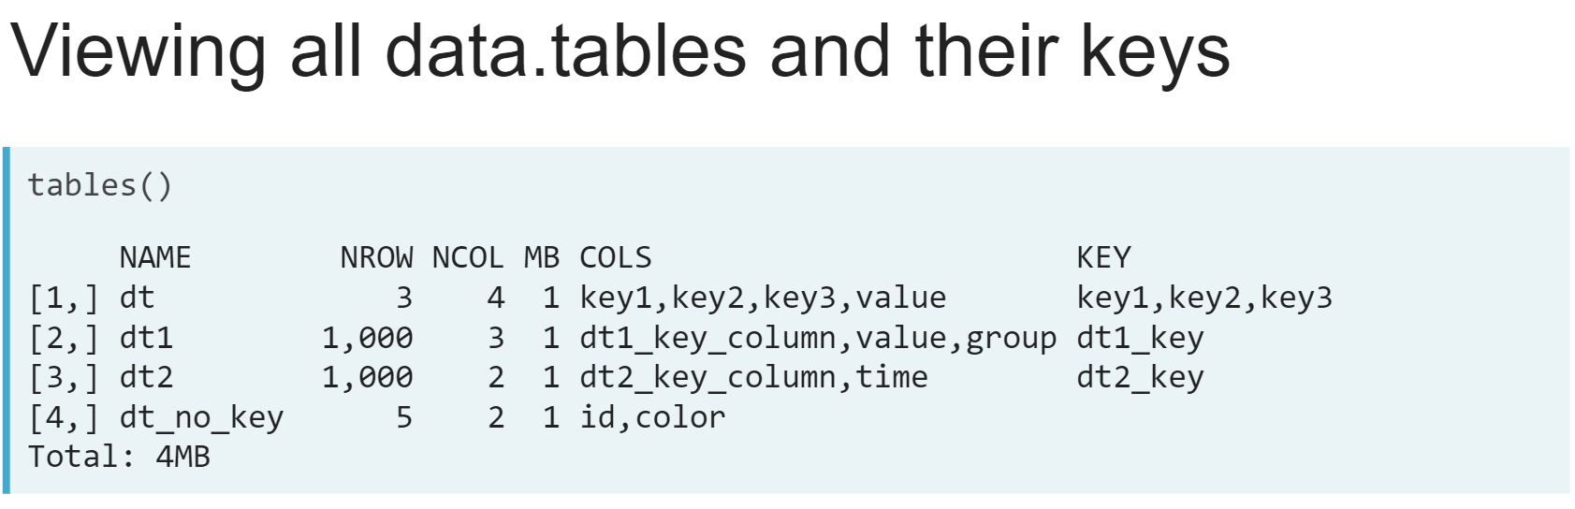  
The ***tables()*** function we learned about in the previous lesson will also show us the keys we have set for any data table in the R session.

# Setting keys

The netflix and imdb data.tables are available in your workspace. Your goal is to set the keys for both data.tables so that you can perform a series of joins without needing to specify the join keys each time.

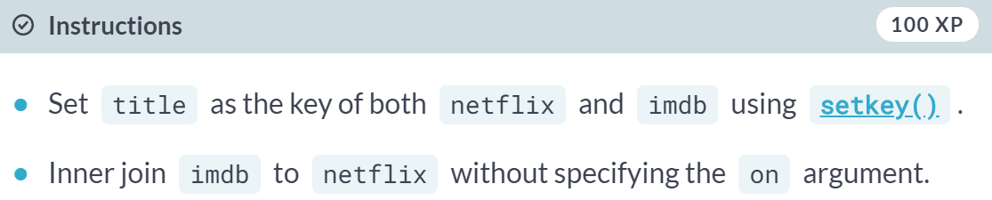

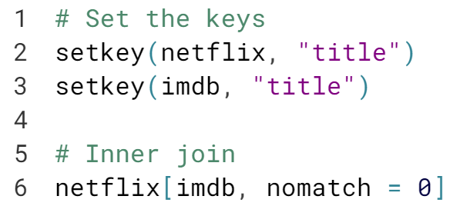

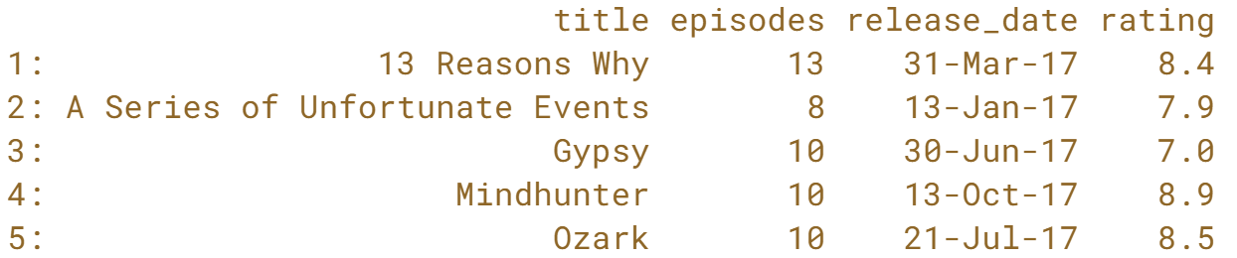  
  
Good job! Using ***setkey()*** will also sort the rows of a *data.table* by the key columns. This makes joins and filter operations on the keys more efficient and can be much faster for large *data.tables*.

# Getting keys

You can also get and set the keys programmatically. In this exercise, only one of netflix and imdb has their key set. Your job is to find out which data.table has had their key set, then use that to set the key for the other data.table.

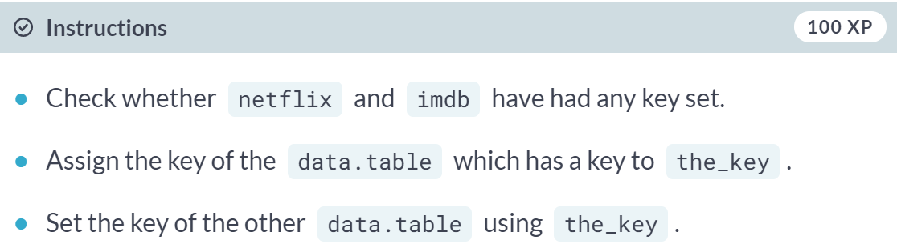

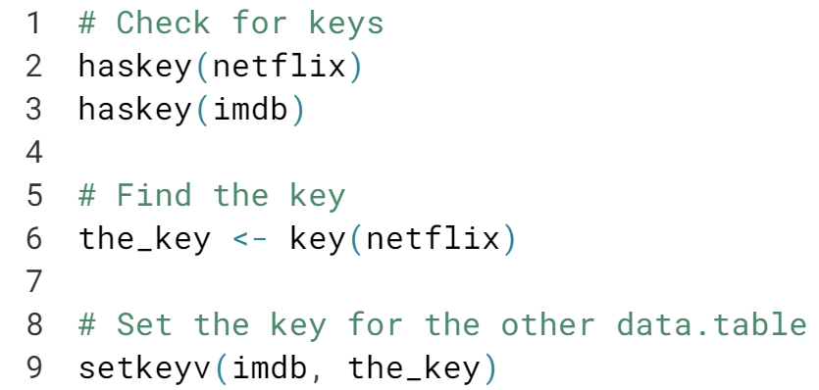

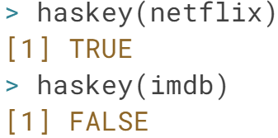

Fantastic! The ***key()*** function is a useful way of reducing typing errors that can happen when manually typing long keys or multiple keys over and over again.

This can be used together with the ***haskey()*** and ***setkeyv()*** functions for programmatic key checking and setting.

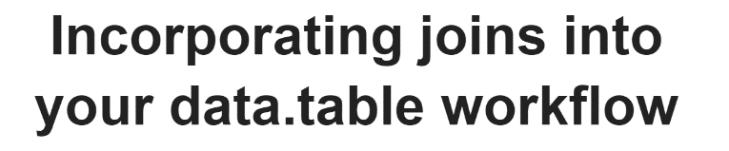

The real power of using the data table syntax for performing joins is that it allows us to incorporate joins into our other data table workflows. This enables us to perform **rapid data analysis** when our data is spread across multiple data tables.

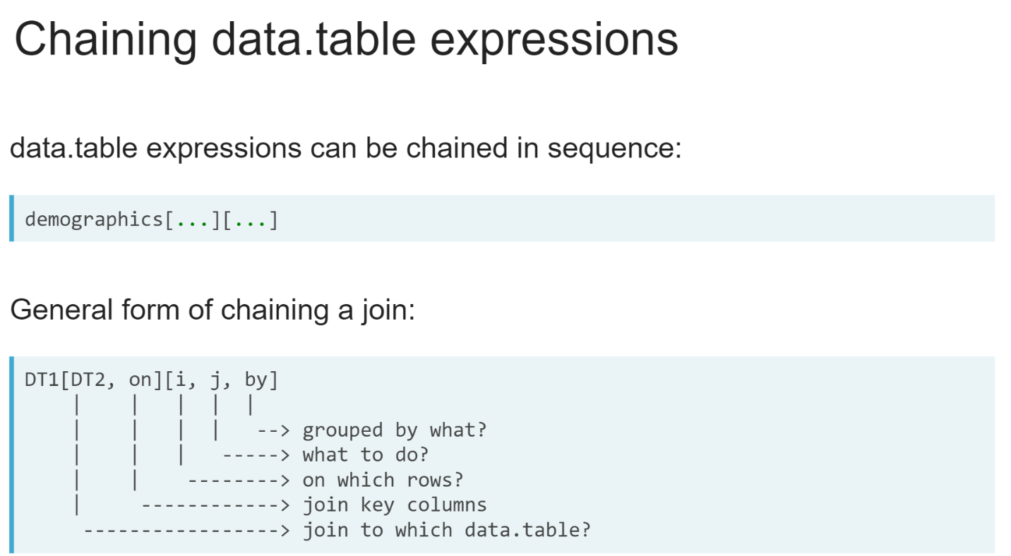  
The most flexible way of incorporating joins into our data table workflows is by chaining data table expressions. In the first expression, we perform our join operation. Then, the second data table expression allows us to work on the result with any of the other data table expression functionality we've learned in the previous course.

The general form on the slide can be read as "join DT1 to DT2 using the column in on as the join key. Then, in the result, filter by rows in *i*, compute on column *j* grouped by values in columns *by*."

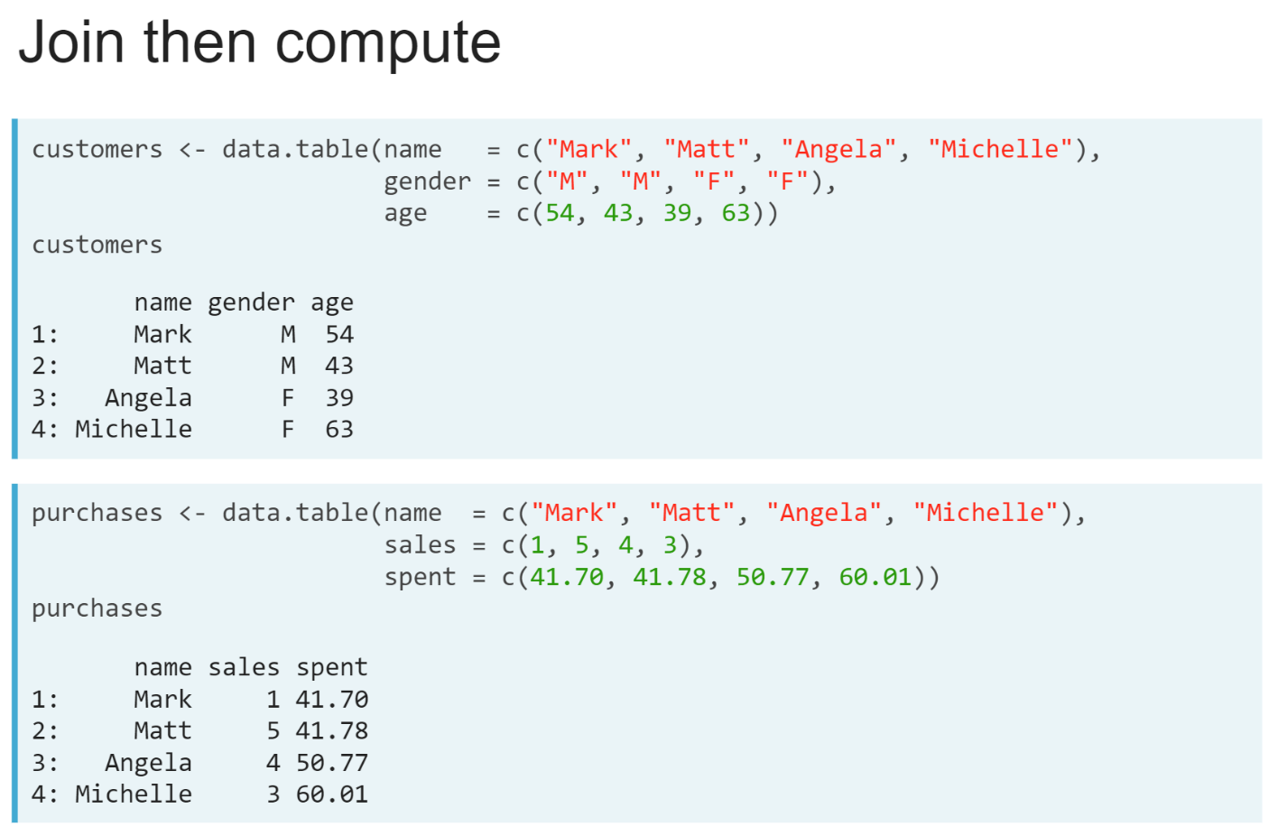  
Here's an example. We have two data tables, one filled with information about the business's customers, and a second with details of the purchase history.  
  
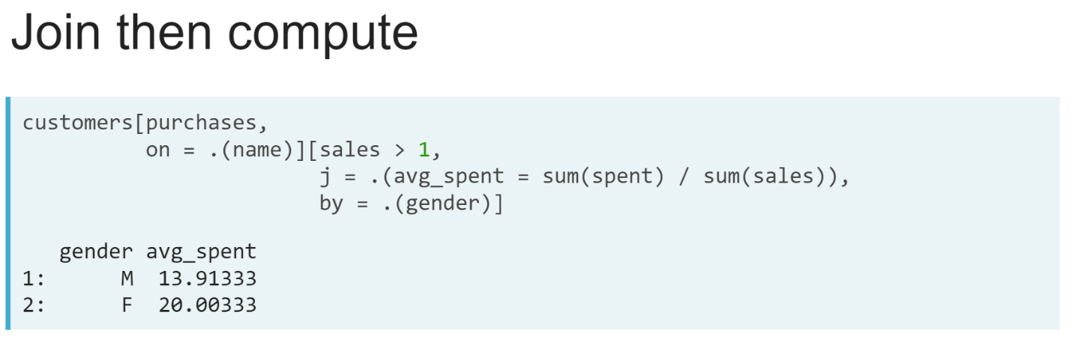  
To get the average spent per sale for return customers grouped by gender, we chain two data table expressions. In the first, we join customers to purchases; then in second, we filter to customers with more than 1 sale in *i*, calculate the average spent per sale in *j*, grouped by the gender column in *by*.

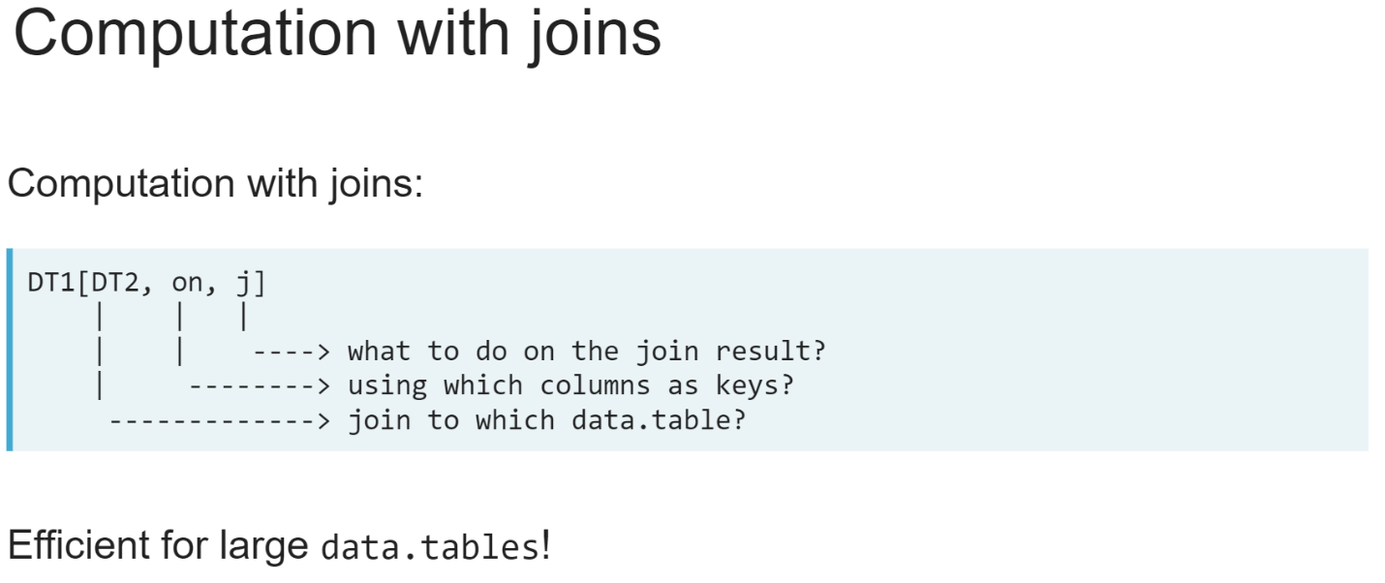  
We can also use the *j* argument to compute on columns in the same data table expressions as a join. This is a memory efficient way to perform calculations on the result of a join because the data table expression will create only the join result for the columns used in *j* in memory. As stated earlier, this can save a lot of time and memory for large data tables!

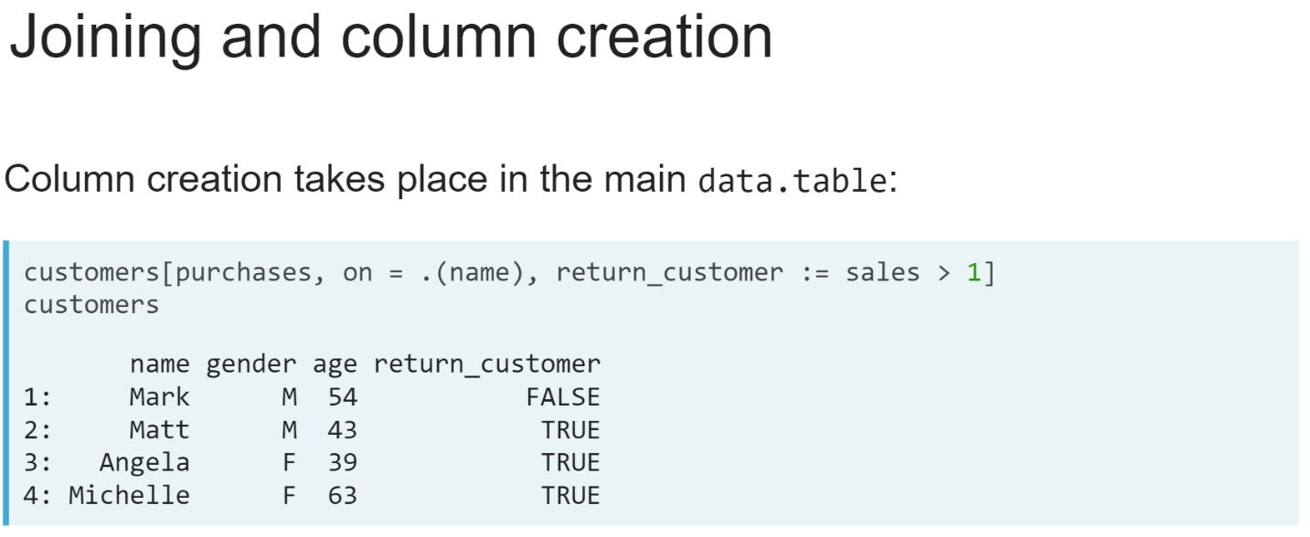  
Column creation can also be performed in the same data table expression as a join. The new column will be added to the main data table on the left side of the join.

In the example on the slide, after joining purchases to customers, we are adding a new column, *return_customers* to the *customers* data table, which is computed based on the sales column from the purchases data table in the result of the join.

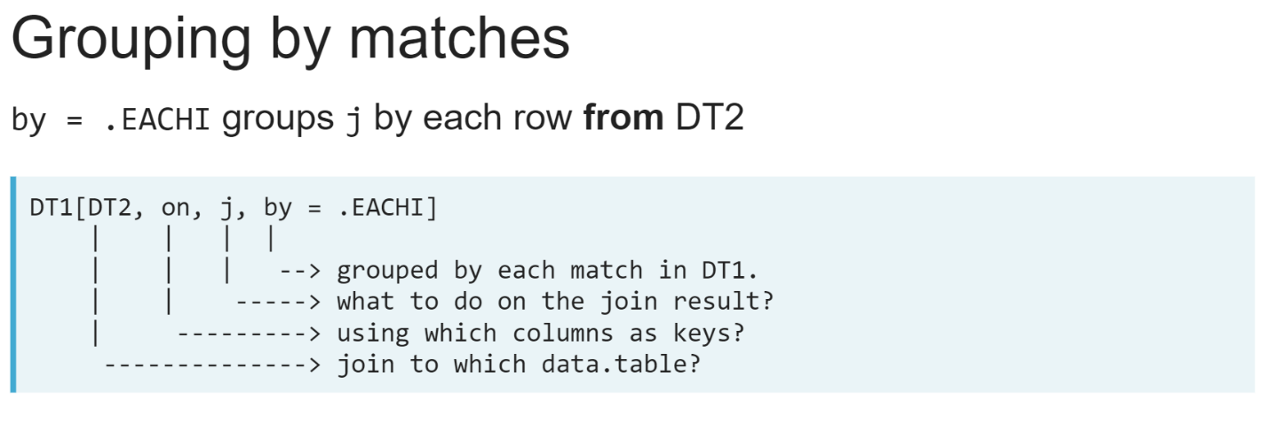The *by* argument gains a special symbol, '*.EACHI* ', when used in a join expression. This lets us group computation in *j* by each row in the data table on the right side of the join. This can be read as "Join DT1 to DT2, then for each row in DT2, group calculations in *j* by the matching rows in DT1."

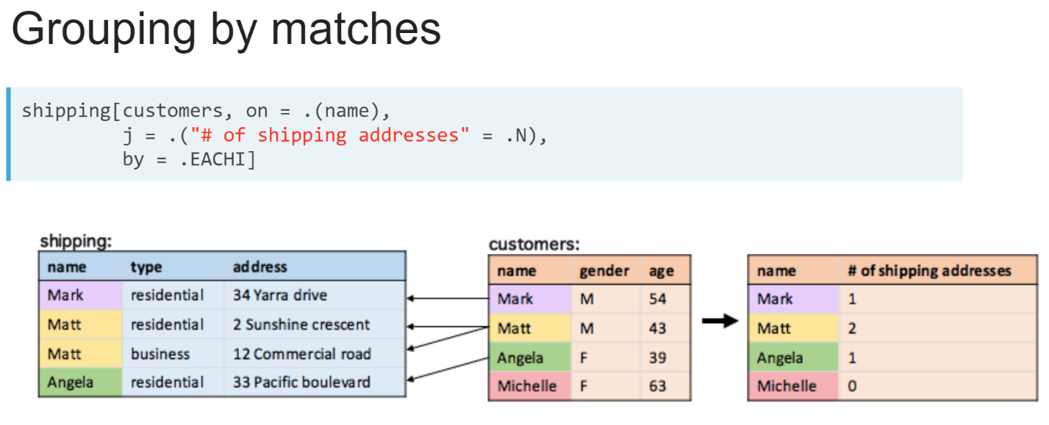  
In this example, we used '*by = .EACHI* ' to count the number of shipping addresses associated with each person in the customers data table.

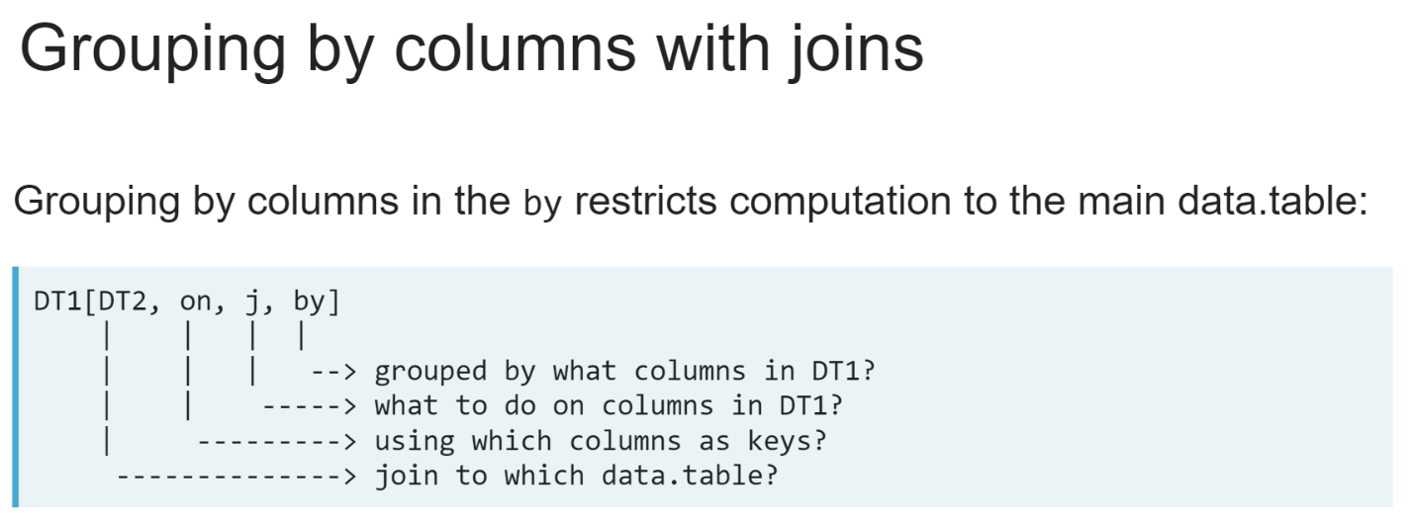  
The *by* argument also works slightly differently than normal when used in a join expression. It can only be provided columns from the main data table on the left side of the join, and we can only perform computation on columns from the main data table.

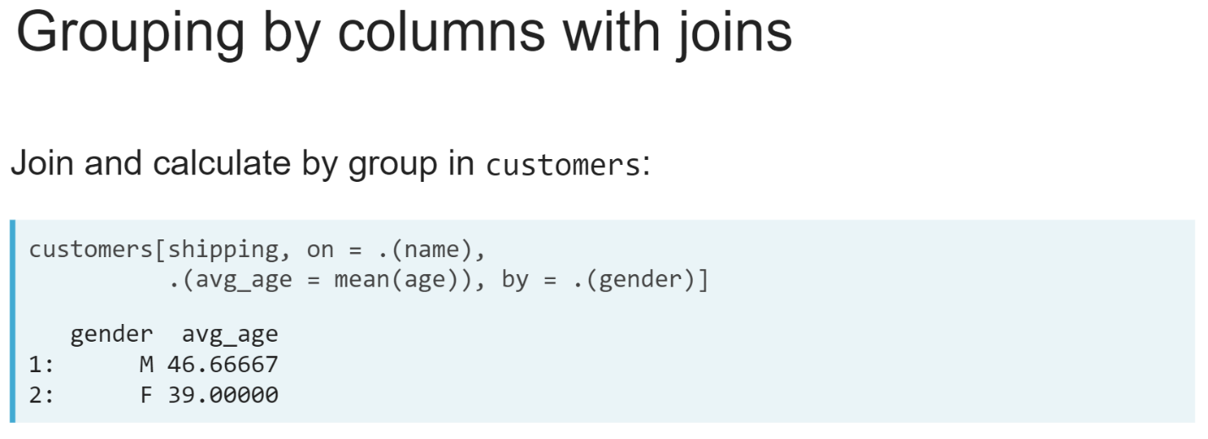For example, we could left-join shipping to customers to calculate the average age, grouped by gender, of customers with shipping addresses, because both the *age* and *gender* columns are in the customers data table.

# Exploring the Australian population

Your goal is to calculate the total percentage of people living in major cities of Australia (listed in capitals). For this exercise, population has a new column ("percentage") containing the percentage of people living in each of its listed cities.

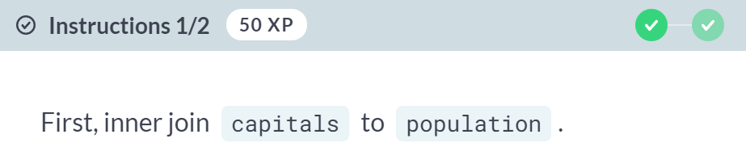

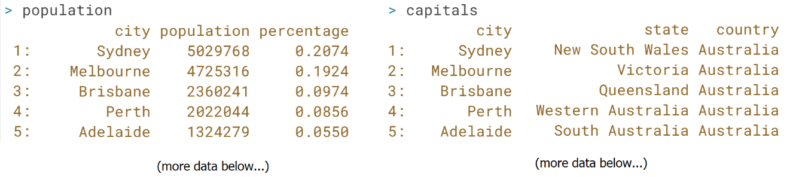



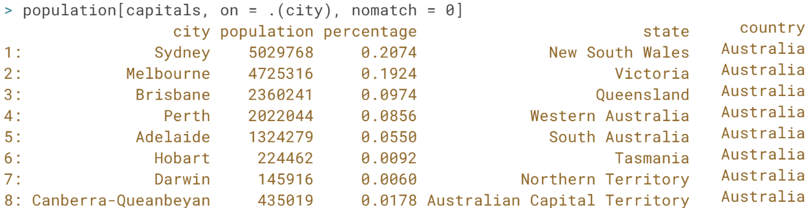

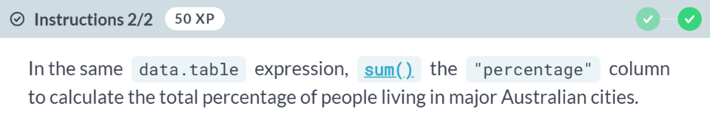

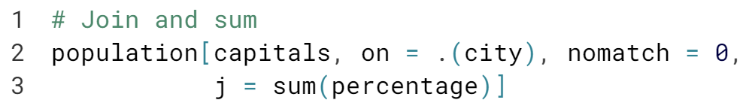

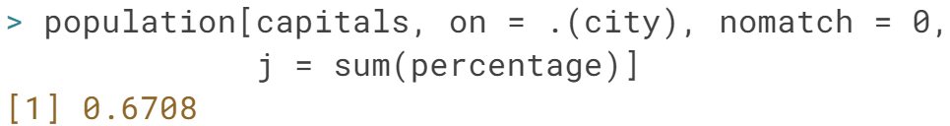

Well done! Using the *j* argument to compute information from the result of the join will allow you to quickly ask and answer questions about your data.

Here in a single command you've learnt roughly 67% of Australians live in one of its major cities.

# Finding multiple matches

Two new data.tables have been loaded in your workspace:

* life_exp: contains the life expectancy of each country in 2010 sourced from the [**Gapminder foundation**](https://www.gapminder.org/)
* continents: contains a mapping between each country and the continent(s) they are part of built from information provided by [**Countries-ofthe-World.com**](https://www.countries-ofthe-world.com/).

In this exercise, you will find the countries that are listed in more than one continent

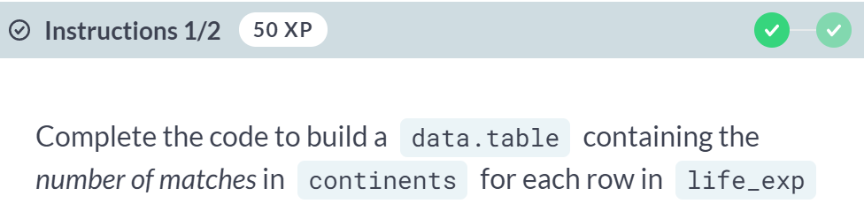  
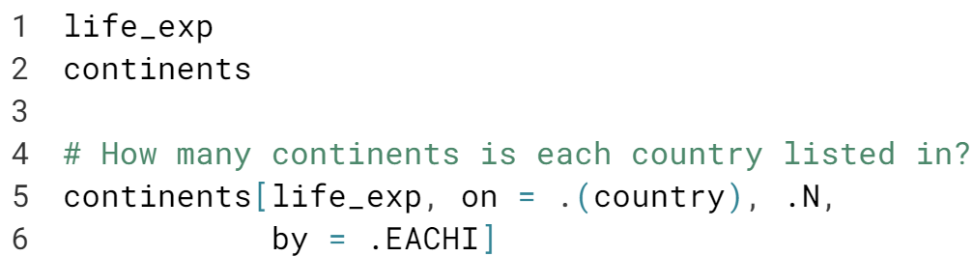  
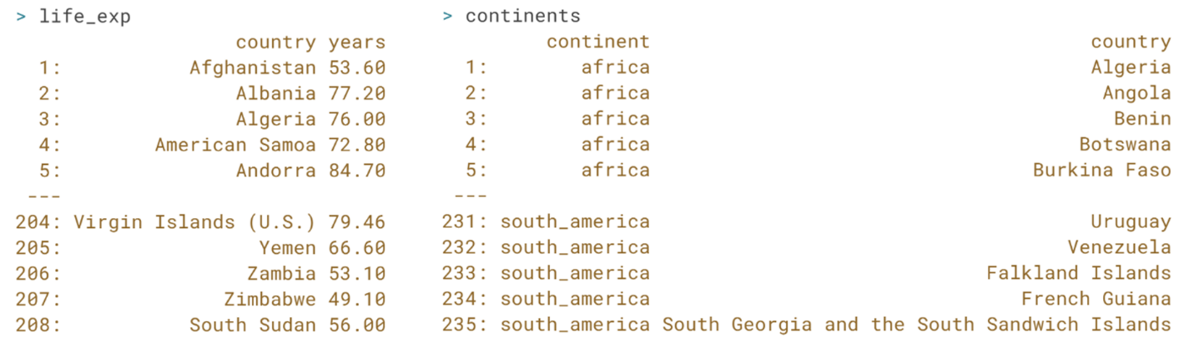  
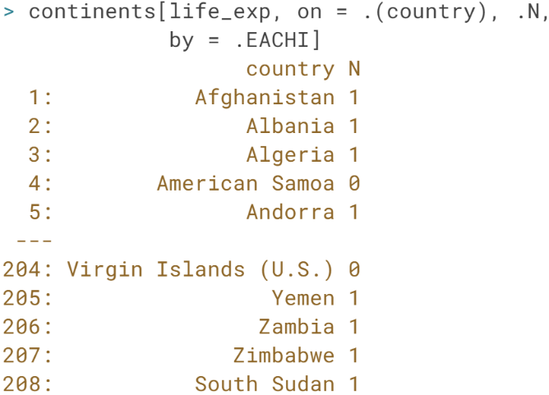

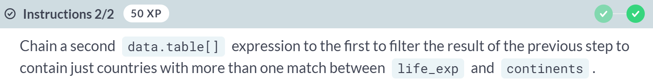  
  
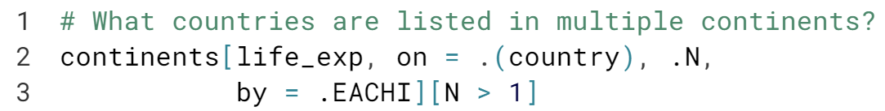

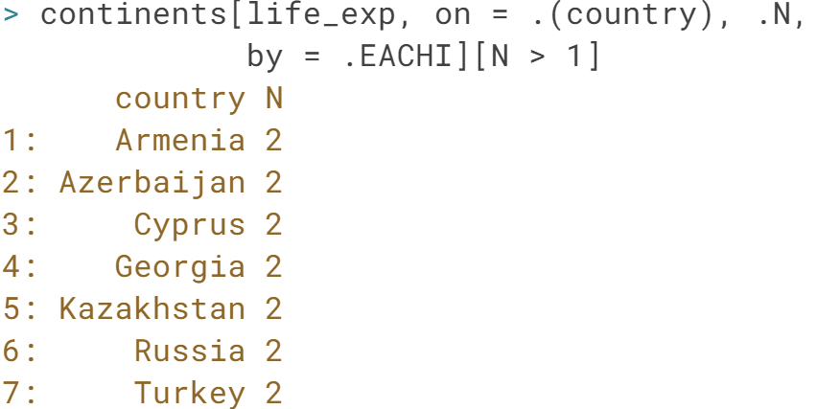

# Exploring world life expectancy

The two data.tables from the previous exercise have been loaded into your workspace:

* life_exp: contains the life expectancy of each country in 2010 sourced from the [**Gapminder foundation**](https://www.gapminder.org/)
* continents: contains a mapping between each country and the continent(s) they are part of built from information provided by [**Countries-ofthe-World.com**](https://www.countries-ofthe-world.com/).

Your goal this time is to calculate the average life expectancy across countries within each continent.

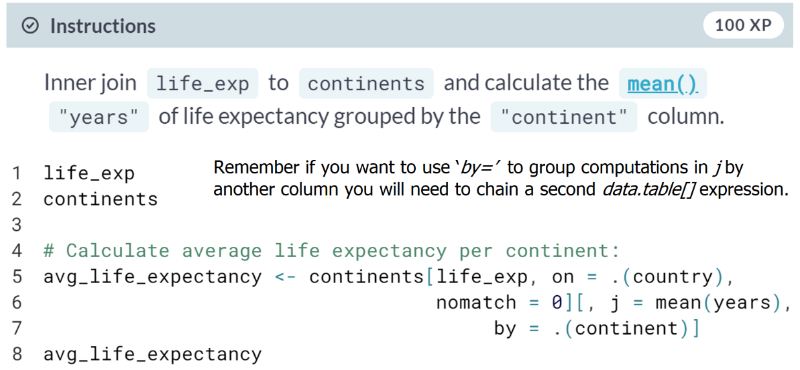

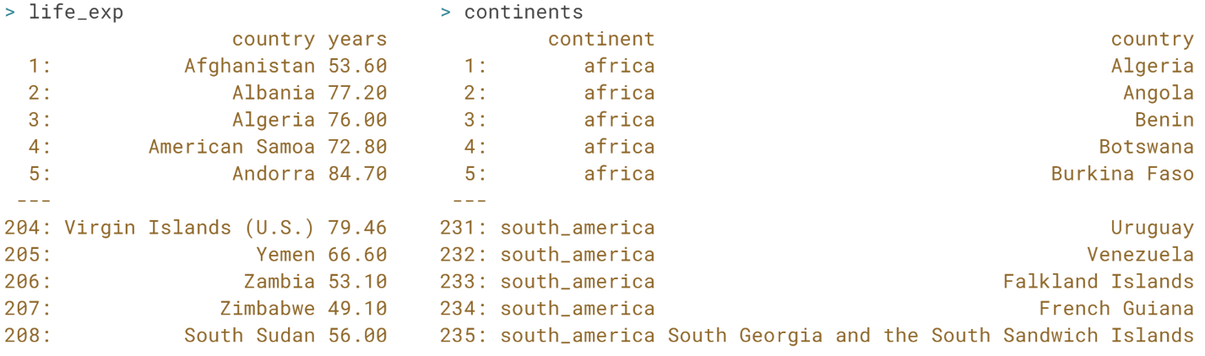  
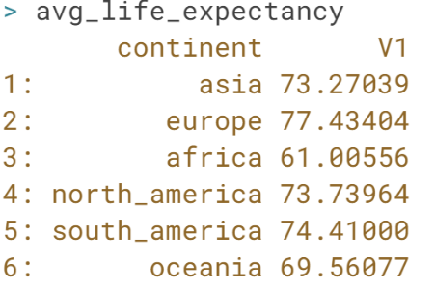  
Excellent work! Using *by = .EACHI* is a useful way of checking your join has the number of matches you expect and finding rows that may cause problems in downstream analysis.

**Diagnosing and Fixing Common Join Problems**This chapter will discuss common problems and errors encountered when performing data.table joins and show you how to troubleshoot and avoid them.

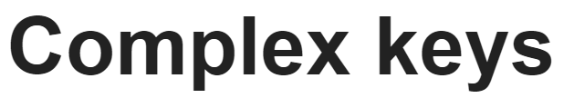

In this lesson, we will learn how to diagnose misspecified joins and how to use more complex join keys.

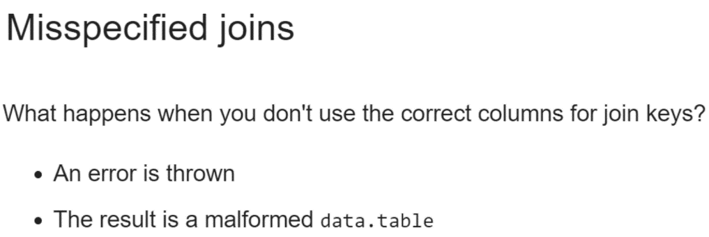  
A misspecified join is one where we don't use the correct join keys. This can lead to a variety of errors and malformed data tables. All of these are good indicators we need to go back and double check our join keys.  
  
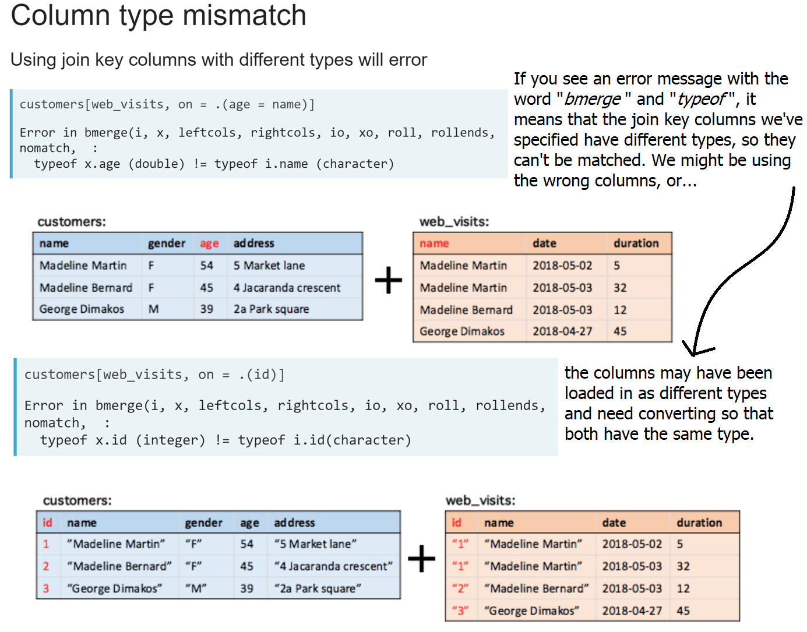

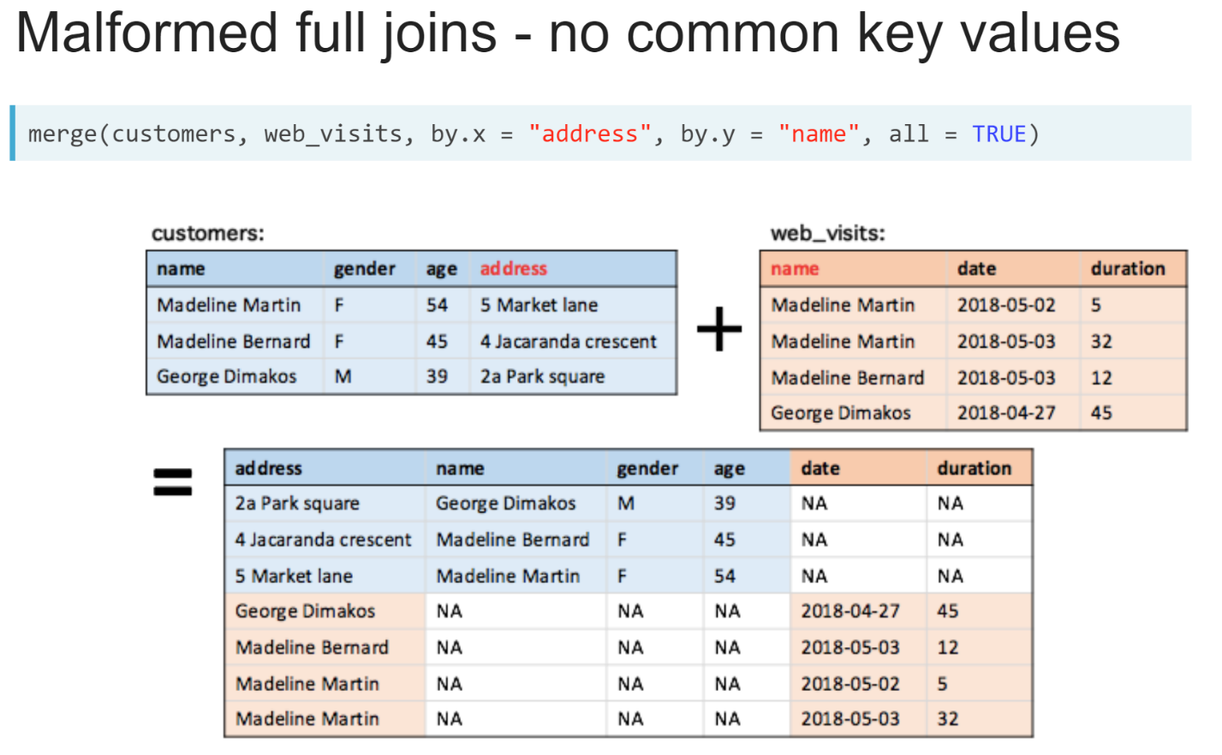  
If the columns have the same type, then the output and difficulty of diagnosing the problem will depend on the type of join and whether the columns coincidentally have any values in common. If the columns have no values in common, then a *full join* will lead to the two data table being stacked and filled with missing values.

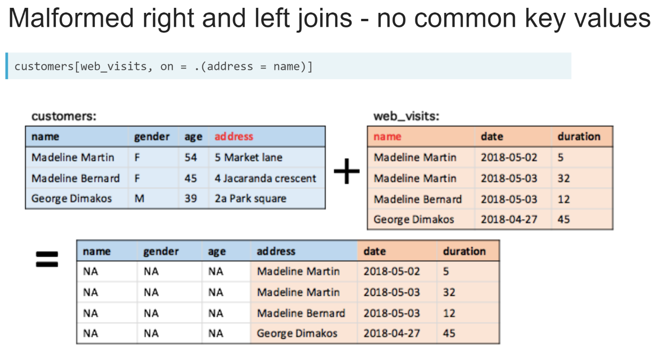  
A *right* or *left join* will just return the rows from one of the data tables, with columns from the other filled entirely with missing values.

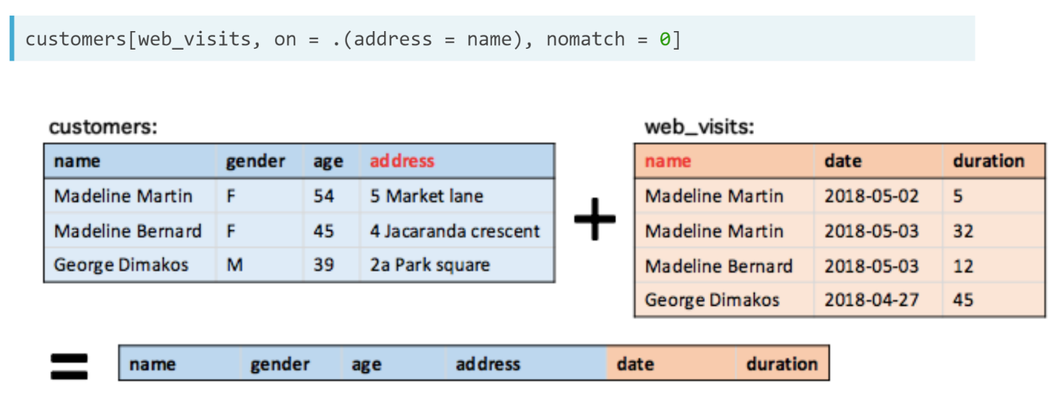  
And an *inner* *join* will have zero rows.

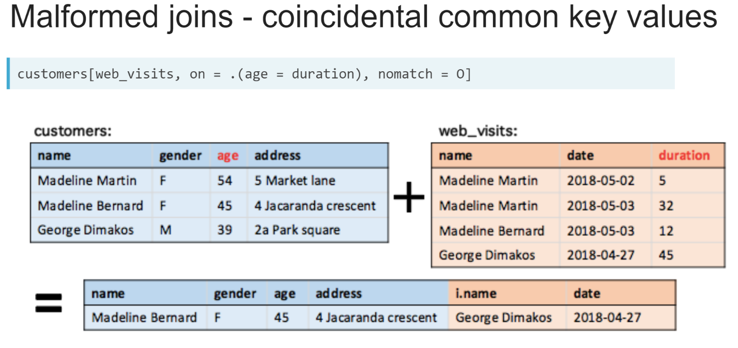  
If we used the wrong key, but the columns coincidentally share some common values, the problem can be much harder to pick up. So, it's important to check that the result of our join makes sense.  
  
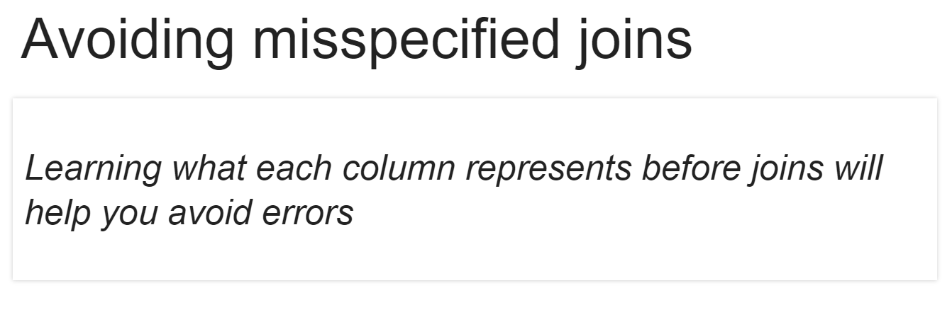  
The best way to avoid misspecified joins ins to take the time to learn about the information each column contains so that we can critically reason about how there are several factors that can make identifying join keys more difficult than the examples we've encountered so far.

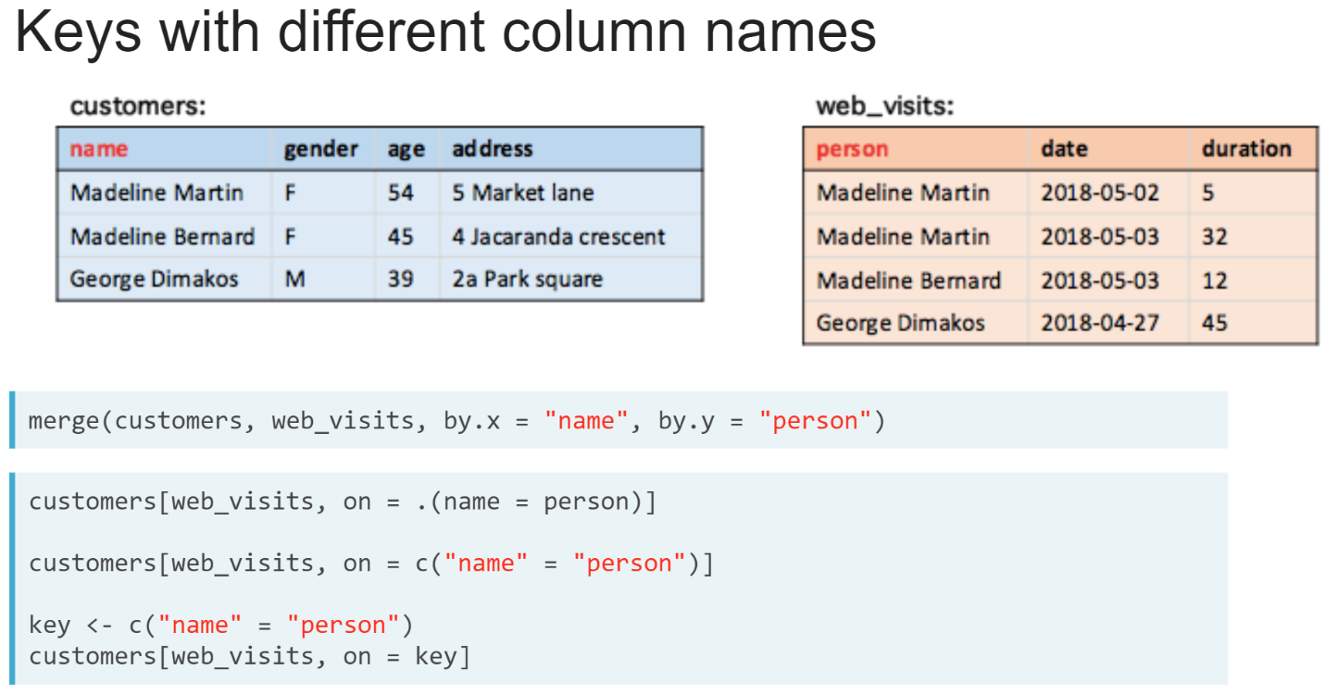  
Sometimes the join keys might have different column names in each data table. In these cases, we use the *by.x* and *by.y* arguments in the merge() function, and in the data table join syntax we use an equals operator in the on argument, or in the character vector supplied to the on argument.

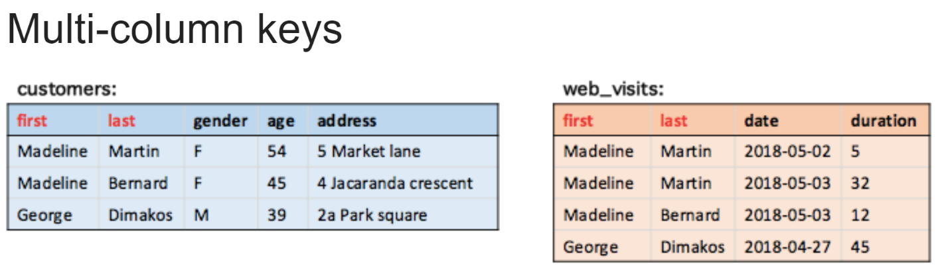  
We may also need multiple columns to match rows between data tables. This can be because the information that uniquely identifies rows is split across multiple columns,

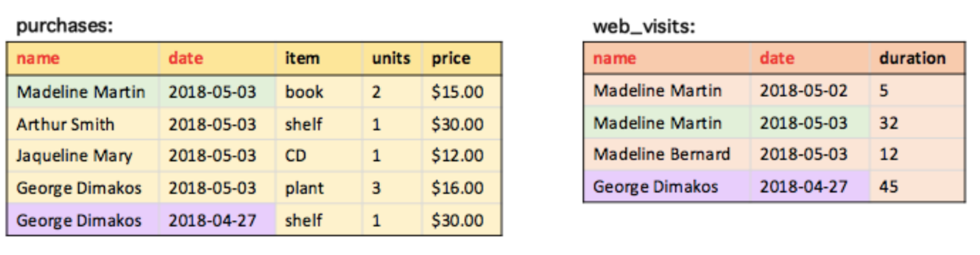  
or because there are multiple entries for each entity.

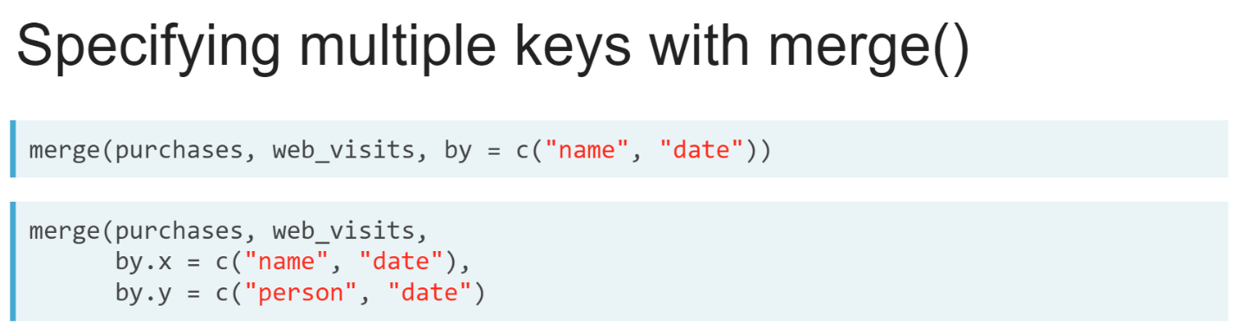  
In the ***merge()*** function, multiple key columns are supplied as a character vector to the by argument. If one or more of these keys has different column names in both data tables, we will need to supply a character vector to both the *by.x* and *by.y* arguments. Join key column names are matched in the order they appear in each character vector.

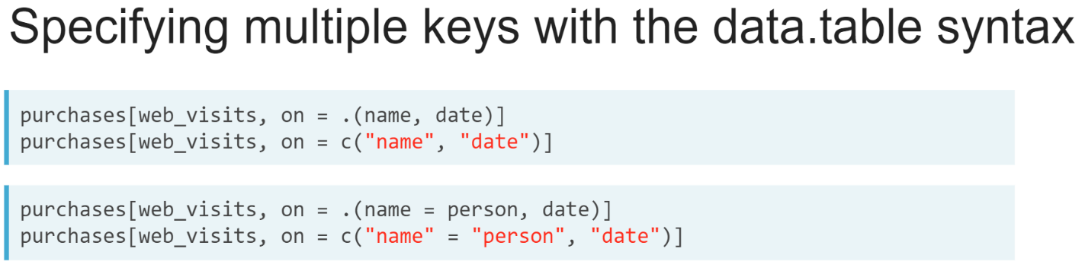  
When using the data table syntax, multiple keys can be supplied separated by commas. And columns that have different names are specified using an equals sign.

# Keys with different names

You have been contracted by a local school to perform some analysis using their internal databases. Two of those datasets are available in your R session:

* students: contains information about the students attending the school
* guardians: contains information about the adult who is the primary point of contact for the school for each student.

Your goal is to build a new data.table containing all the information about the guardian for each student.

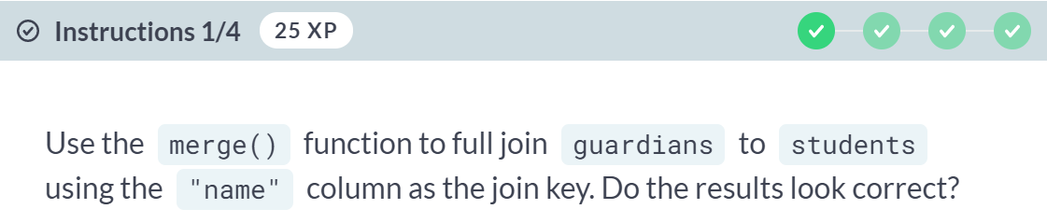  
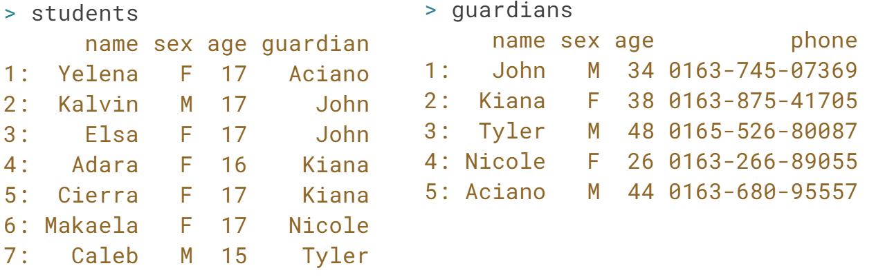  
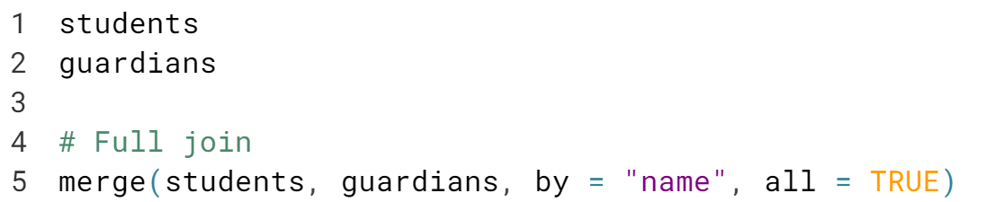  
  
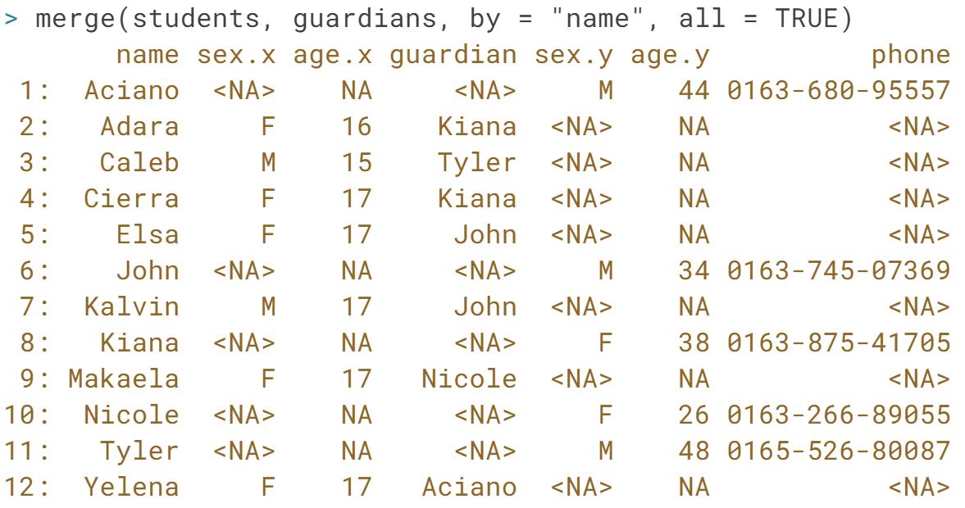

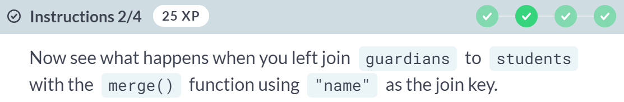  
  
  
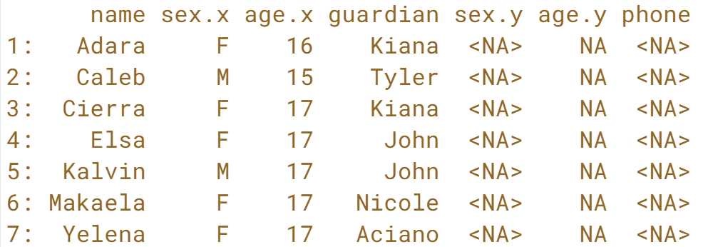

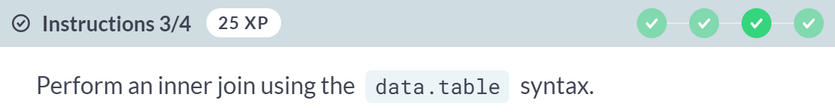  
  




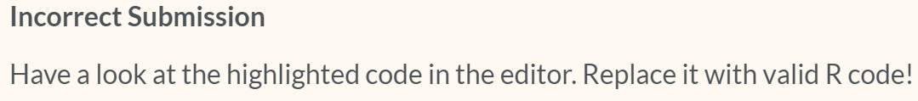

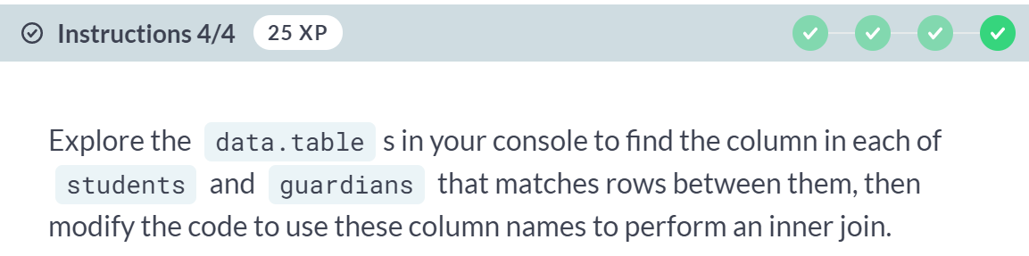

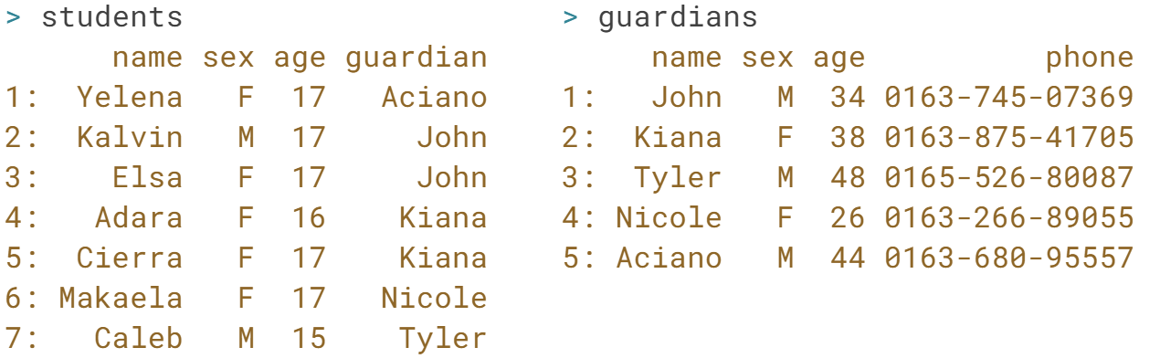



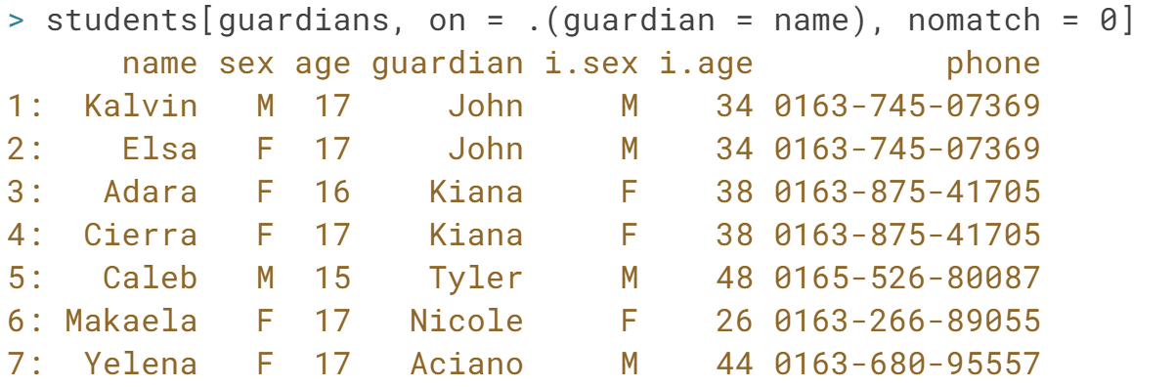

Nice work! Knowing what to expect when a join goes wrong will help you quickly catch and diagnose problems in the future. Remember, join keys can have different column names in each *data.table*.

# Multi-column keys

Two new datasets are available in your R session:

* subjects: contains the subject each student is taking each semester this year
* locations: contains the room allocations for each subject

Your goal is to build a new data.table with the locations of each subject for each student.

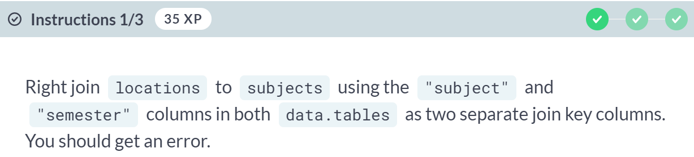  
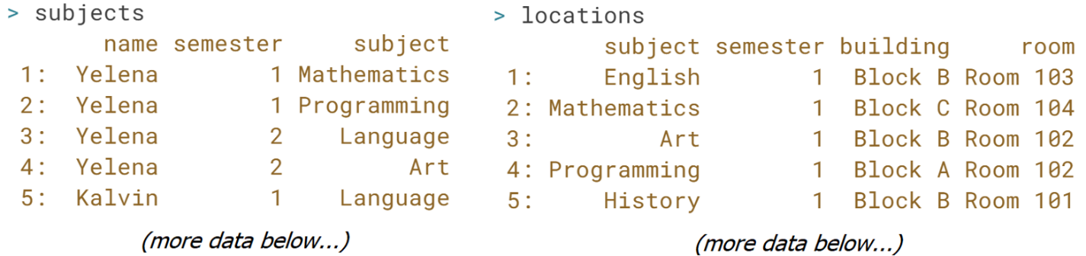

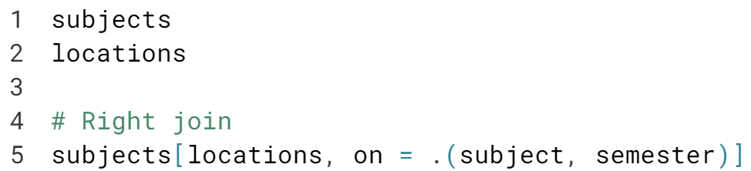



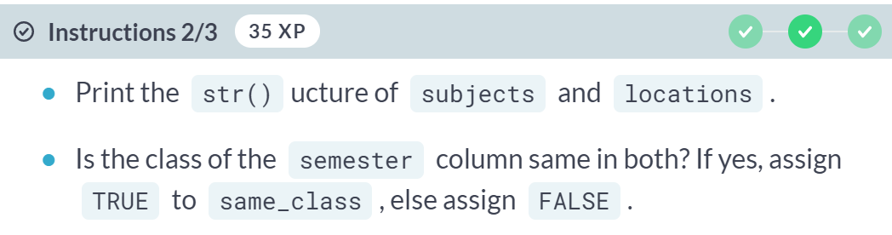

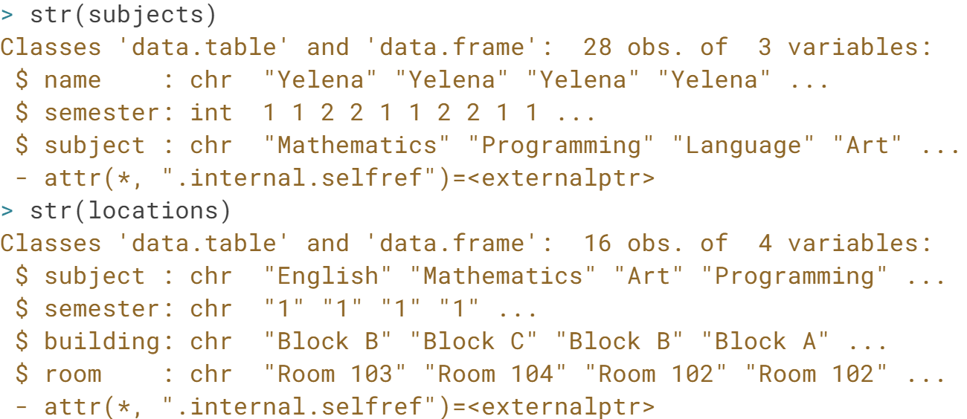

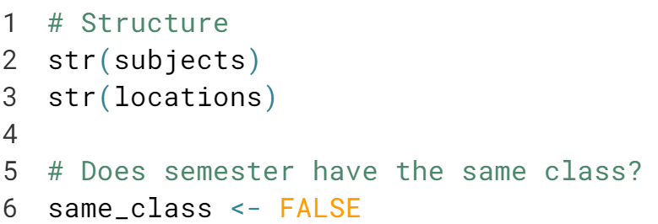

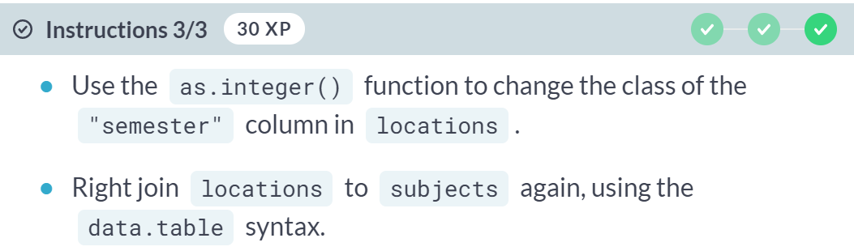

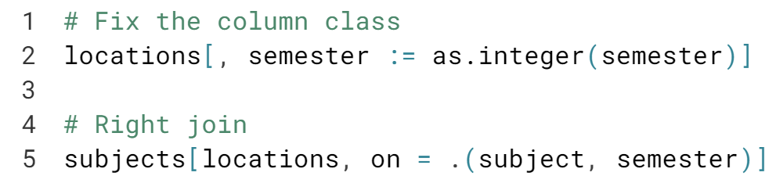

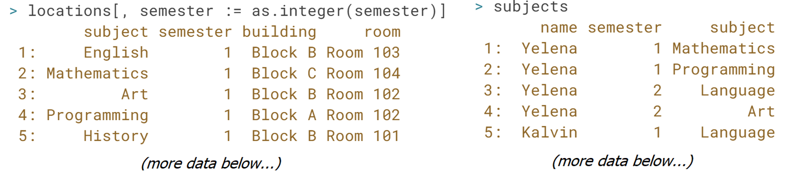  
  
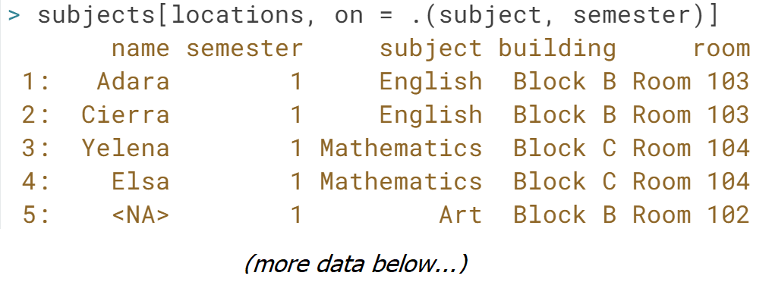  
Great job! Sometimes you will need to make the column types consistent to perform a successful join.

# Multi-key, single-key

In addition to locations, you will work with the teachers dataset in this exercise. It contains information about the teacher for each subject. The teacher of each subject does not change between semesters. Your goal is to build a new data.table containing the room allocation for each subject, using the teachers and locations data.tables.

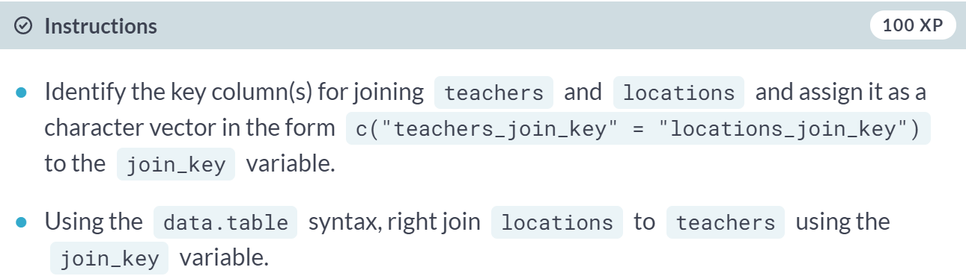

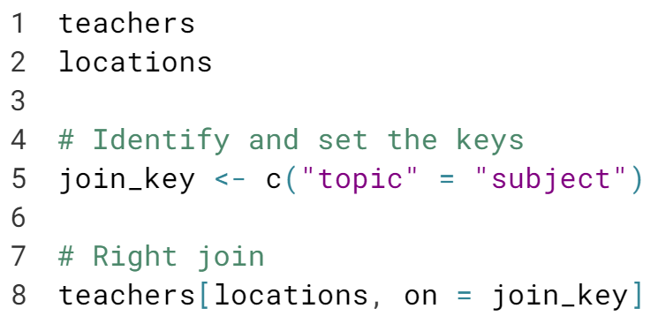

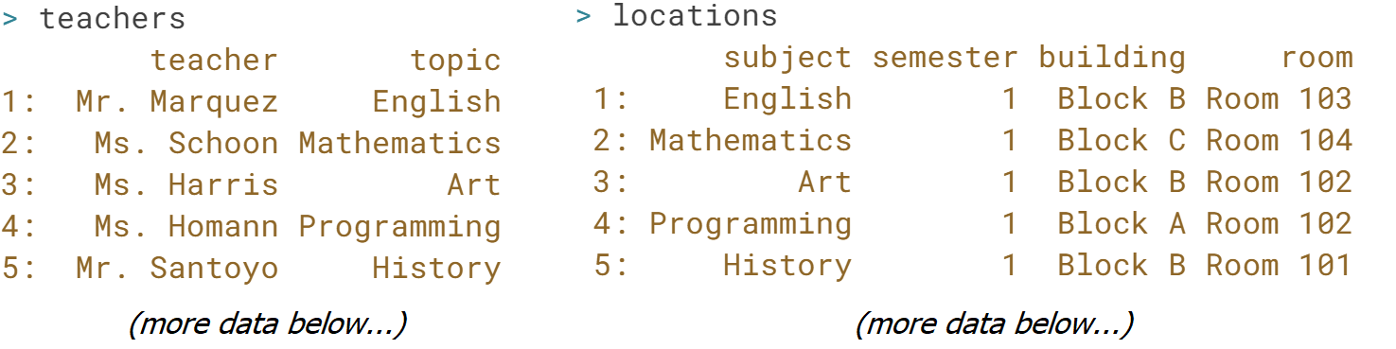

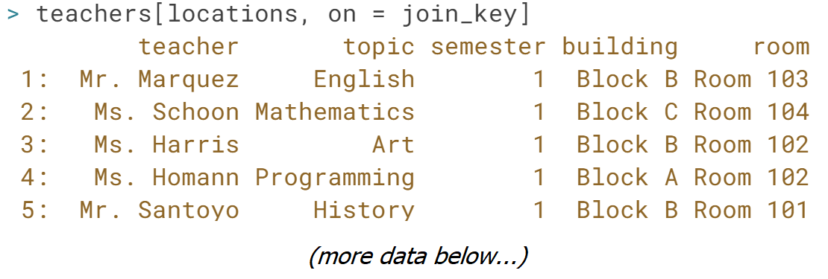  
Fantastic job! Even though the previous exercise required the *"subject"* and *"semester"* columns from locations as the join key, here only the *"subject"* column was required to match its rows to teachers. Remember the join keys depend on the two data.tables in the join!

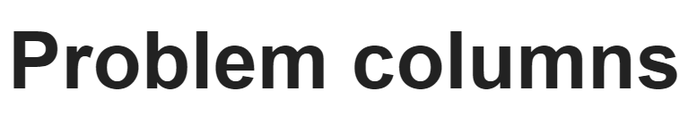

In the last lesson, we learned how to work with complex join keys and how to diagnose and fix problems arising from misspecified joins. In this lesson, we will learn how to diagnose common problems we may encounter with data table columns when joining.

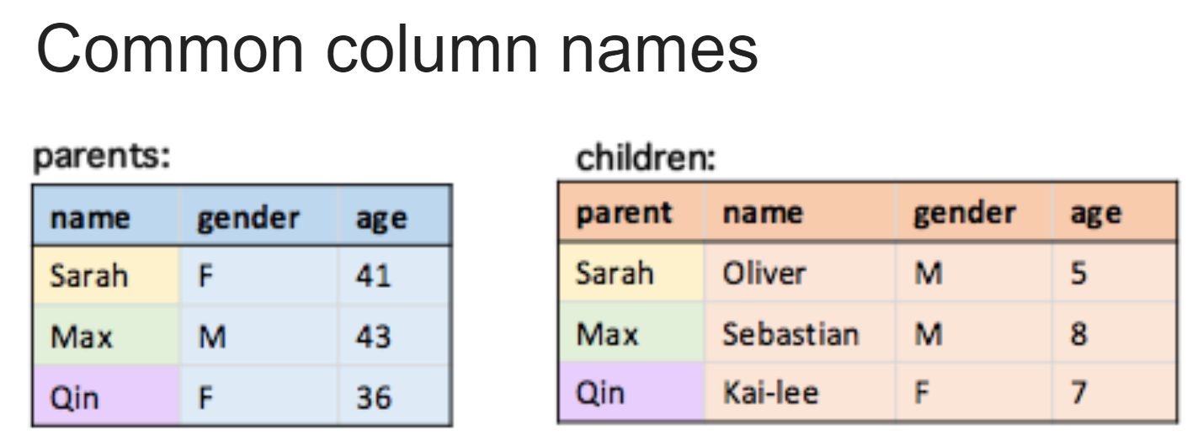  
When joining two data tables, we may sometimes find that they share columns names, which aren't the join keys. An example is shown above. Both data tables have "*name* ", "*gender* ", and "*age* " columns, and we can see that to join these two data tables, we would need to match the name and parent columns for the join keys.

Common column names like this pose two challenges: they make it harder to correctly **identify** the join keys and they make it harder to **interpret** the result of the join.

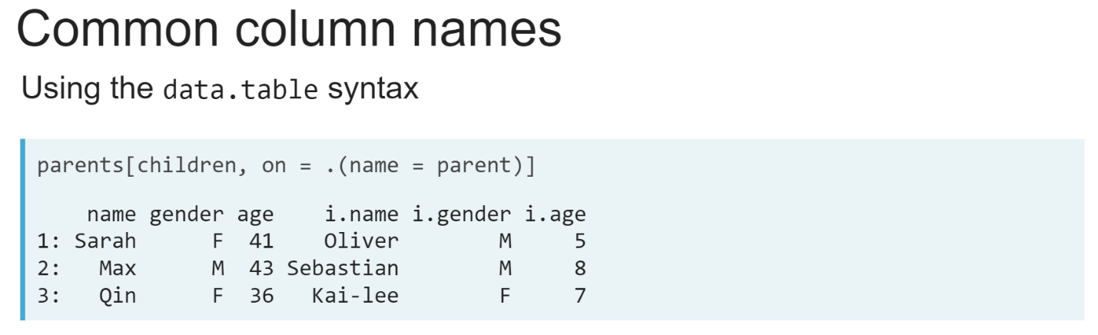  
So, what happens to these columns in a join? With the data table syntax, columns from the data table passed to the i argument will have "*i.* " added to the start of their column names.

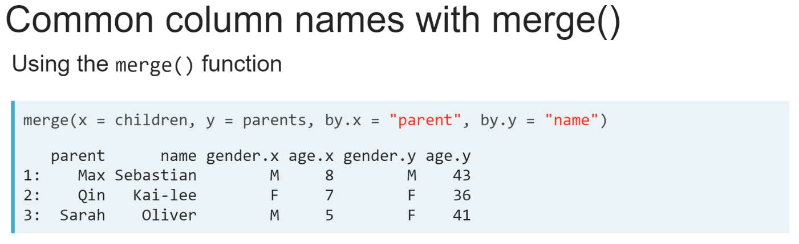  
When using the ***merge()*** function, these common column names will instead have *".x"* or *".y"* added to the end, denoting which of the input data tables they came from.

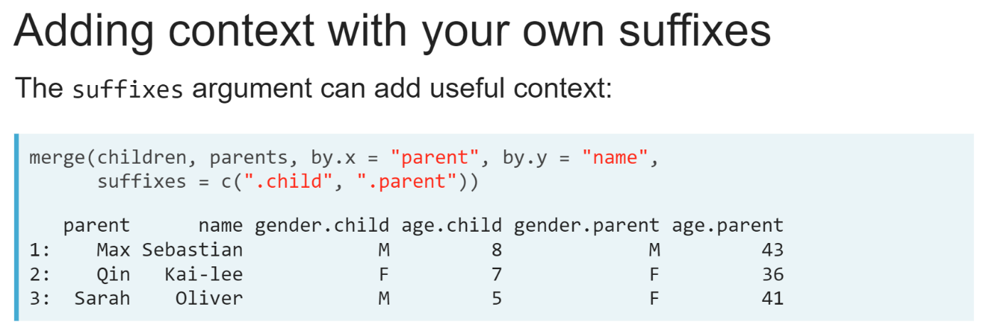  
The suffixes argument to the ***merge()*** function allows us to use different suffixes than just *".x"* and *".y"*. This is a useful way of providing helpful context to the result of the join.  
  
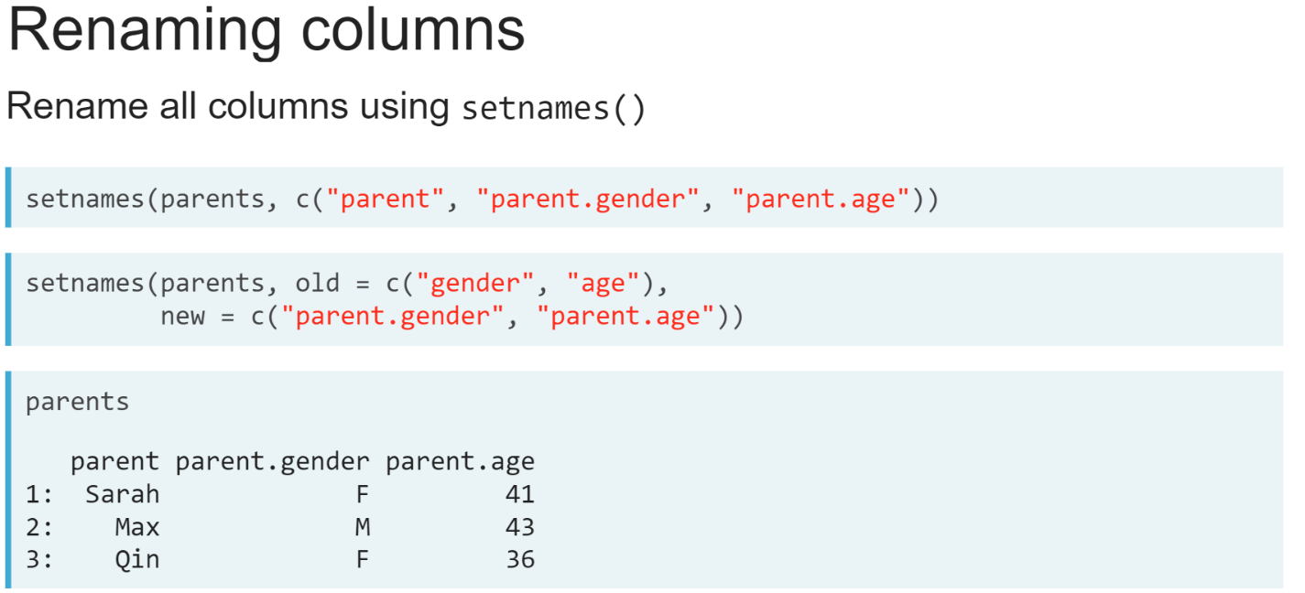  
Another solution is to rename these columns, either before or after the join. This can be done with the ***setnames()*** function. We can either give it a single character vector to give new names to all the columns in a data table, or two-character vectors to rename a subset of columns.

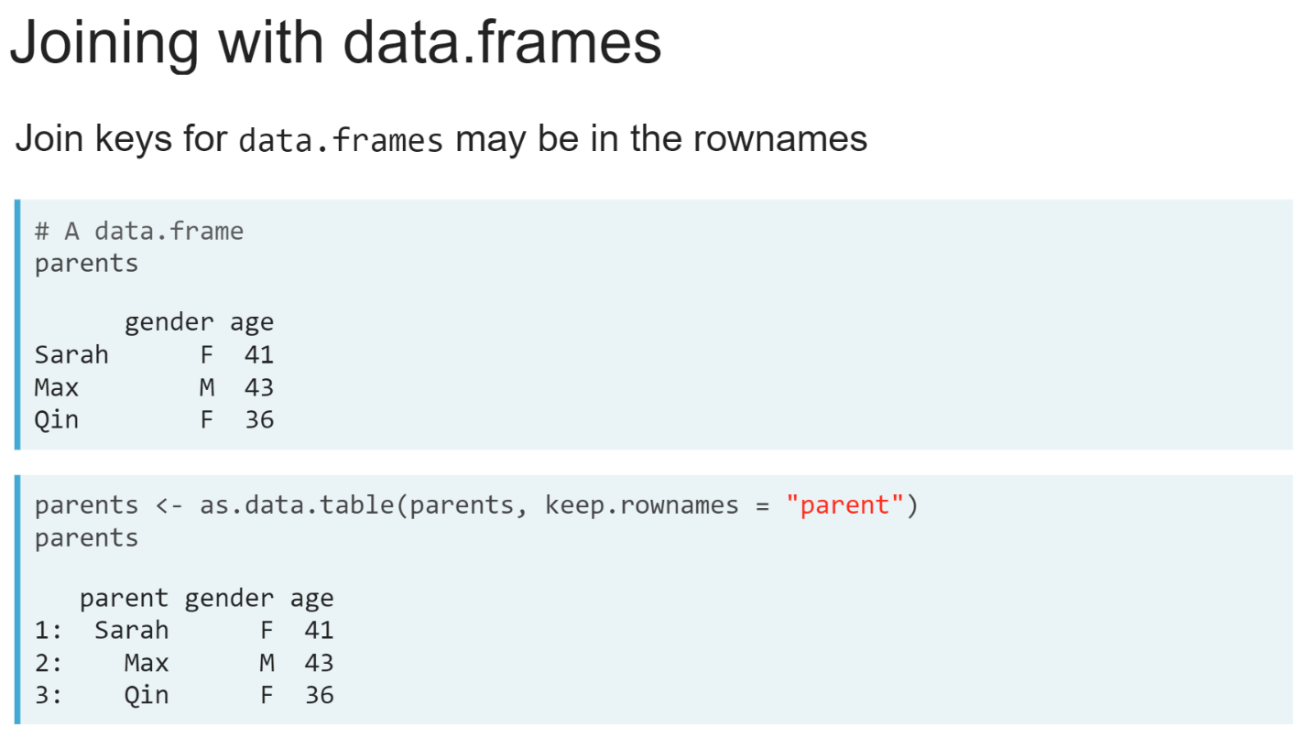Another problem we may run into is mixing of data tables and data frames in our R session. The ***merge()*** function also works for data frames and can also be used to join a data frame with a data table. However, data frames sometimes store the unique identifying information about their rows in the row names.

We will need to extract these if we want to use them as the join keys or want to keep that information in the result of the join. The simplest way to do this is to convert is to a data table using the ***as.data.table()*** function, along with the ***keep.rownames*** argument to convert this into a column with the column name of your choice.

# Column name suffixes

The three data.tables containing information about the geography and population of Australia have been loaded into your R session: capitals, area, and population. Both area and population now have a column named "percentage". The "percentage" column in area contains the percentage of total land mass each state occupies. The "percentage" column in population contains the percentage of the total population living in each city.

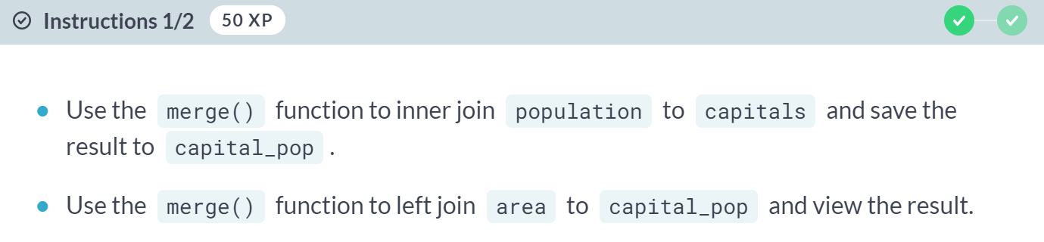

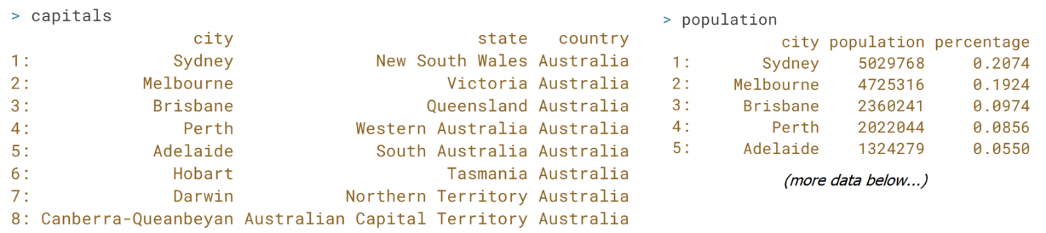

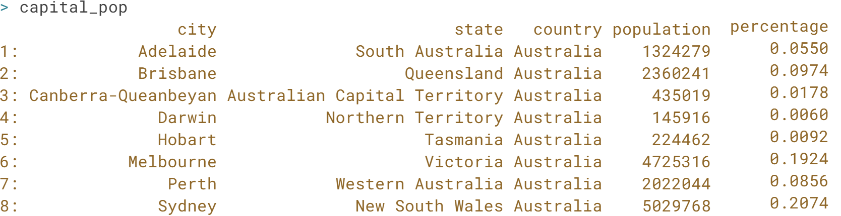

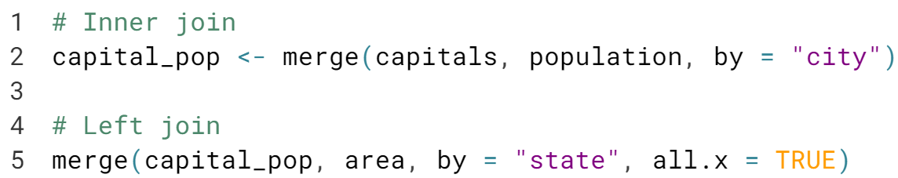

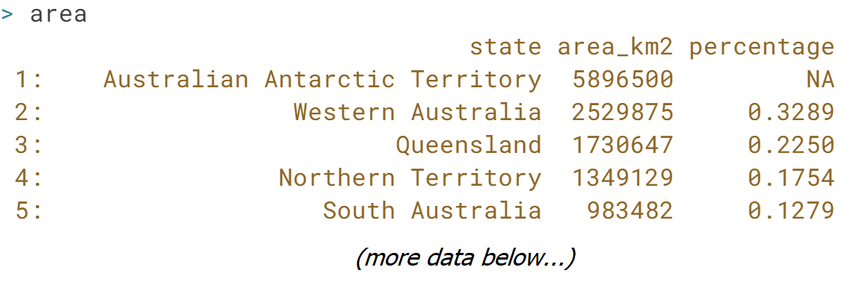  
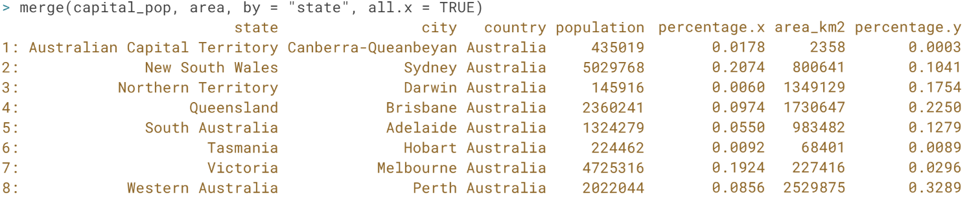

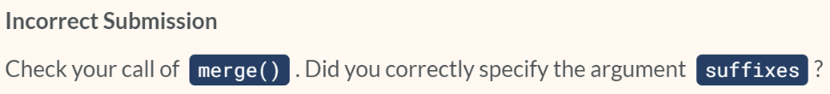

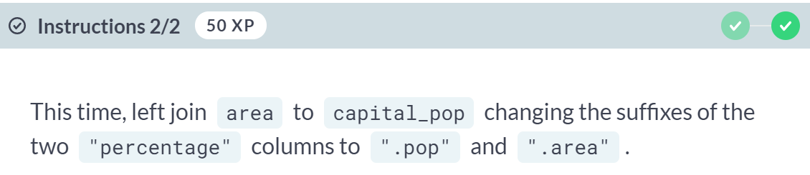  
  
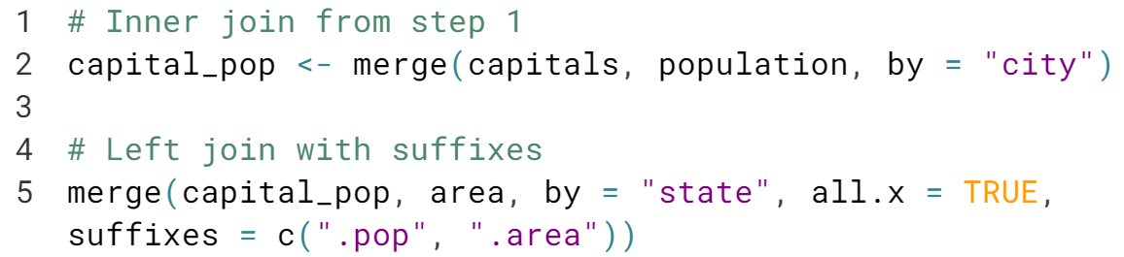

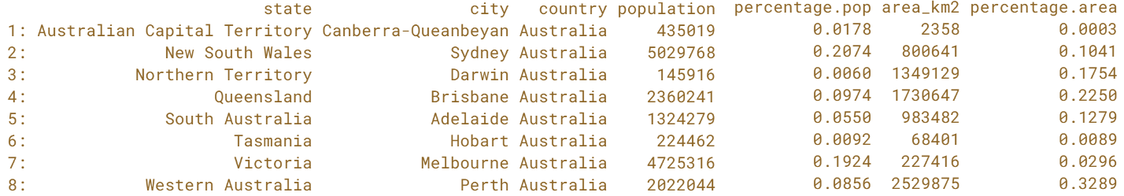  
  
Good job! Changing the suffixes is good practice because it makes it easier to know what each column represents when you come back to the joined *data.table* at a later time.

# Joining a data.frame

The netflix and imdb datasets have been loaded into your R session. Your goal is to add IMBD ratings to all series in the netflix dataset, but this time netflix has been loaded in as a data.frame instead of a data.table.

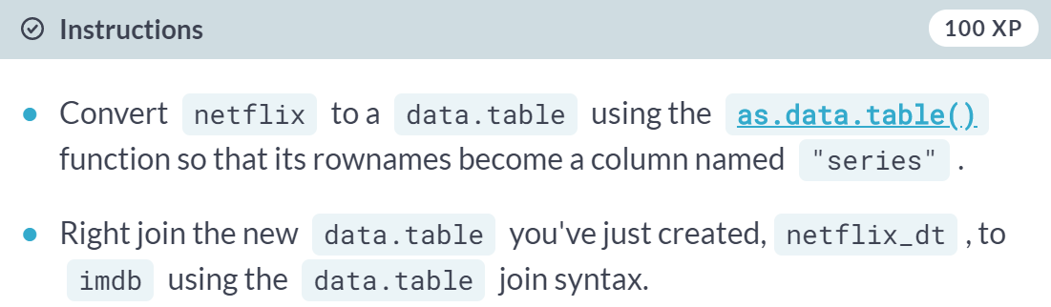

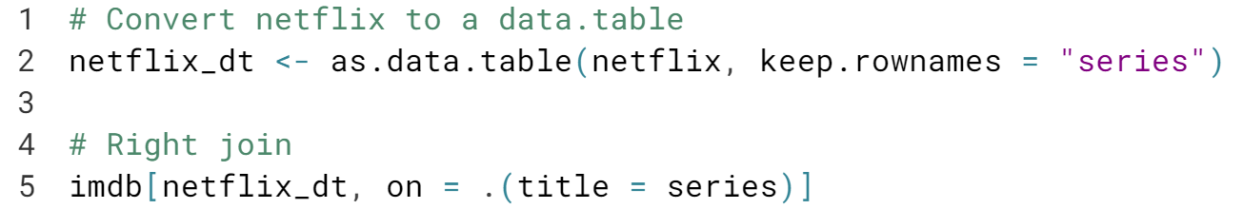

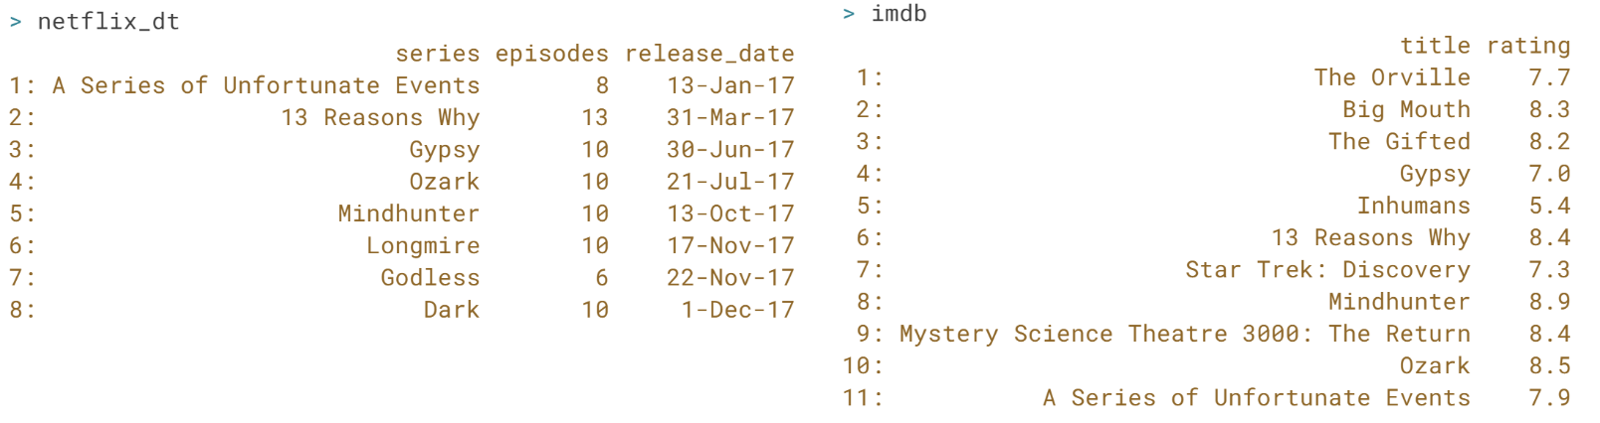

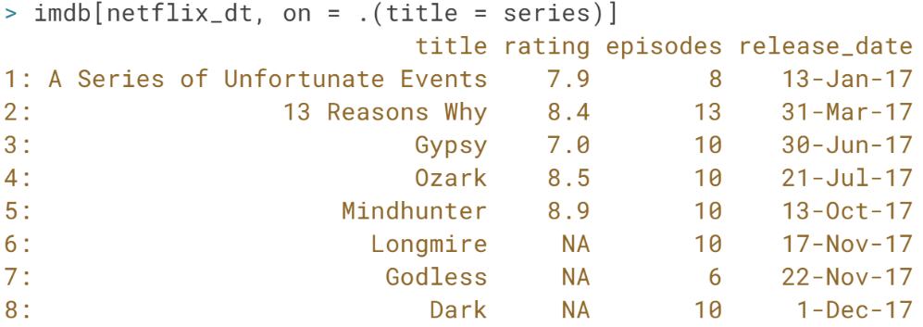  
  
Nice one! You can use the ***merge()*** function to join a *data.frame*, but if you want to use the row names you will need to convert it into a column first.



The last set of join problems we will commonly encounter arise from duplicate matches in the join key values.

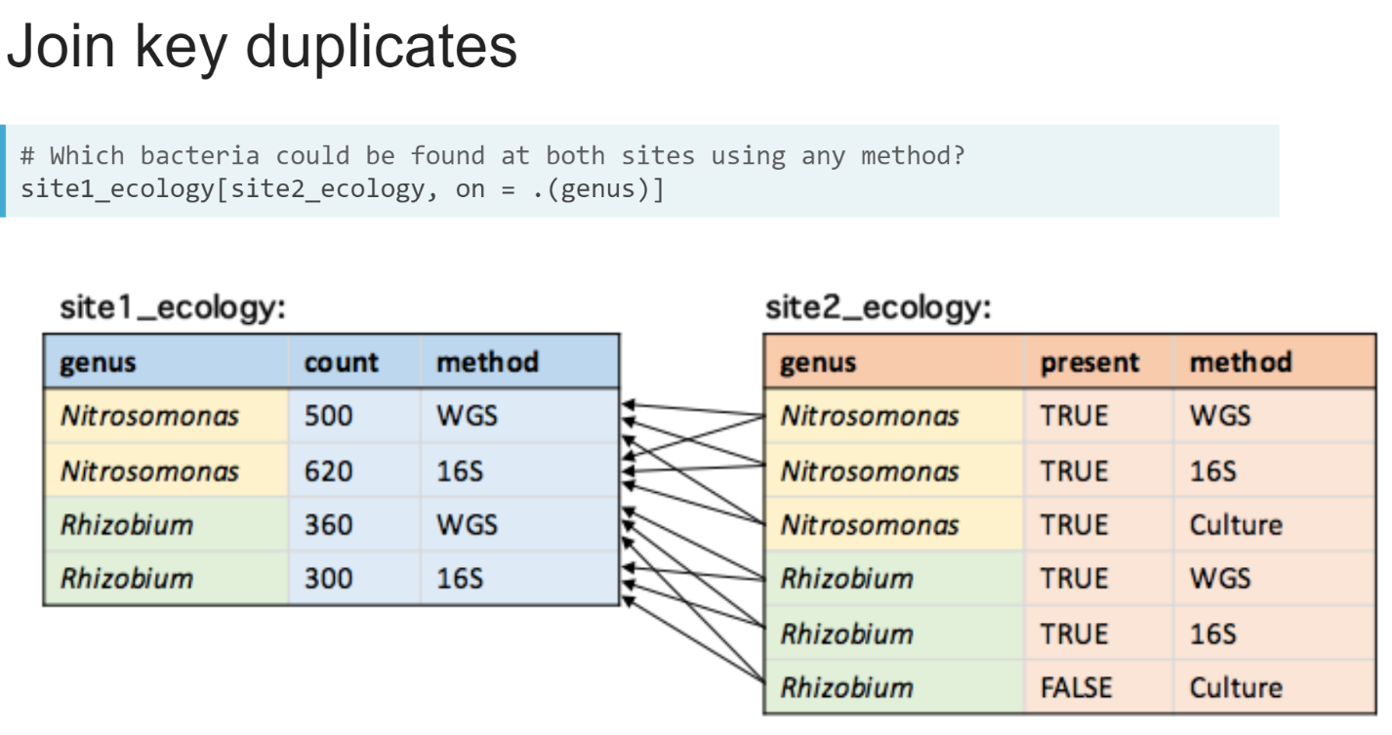  
Sometimes we will want to join two data tables based on columns with duplicate entries. In the example shown on the slide, we are joining two data tables containing data we've measured on the microbial content of soil at two different farm sites.

We've used multiple methods to try to quantify whether a bacterial genus is present, and if so, by how much. We then might want to join these two data tables to get a list of bacteria that could be found at both sites using any method, so we join the two data tables using the *genus* column as the join key. This leads to multiplicative matches. Each row in the *site2_ecology* data table will match two rows in the *site1_ecology* data table, leading to 12 matches all up, six for each bacteria shown.

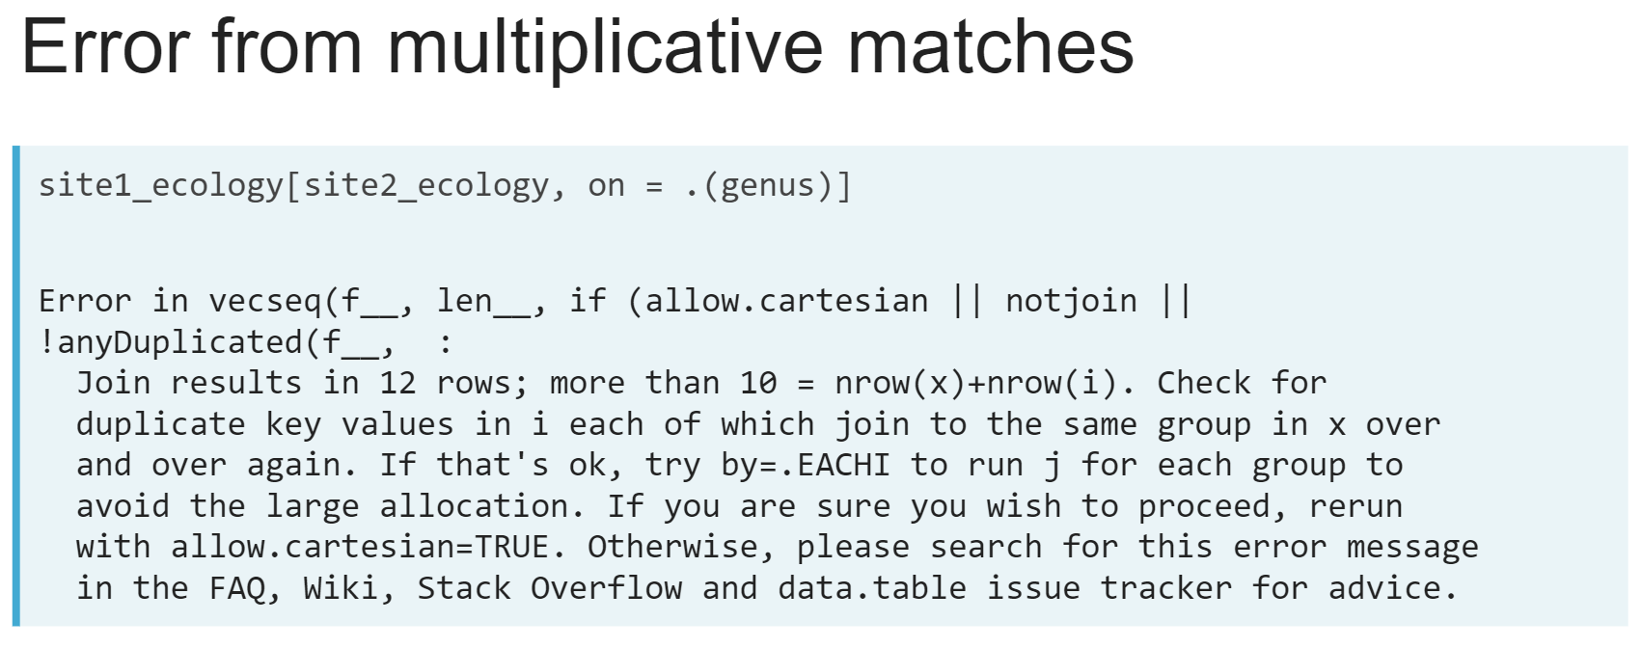If we try to run this code, we will get a long error as shown here, warning us that the result will have more rows than both data tables combined. This error message is shown to protect us from making unexpectedly large data tables by accident because multiplicative matches are a common problem in misspecified joins, which we learnt about in the first lesson of this chapter.

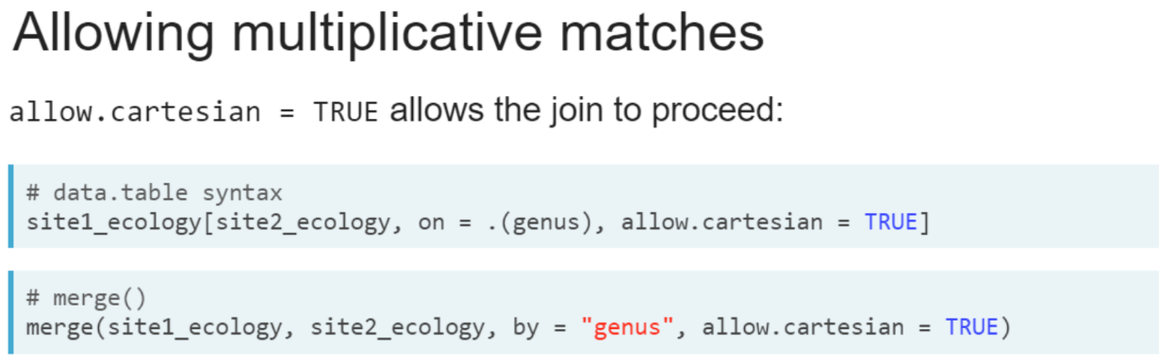  
When we do a join like this intentionally, we can set ‘***allow.cartesian = TRUE’*** to let the join proceed. This argument is found in both the data table syntax and the ***merge()*** function.  
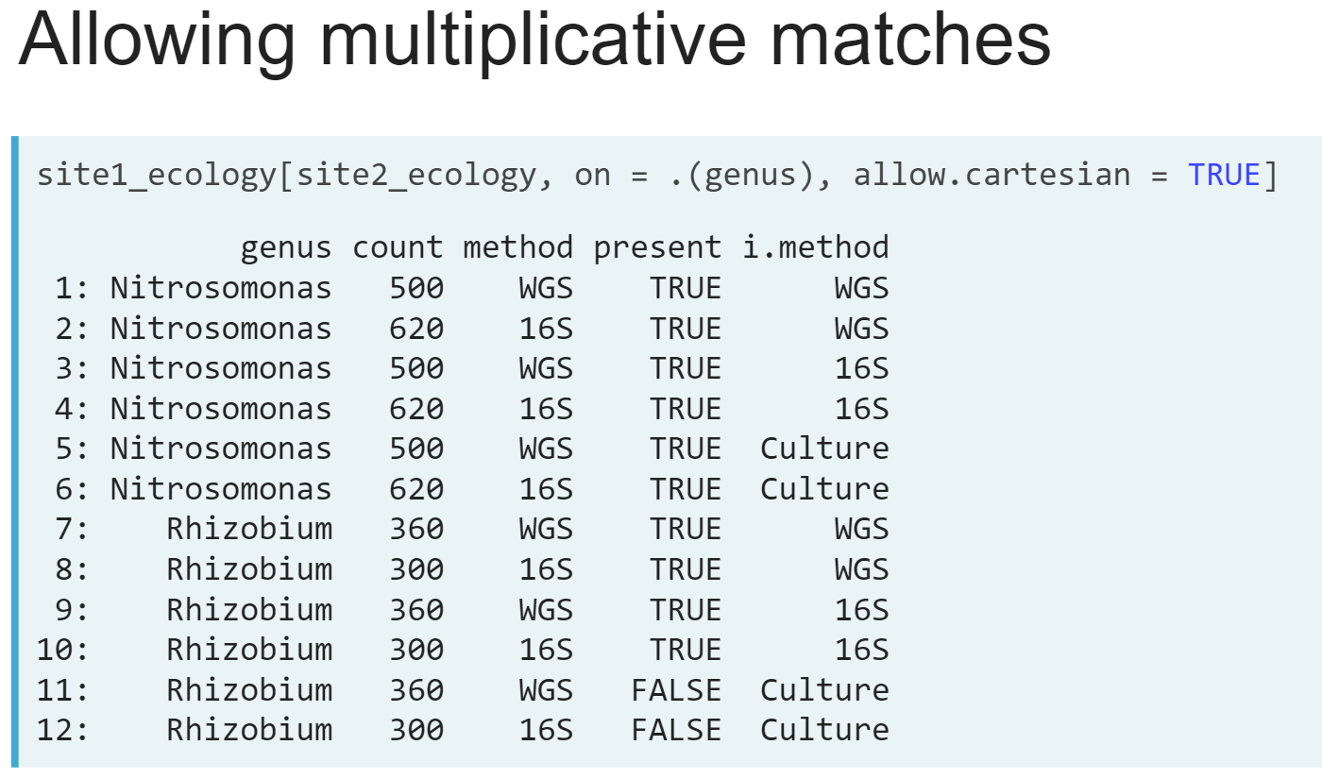  
With data table syntax, we will get the following data table as a result.

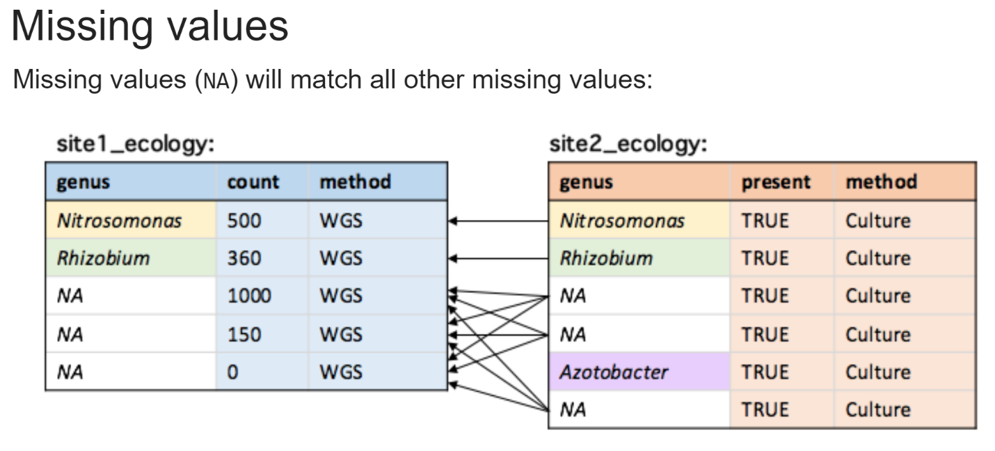  
If we have missing values in our join key column, then these can also lead to multiplicative matches, because they will match all other missing values in the join.

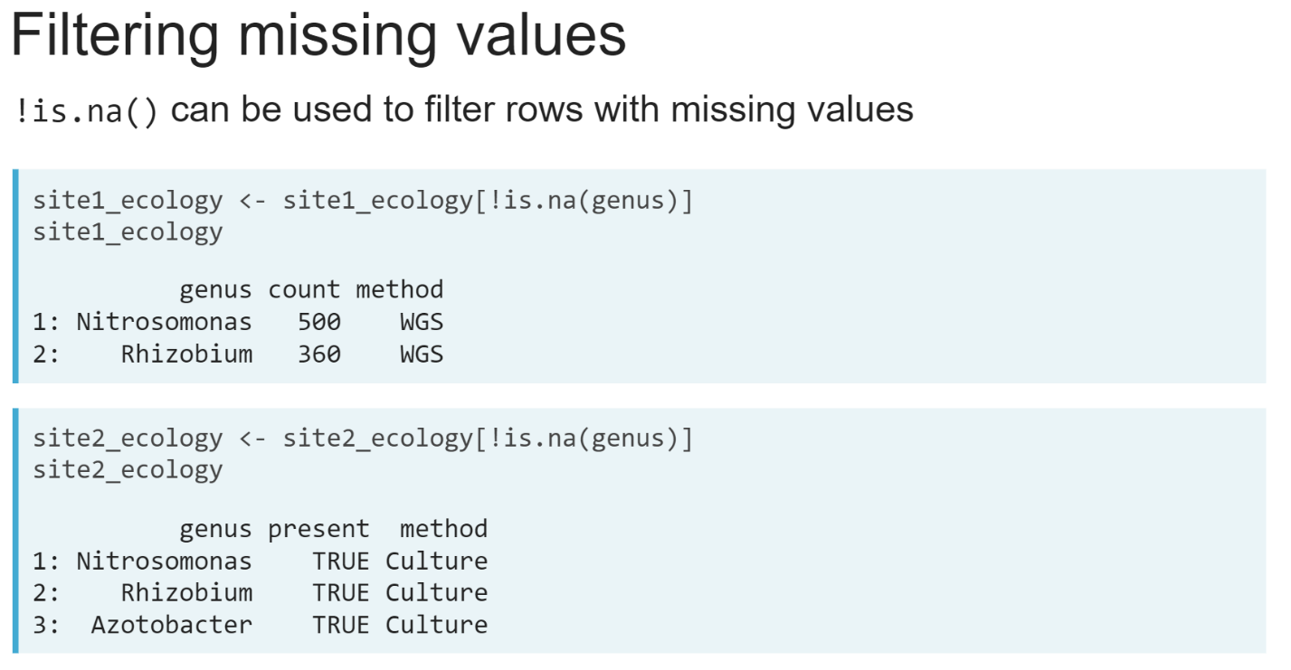  
To remove these matches which are likely meaningless, we can filter out rows with missing values in the join key columns using the ***is.na()*** along with ***not(!)*** operator.

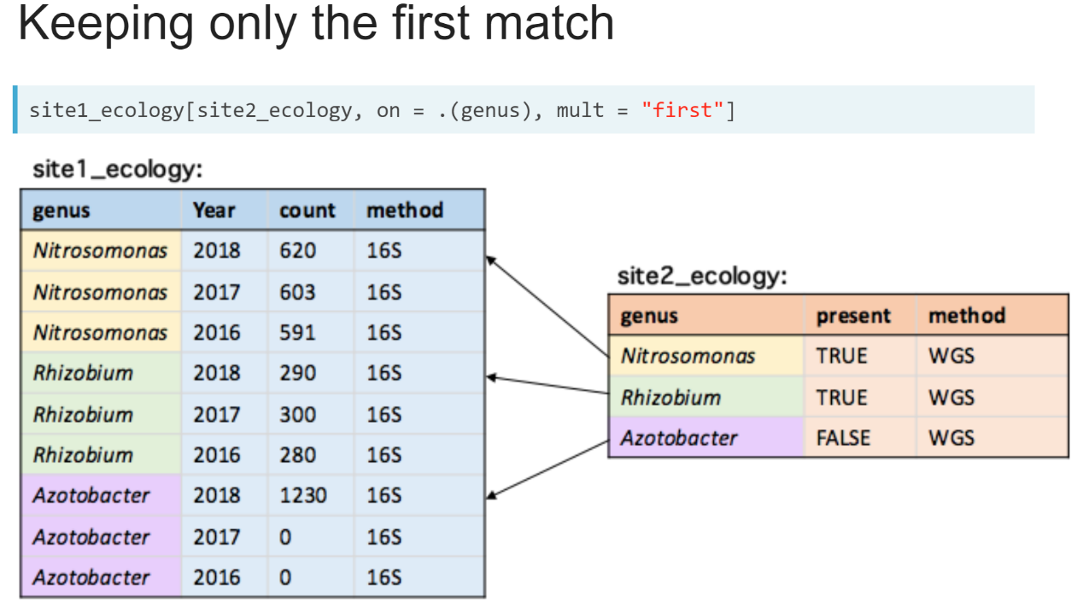  
In some cases, we may want to join two data tables where each value in the join key column has multiple matches, but we only want to keep the first match.

For example. we might have multiple collections at site 1, but when matching to *site2_ecology* data table, we only want to match the most recent collection.

To do this, we can set ***mult = "first"*** argument to keep only the first matching row in the main data table on the left side of the join.

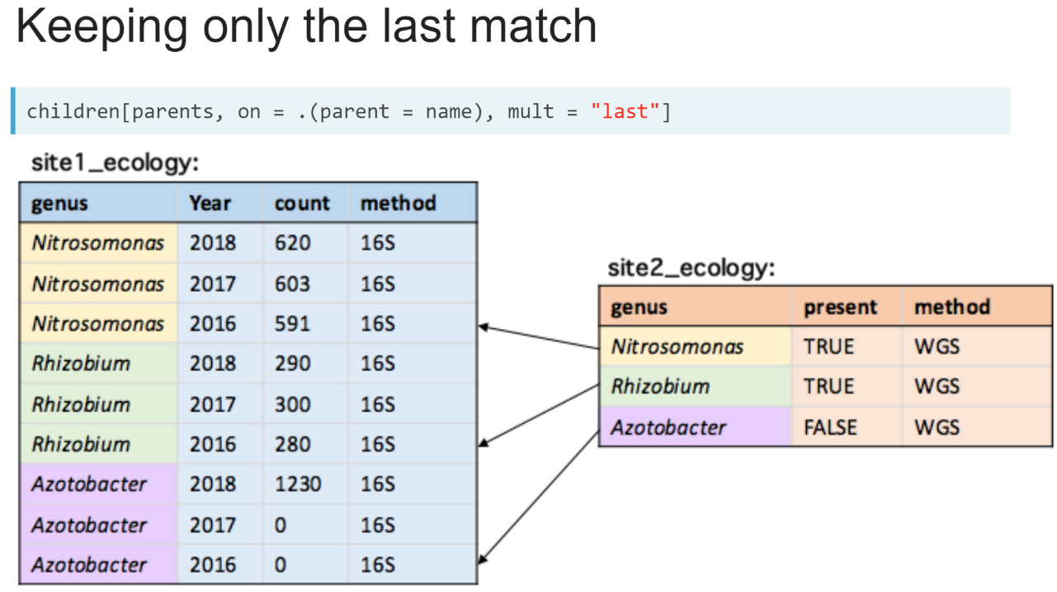  
Conversely, we can set ***mult = "last"*** argument to keep only the last matching row.

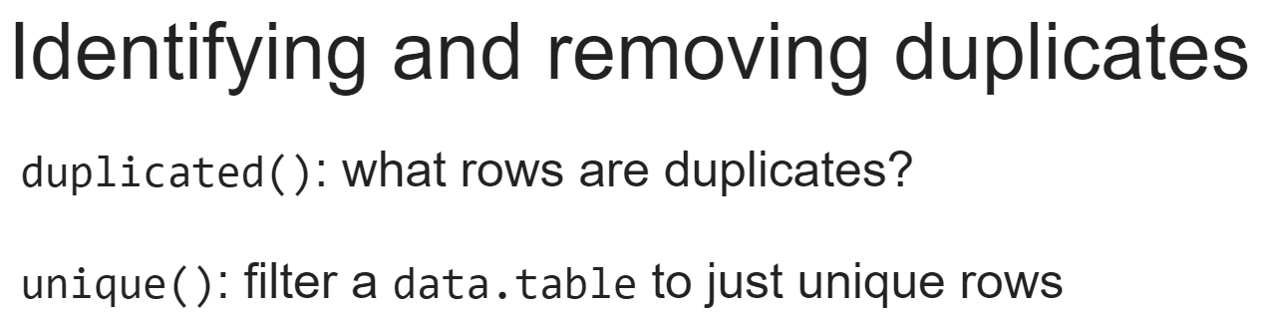  
We can also use the ***duplicated()*** and ***unique()*** functions to identify and remove duplicates.

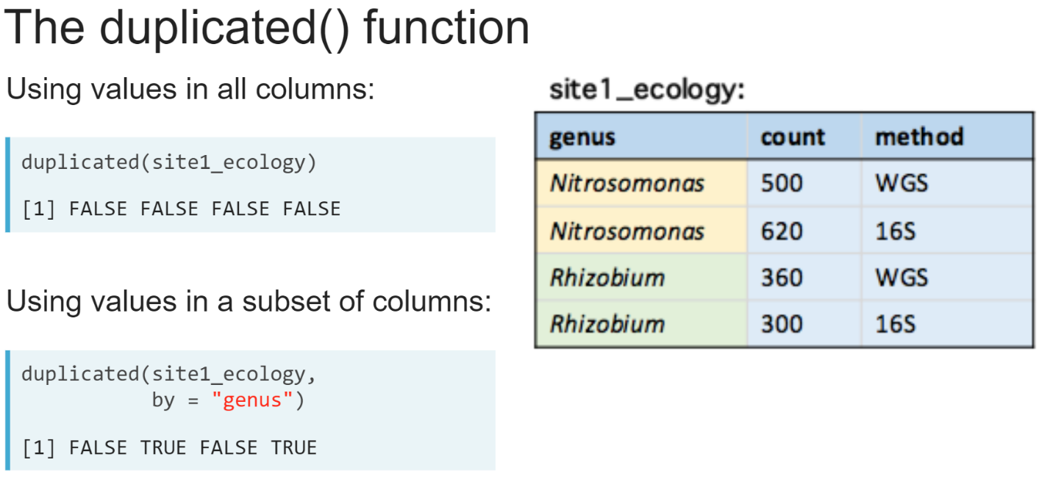  
The ***duplicated()*** function from the data table package will tell us which rows are duplicates. It returns a vector of **TRUE** and **FALSE** values, where each entry corresponds to a row in the data table.

A value of **TRUE** means that row has the same values as one of the previous rows in the data table. An additional argument, "*by* ", can be used to restrict those checks to only a subset of columns, for example looking for duplicates in just the join key column.

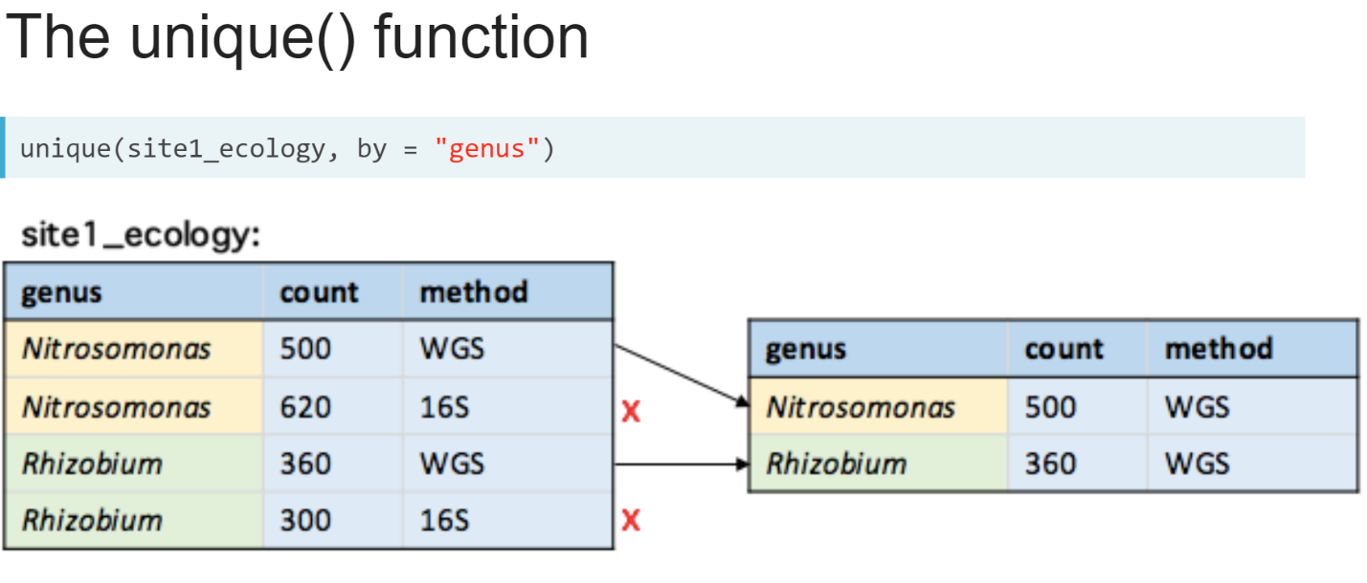  
The ***unique()*** function takes the same arguments, but instead returns the data table without the rows that were determined to be duplicates.

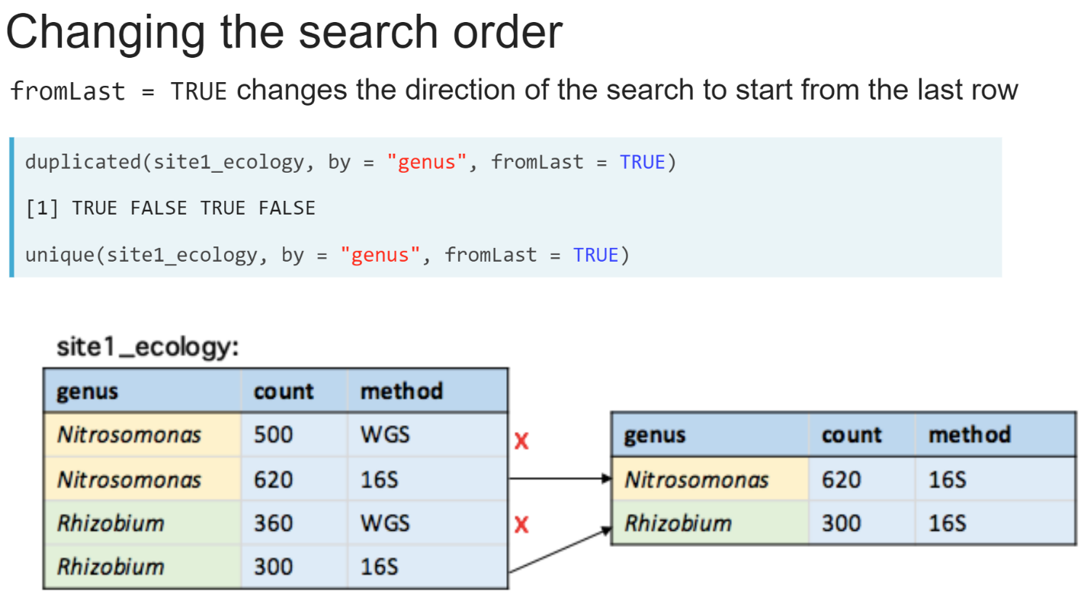  
We can also change the direction the duplicated() and unique() function search for and remove duplicates by specifying ***fromLast = TRUE***.

# Joining with missing values

Two new data.tables have been loaded into your R session: heart and cardio. Each one contains a set of [**microarray probes**](https://en.wikipedia.org/wiki/DNA_microarray) you have found to be associated with heart disease in two separate studies*.

Each probe measures the [**expression levels**](https://en.wikipedia.org/wiki/Gene_expression) of a gene. Each gene can be measured by one or more probes, and some probes do not have any known gene annotation in the [**human genome reference sequence**](https://www.ncbi.nlm.nih.gov/refseq/).

The two studies have used different microarray platforms that use different probes to measure each gene. Your goal is to find which genes had reproducible associations with heart disease in both studies.

* Note: associations are randomly generated, not representative of any true biological finding or real dataset.

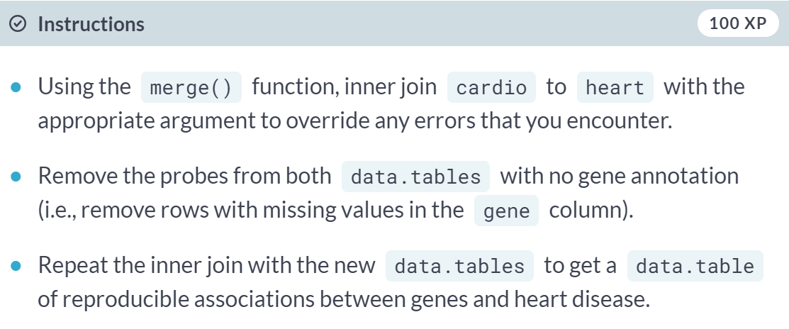

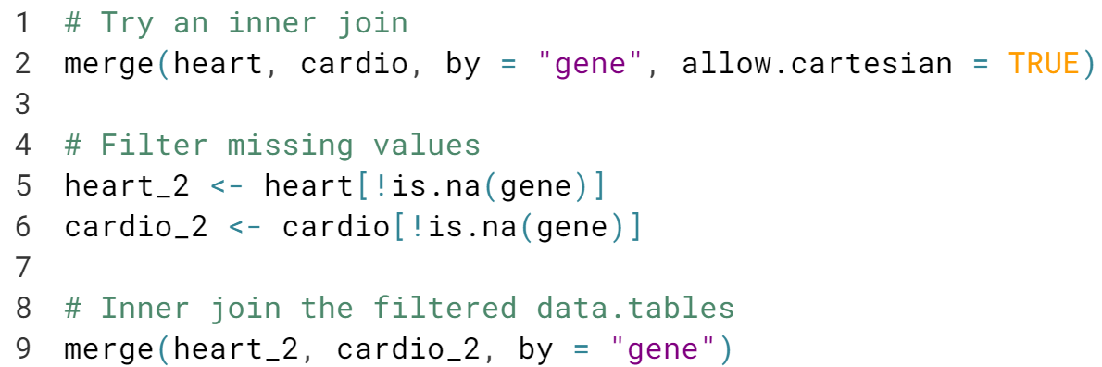

(See the next page for the result of running the code)

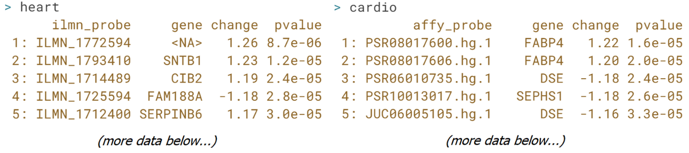

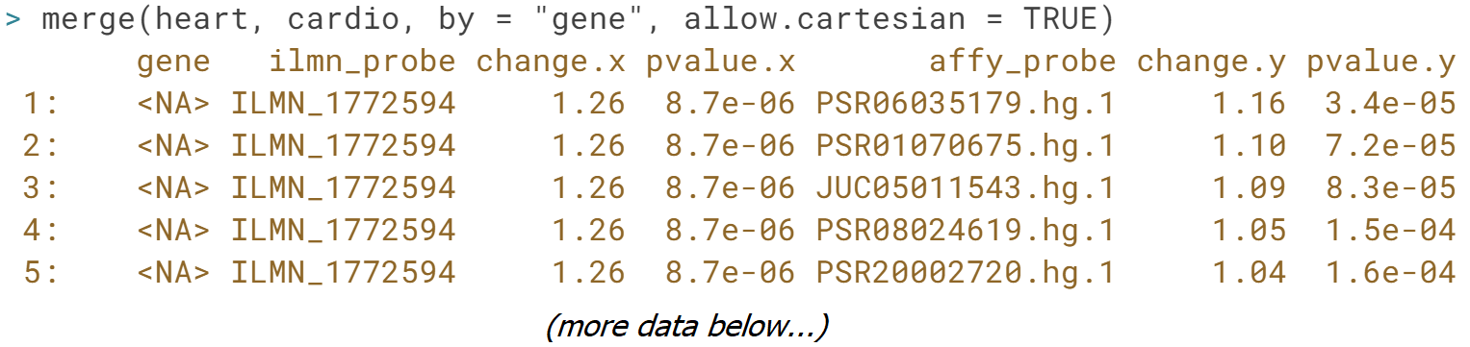

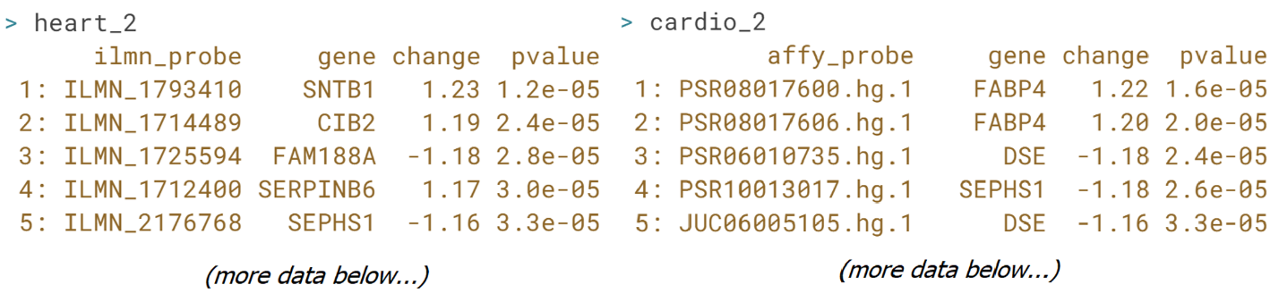

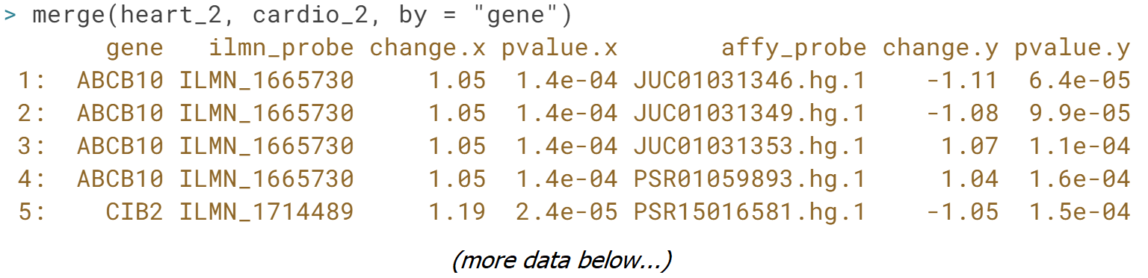  
  
Nice work! If the only columns that have the same name across two data.tables are the join keys, you can drop the by argument from ***merge()*** - it will find and use these columns as the join keys automatically!

# Filtering duplicates

The heart_2 and cardio_2 data tables you filtered for missing values are available in your workspace. Your goal is to select one representative probe per gene in each data.table so that each gene has only a single entry in the join result. You want to select the probe with the weakest association to get a conservative estimate of reproducibility. The "change" column contains the fold change in expression levels for each probe between the healthy subjects and those with heart disease*. The "pvalue" column contains the p-value for the association strength. Rows are ordered by decreasing order of association strength (by increasing P-value).

* Note: associations are randomly generated, not representative of any true biological finding or real dataset.

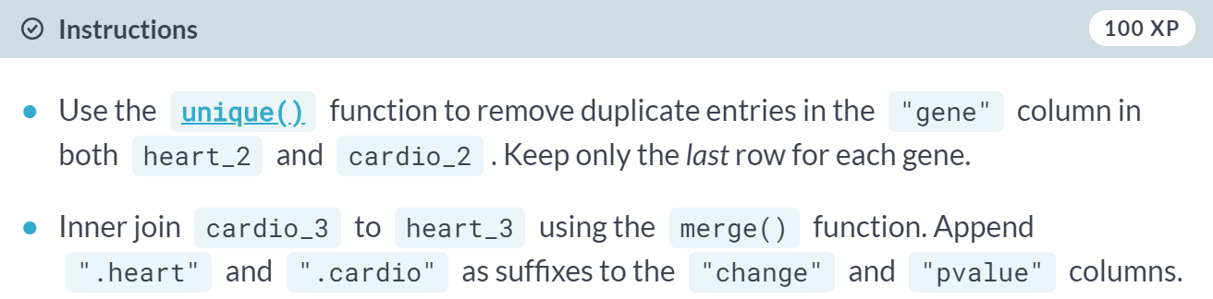

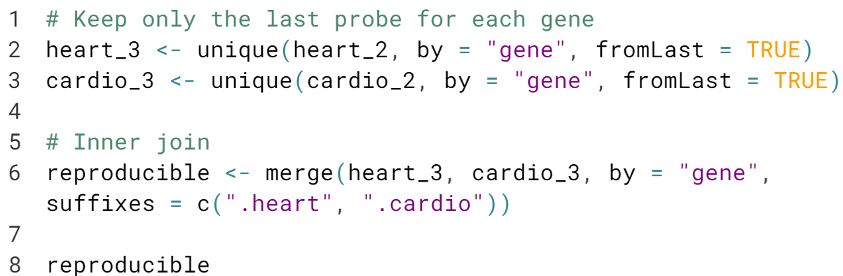

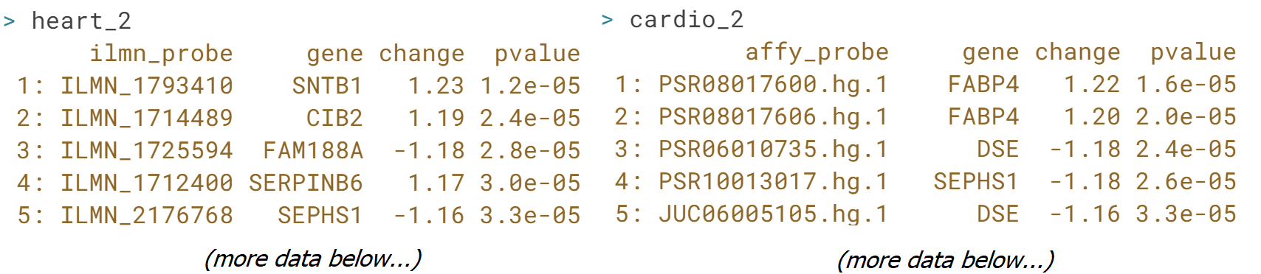

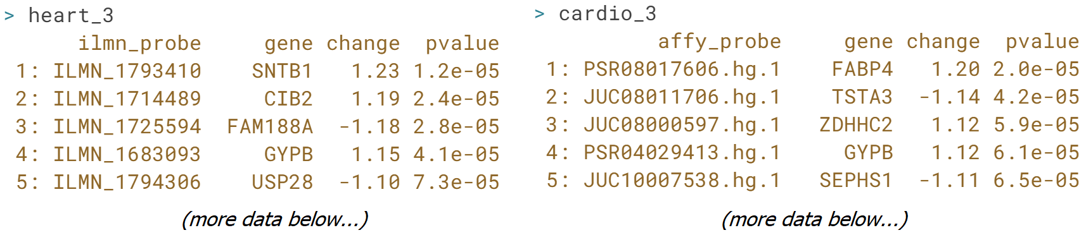

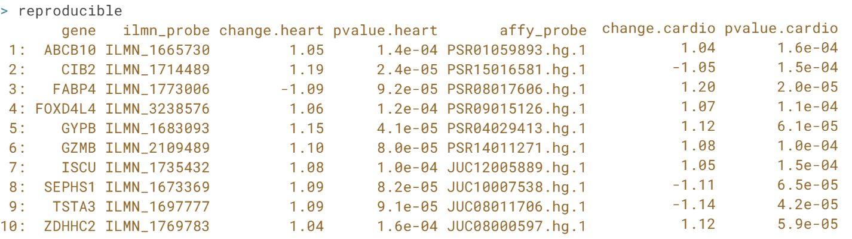

Great job! You could also have filtered duplicates using the ***duplicated()*** function:   


# Joining and filtering duplicates

Another data.table has been loaded into your R session, framingham, containing a set of 35 genes and their associations with heart disease from an open access study [**by Joehanes R. et al. published in 2013**](https://www.ncbi.nlm.nih.gov/pmc/articles/PMC3684247/). Your goal is to compare the results of this study to the results from each of your studies. The cardio_2 and heart_2 data.tables filtered for missing values, but still containing multiple probes for each gene, have been loaded into your R session. The data.table of reproducible associations you created in the last exercise, reproducible, has also been loaded into your R session.

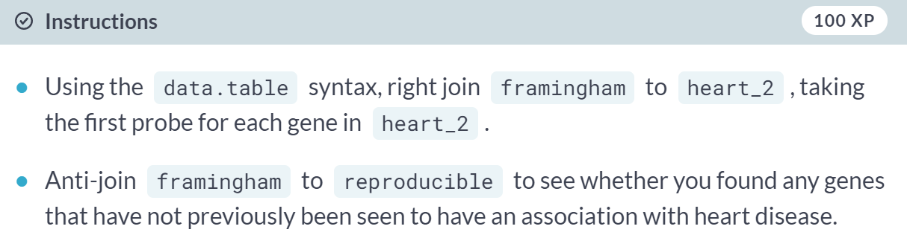

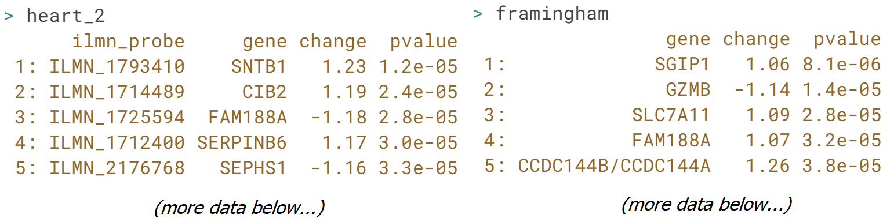  
  
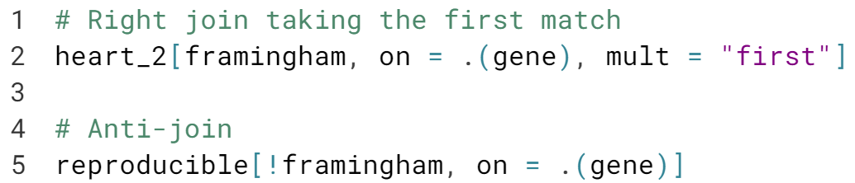  
  
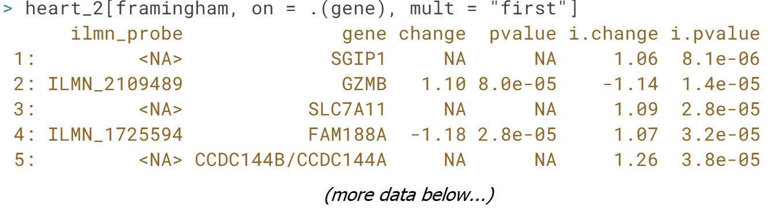  
  
Excellent work! You could also select the last probe per gene by setting ***mult = "last"***.

**Concatenating and Reshaping data.tables**In the last chapter of this course you'll learn how to concatenate observations from multiple tables together, how to identify observations present in one table but not another, and how to reshape tables between long and wide formats.



In this lesson, we will learn how to work with datasets whose rows are spread across multiple data tables by concatenating them into a single data table.

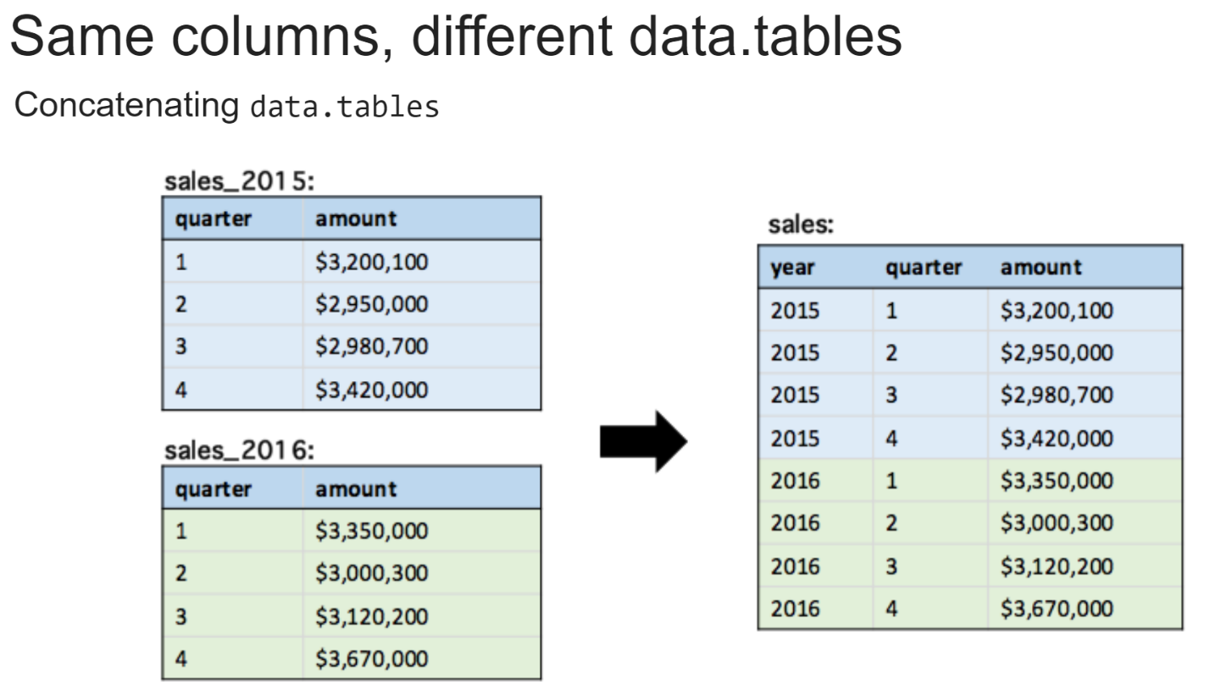Sometimes datasets we want to work with are split across multiple data tables, usually because they've been read in from multiple files. We may want to concatenate these rows into a single data table to ease our workflow.

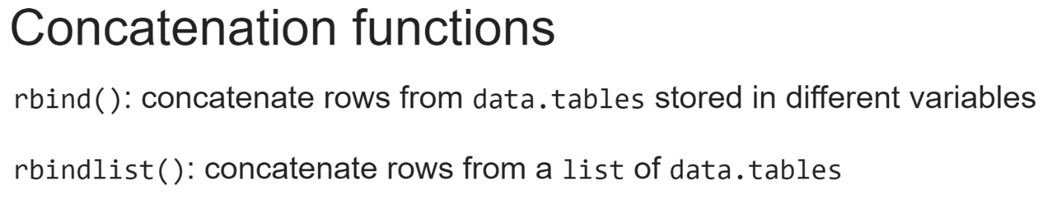  
There are two functions we can use to concatenate data tables. The ***rbind()*** function, and the ***rbindlist()*** function.

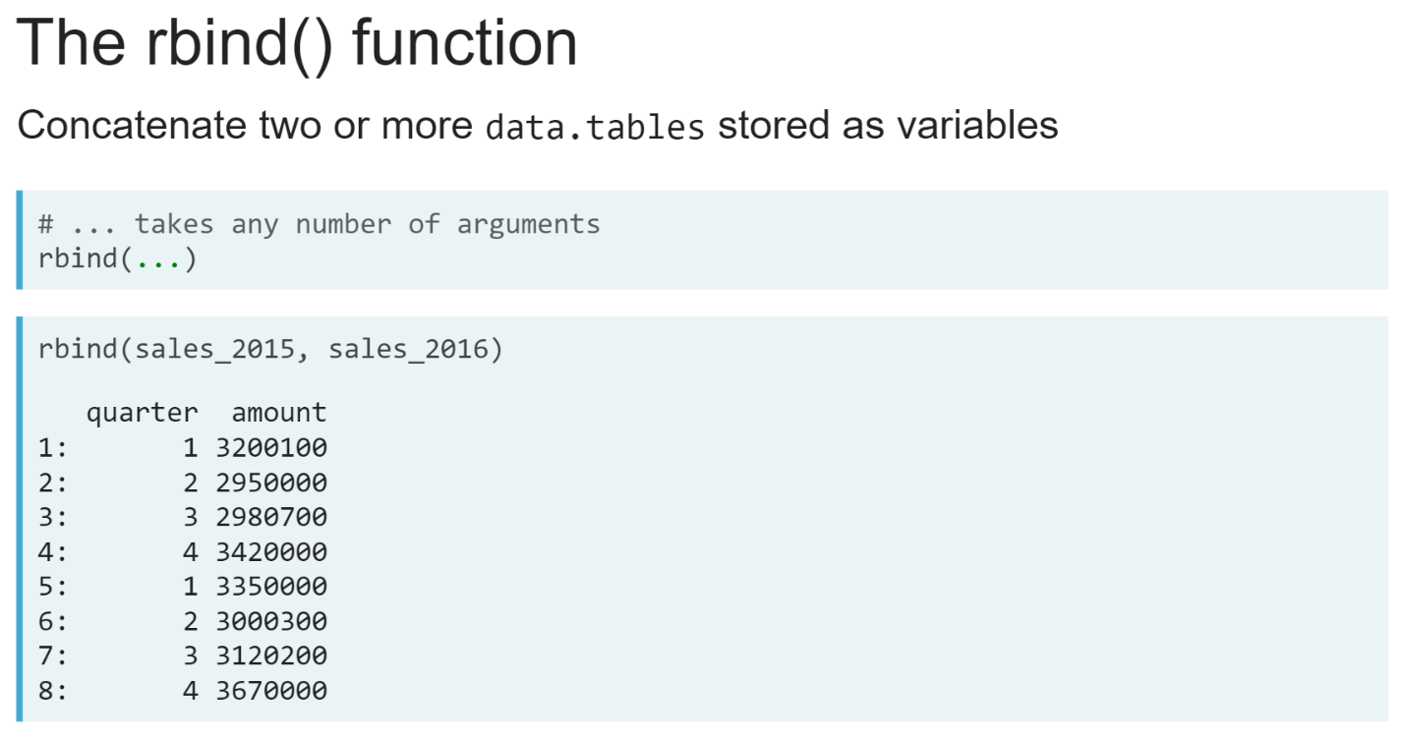  
The ***rbind()*** function takes any number of data tables as inputs and concatenates their rows into a single data table.

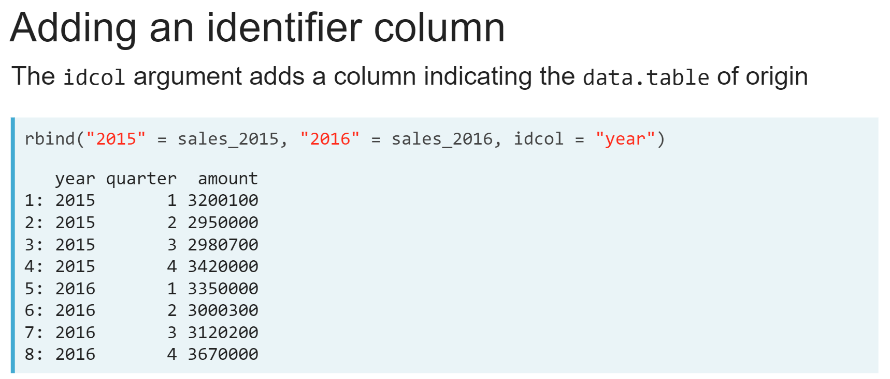Each of these variables can be given names using the ‘***=’*** operator and an extra argument "***idcol***" will tell the ***rbind()*** to use these names to create an extra column in the result that indicates each row's data table of origin.

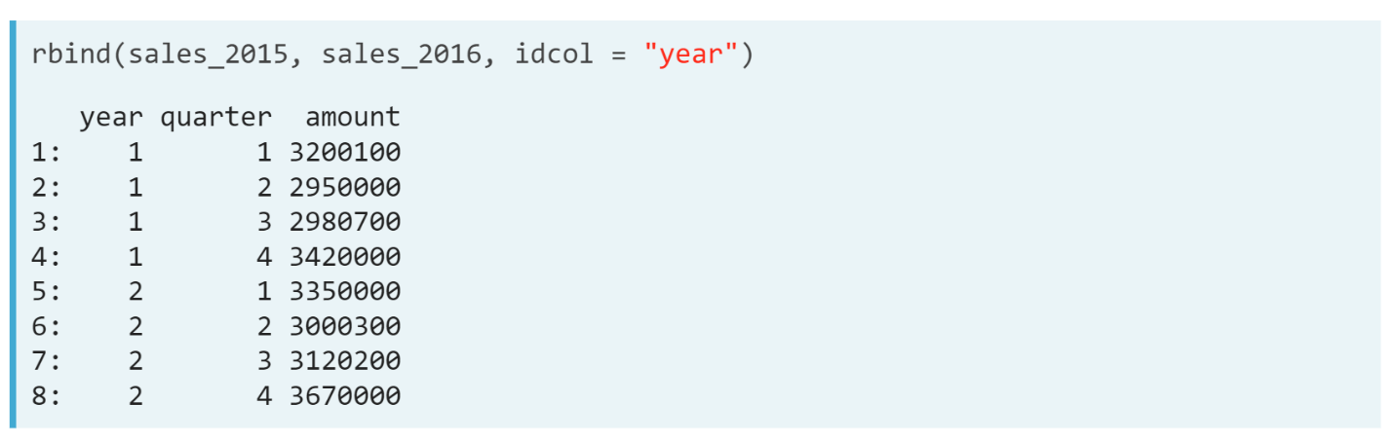  
If we use the *idcol* argument without naming the variables, the data table will be numbered instead.

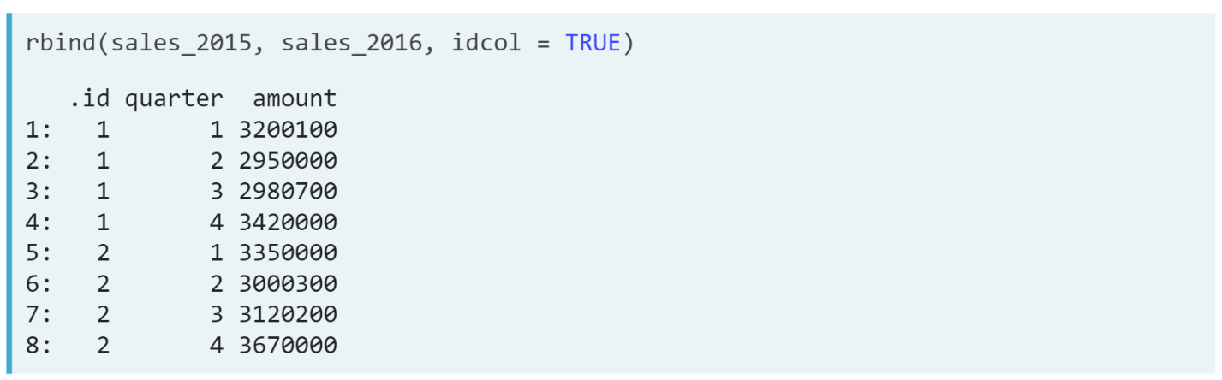  
And if we don't supply a column name to idcol and just set it to TRUE, the column will be named *".id".*

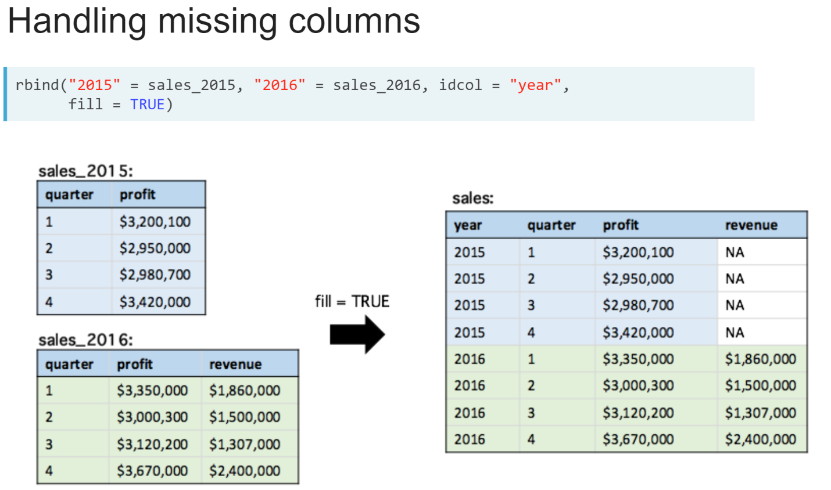  
When the input data tables each have a different number of columns, we will need to set the *fill* argument to **TRUE**. This will fill the missing columns with NAs in the result.  
  
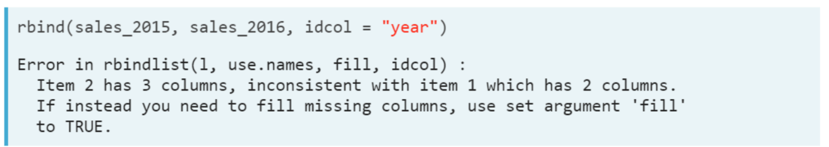  
If we don't do this, the code will result in an error that looks like this, telling us that the column numbers are inconsistent.

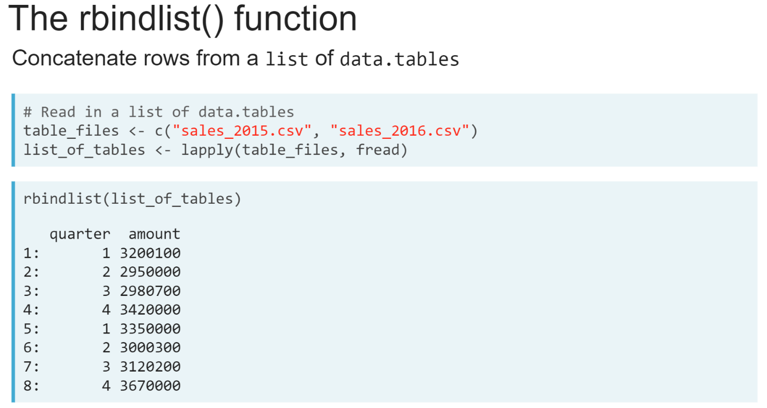  
We can use the ***rbindlist()*** function if the data tables are stored as elements of a single list. An example of where we might find this useful is when we have several files, we want to import into a single data table.

Rather than reading each file into separate variables, we could load these into a list by ***lapply()***-ing the ***fread()*** function over a vector of file names and then use the ***rbindlist()*** function to concatenate their rows into a single data table.

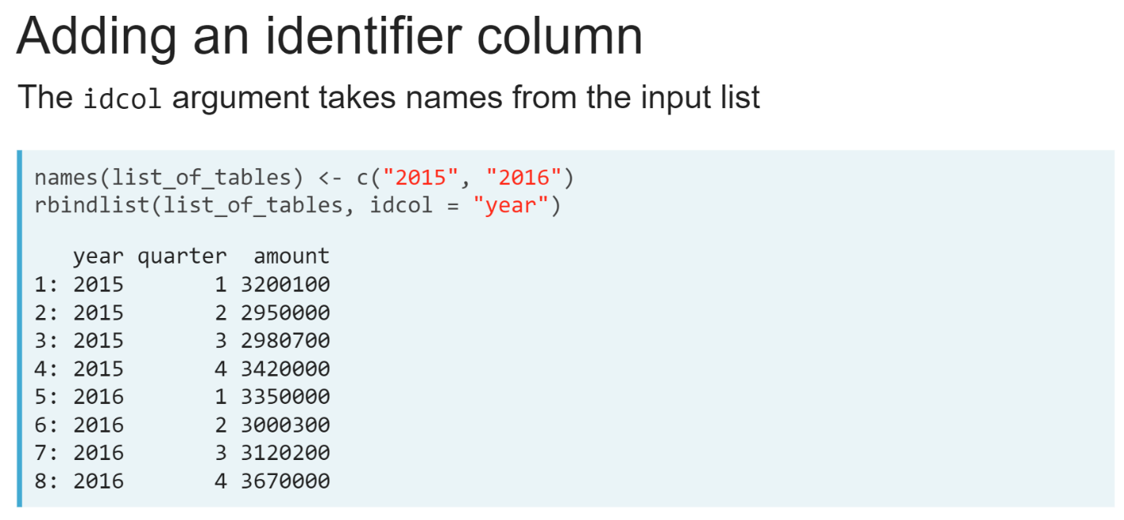  
When using the ***rbindlist()***function, the *idcol* argument uses the names of the list elements when creating the additional identifier column.

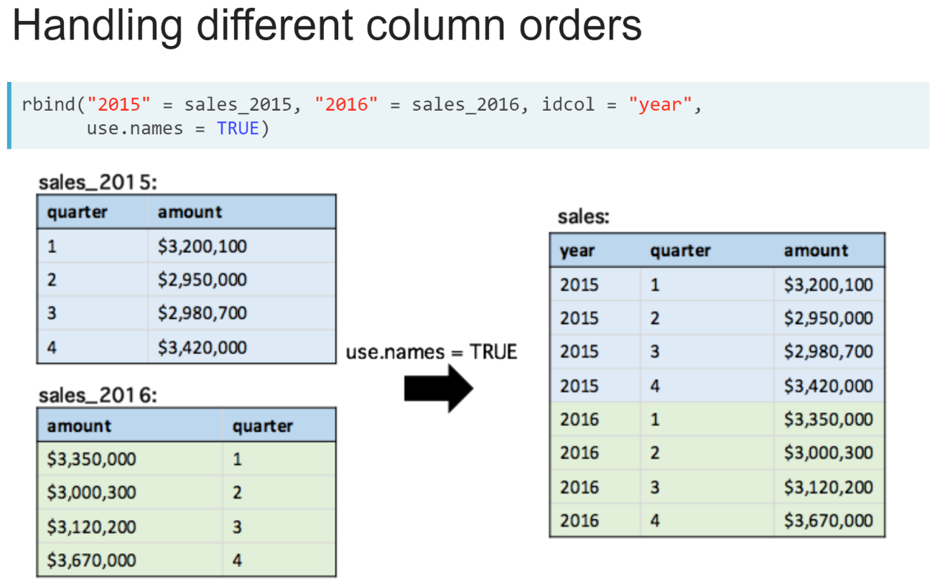  
Finally, the *use.names* argument in both ***rbind()*** and ***rbindlist()*** functions matches columns by their names when concatenating data tables.  
  
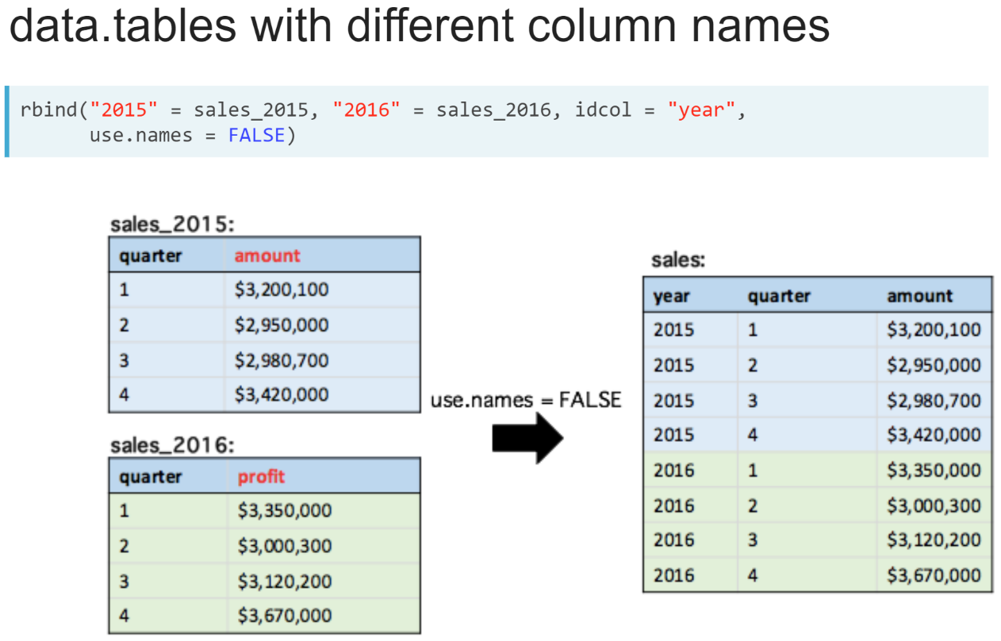  
Setting *use.names* to **FALSE** allows us to concatenate data tables whose columns have different names.

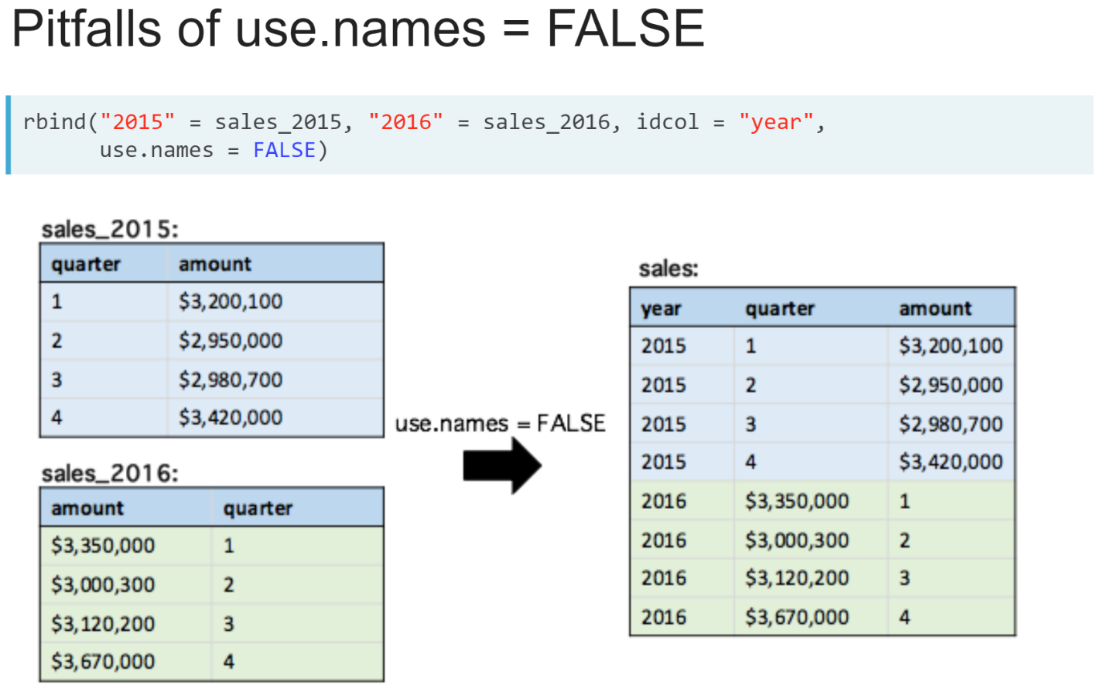  
But we need to be careful because it will mean columns are always concatenated in the order they are found.

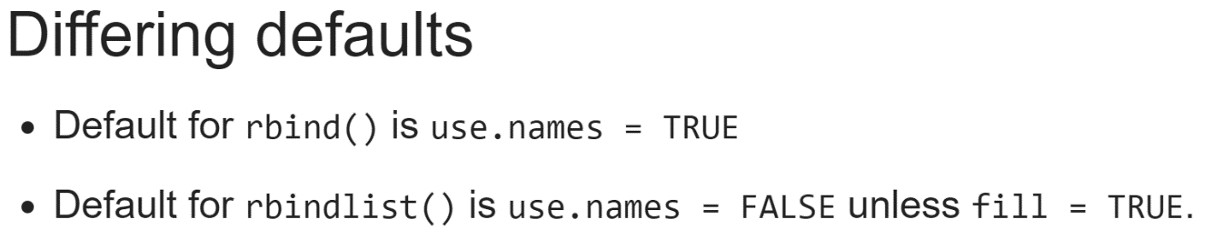  
  
The *use.names* argument has different defaults in the ***rbind()*** and ***rbindlist()*** functions.

By default, it is true in the ***rbind()*** function, but in the ***rbindlist()*** function, its default is **FALSE** and changes to **TRUE** if we set ‘*fill = TRUE* ’.

# Concatenating data.table variables

Three data.tables containing Ebola case numbers [**reported in Guinea to the World Health Organization**](http://apps.who.int/gho/data/node.ebola-sitrep) for three weeks at the height of the 2014 Ebola outbreak have been loaded into your R session: ebola_W50, ebola_W51, and ebola_W52. Your goal is to create a single data.table containing the case numbers in each region of Guinea across all three weeks.

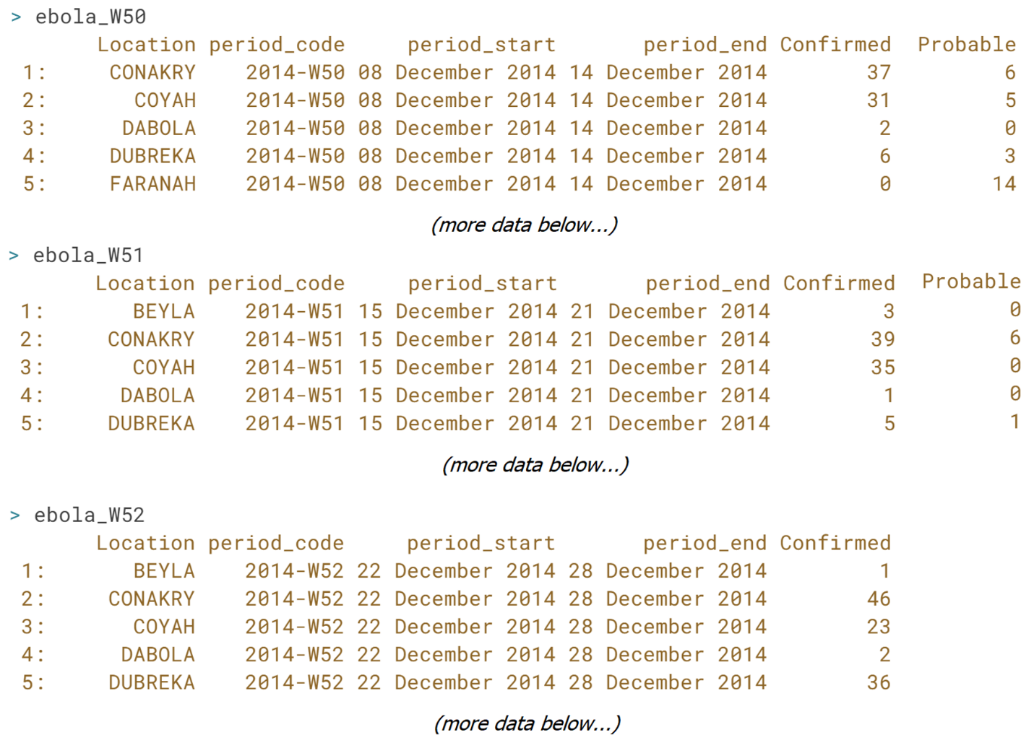

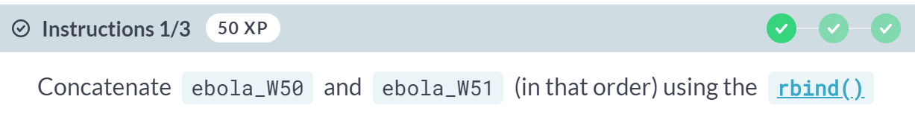



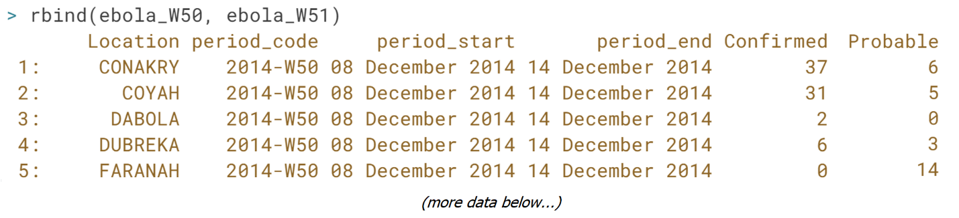

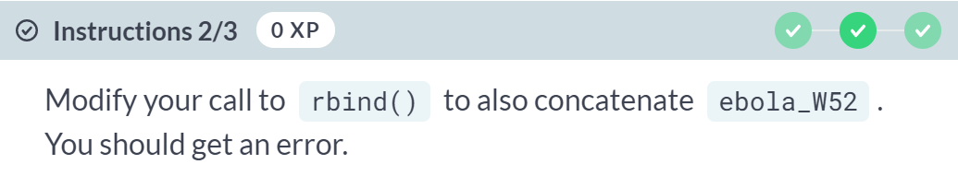  
  
Error: Item 3 has 5 columns, inconsistent with item 1 which has 6 columns. If instead you need to fill missing columns, use set argument 'fill' to TRUE.

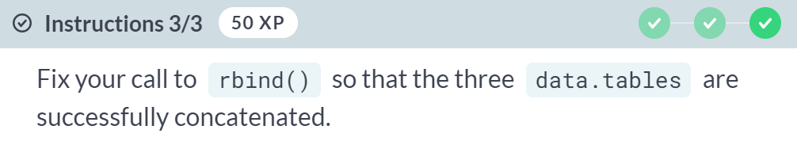  


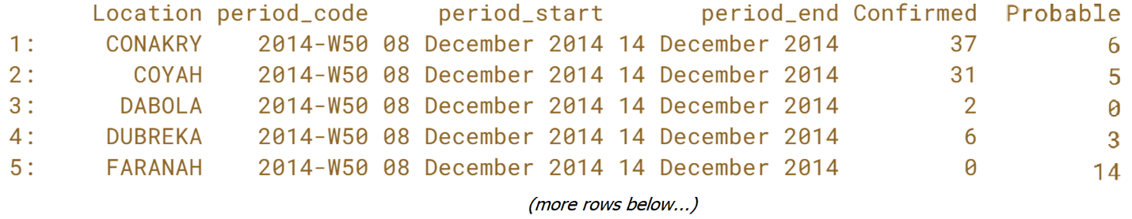  
Good job! Datasets with regular updates may come in separate files.

The ***rbind()*** function enables you to concatenate reliably and efficiently these into a single *data.table* once they have been loaded into your R session with ***fread()***.

# Concatenating a list of data.tables

A list of data.tables has been loaded into your R session: gdp. Its elements contain a data.table for each continent, each data.table containing the gross domestic product (gdp) in the year 2000 for the countries in each continent (data sourced from the [**Gapminder foundation**](https://www.gapminder.org/)). Your goal is to build a new data.table containing the observations from all data.tables in the gdp list

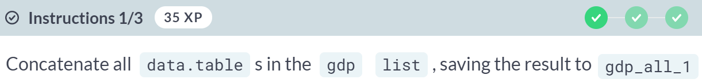  
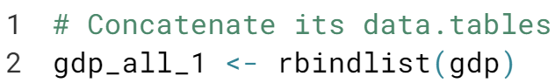  
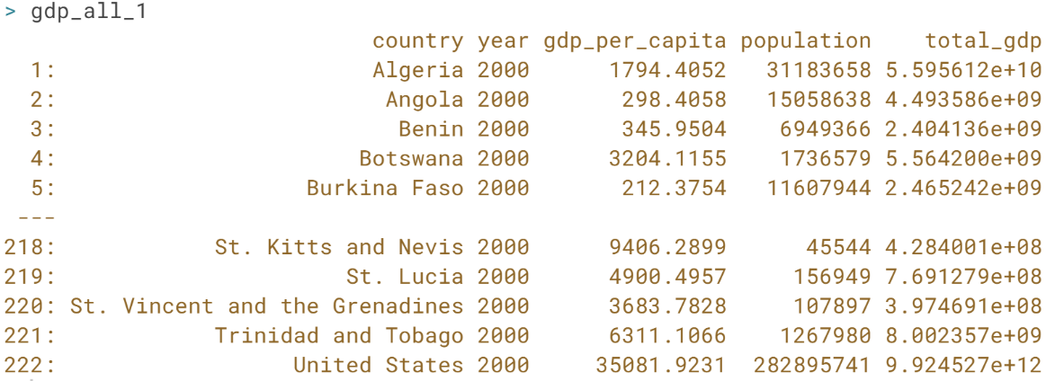  
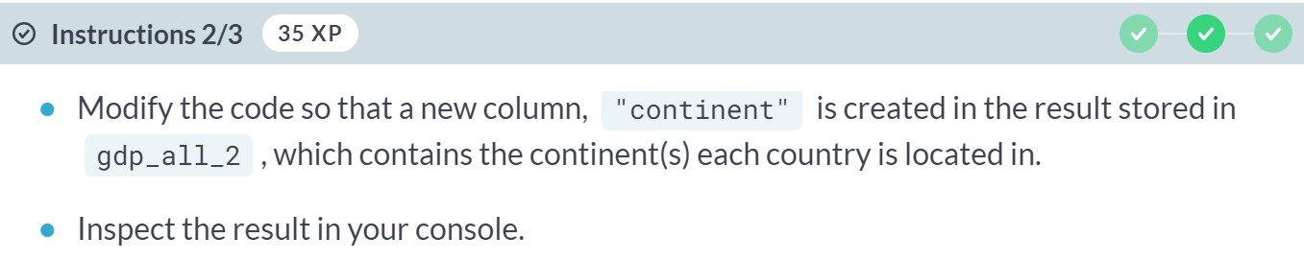  
  
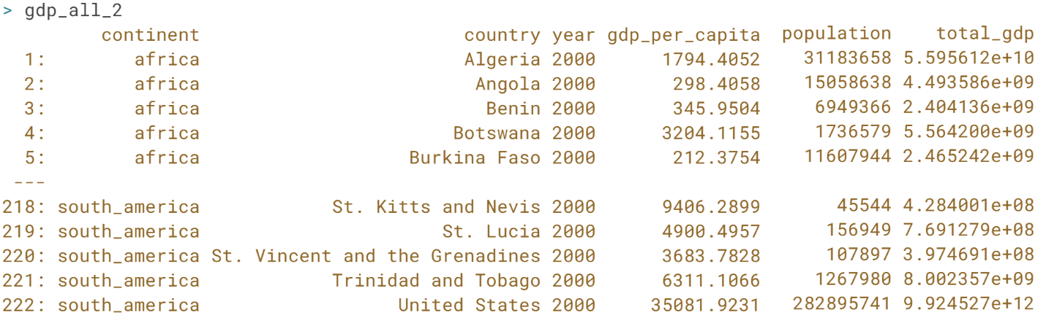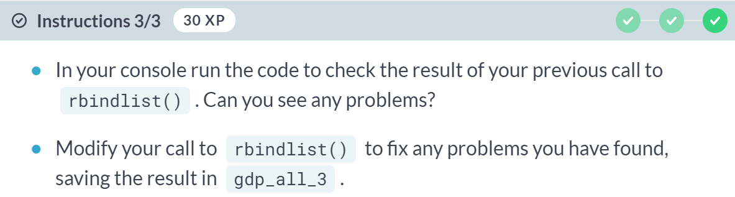  
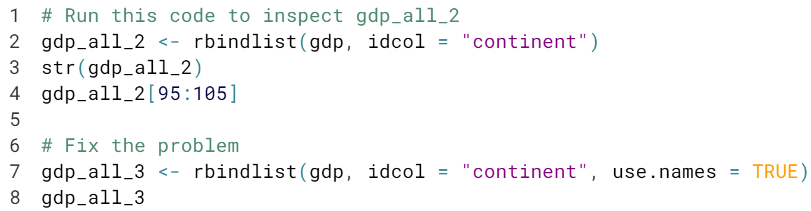

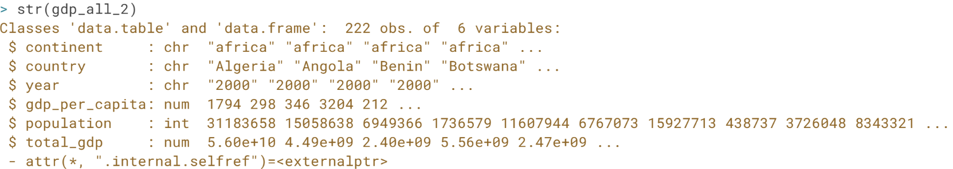  
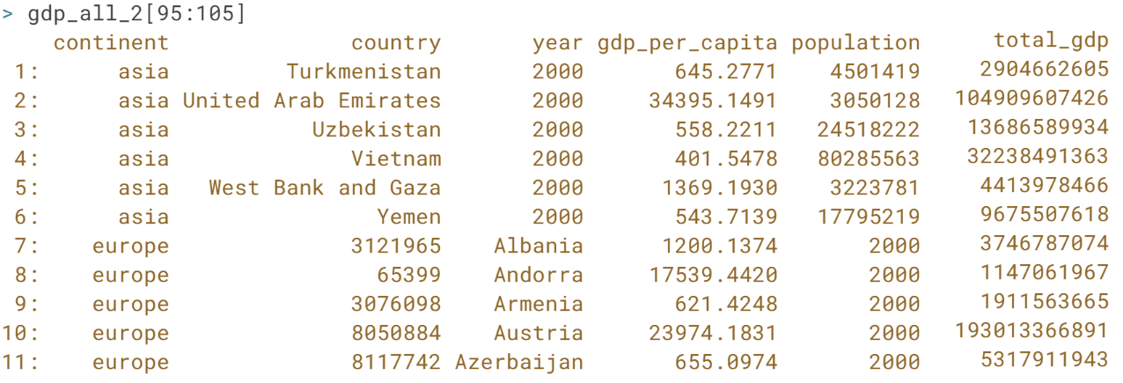  
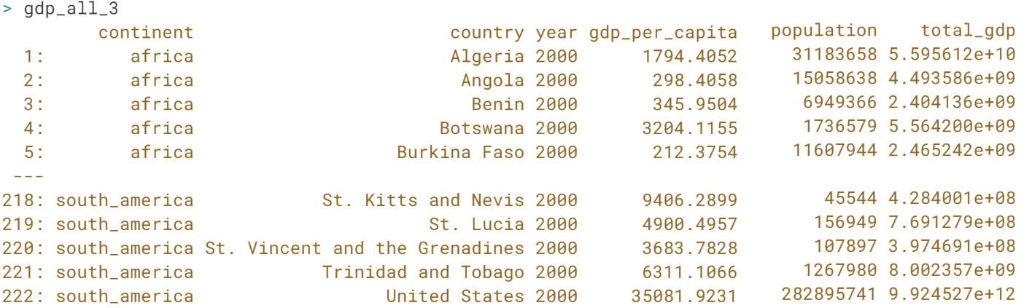  
Fantastic! Remember to check the data tables created by ***rbind()*** or ***rbindlist()*** for correctness: these functions do not throw an error if the wrong columns are concatenated!

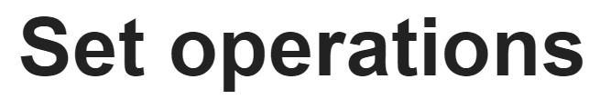

In this lesson, we will learn how to use set operations to compare and combine the rows of two data tables that have the same columns.

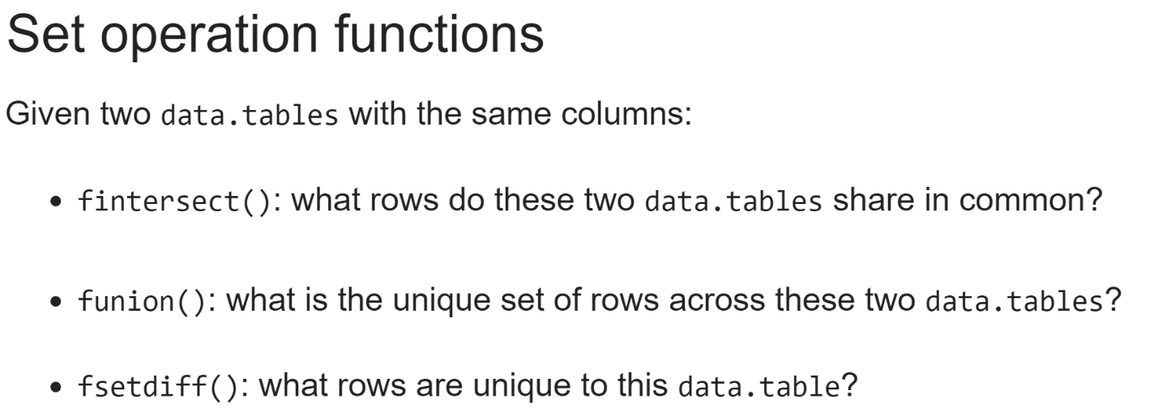  
This group of three functions will enable us to identify rows that are duplicated across two data table, those unique to either data table and concatenate two data tables keeping only the unique rows in both.

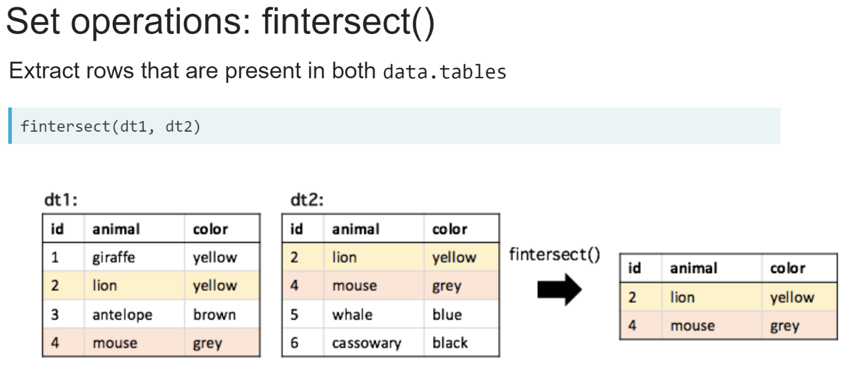  
The ***fintersect()*** function takes two data tables that have the same columns as its inputs and returns a new data table containing the set of rows that can be found in both data tables. We can see in the example running ***fintersect()***on these two data tables will return just the highlighted rows.

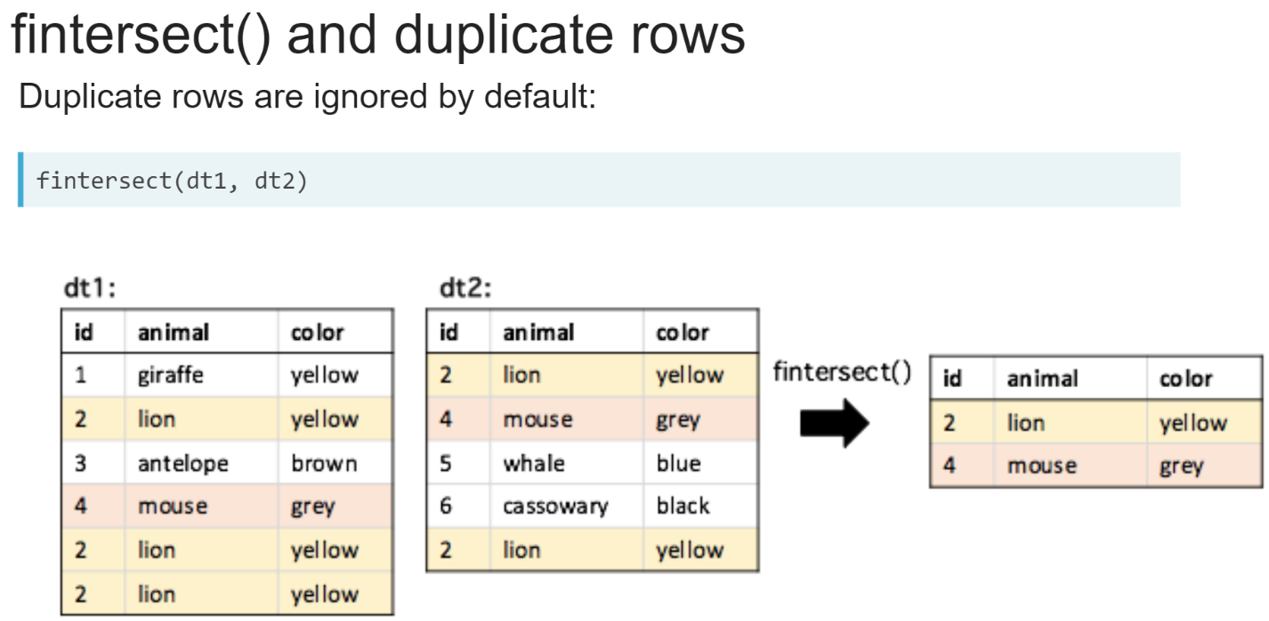  
By default, only one copy of each row is returned, even if there are multiple copies in each data table. We can set *all = TRUE* to keep all pairs of matching duplicates. In the example, two copies of the yellow lion row can be found in both dt1 and dt2, so there are two copies in the result. The extra copy in *dt1* is ignored because it doesn't have another copy it can match to in *dt2*.

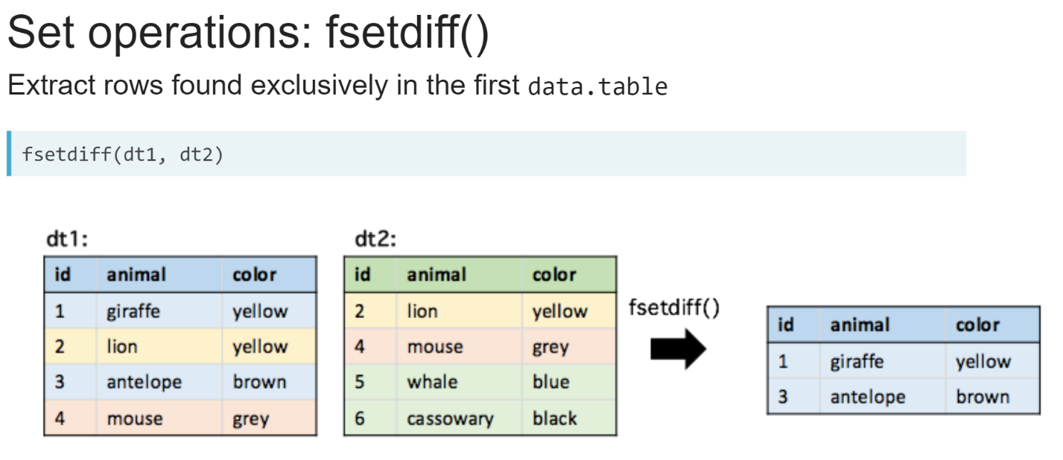  
The ***fsetdiff()*** function takes two data tables that have the same columns as its inputs and returns a new data table containing the set of rows that are only found in the data table supplied as its first argument.

In the example here, we can see ***fsetdiff()***returns the rows from *dt1* highlighted in blue. These are the rows that are unique to *dt1*.

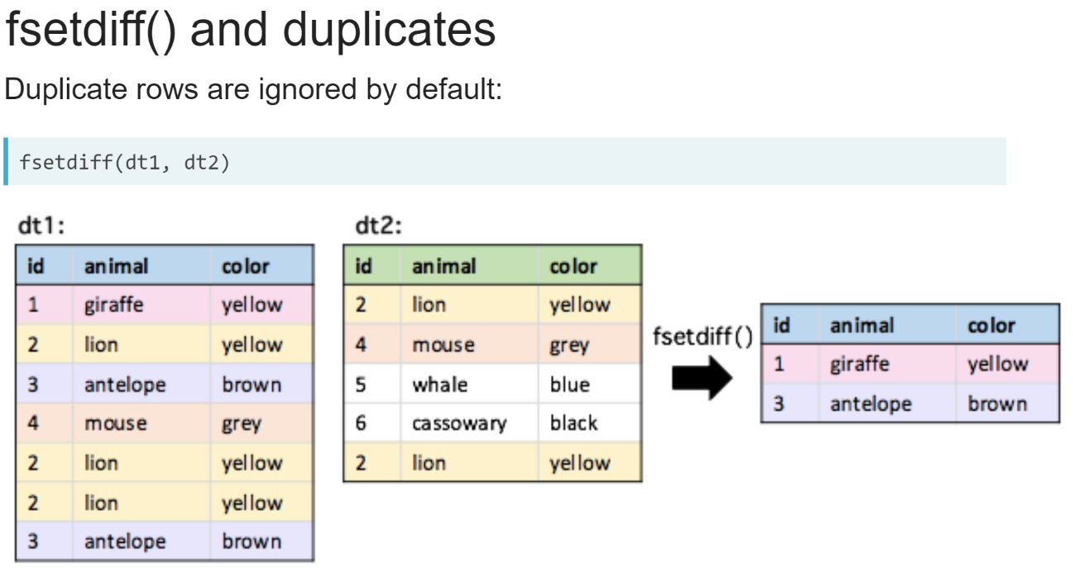  
When there are duplicate rows, only one copy of each row is returned in the result by default.

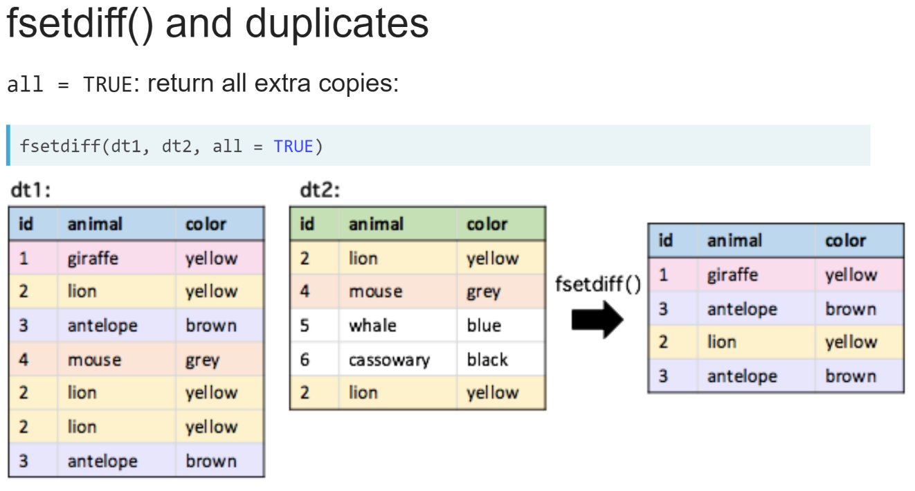  
When we set *all = TRUE*, any copies unique to the first data table are also returned. Here, not only do we keep both copies of the "*antelope*" row highlighted in purple, but one of the "*lion*" rows highlighted in yellow is also included in the result.

This is because there are three copies of this row in *dt1* and only two in *dt2*. So, the extra copy in *dt1* is returned because it doesn't have a matching pair in *dt2*.

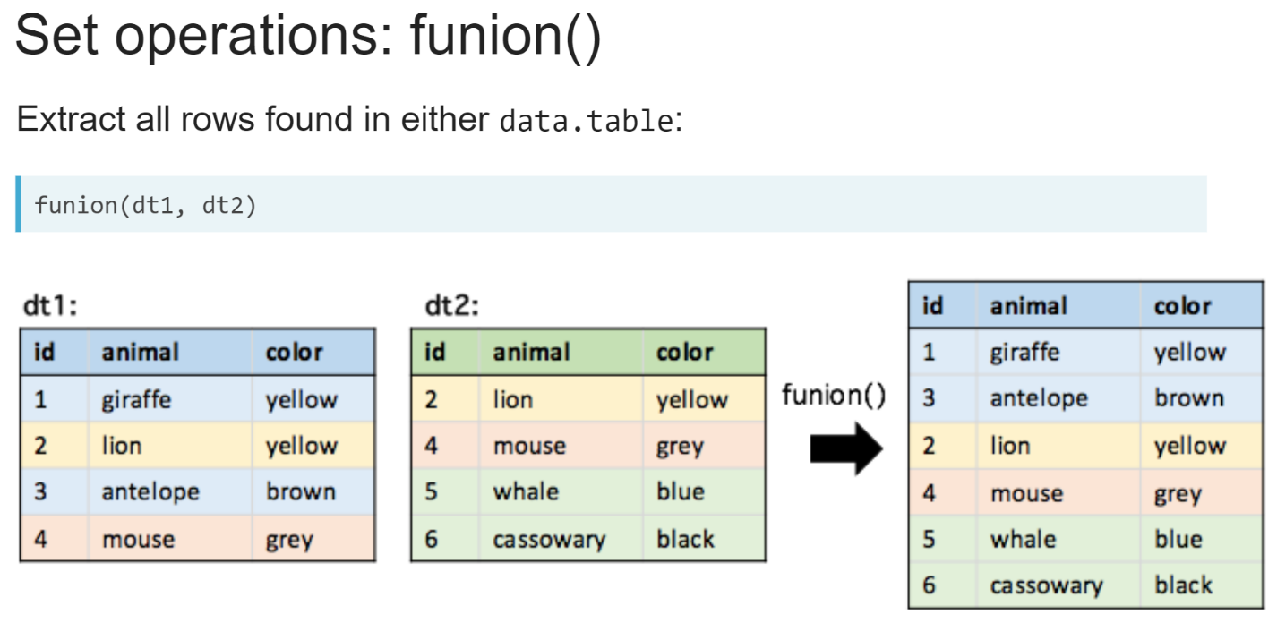  
The ***funion()*** function takes two data tables that have the same columns as its inputs and returns a new data table containing the set of all unique rows found in either data table.

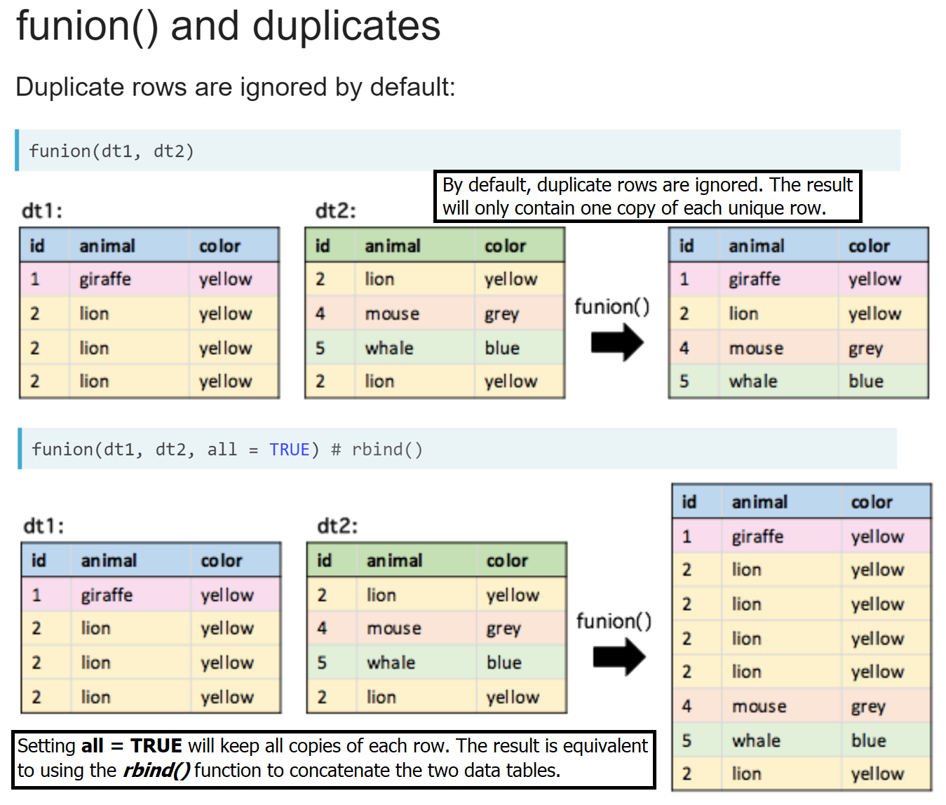

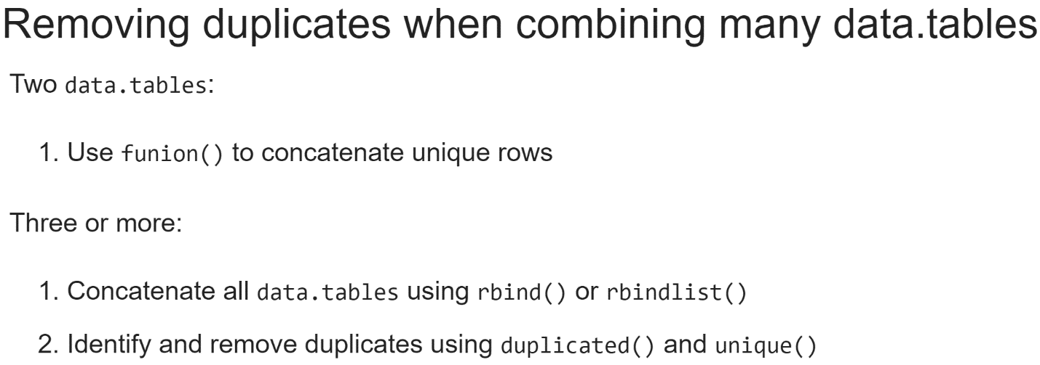  
  
The ***funion()*** function is a useful way to concatenate two data tables while removing duplicate rows. When working with more than two data tables, we can concatenate them all using the ***rbind()*** or ***rbindlist()*** functions and then use the ***duplicated()*** and ***unique()*** functions to identify or remove the duplicate rows.

# Identifying observations shared by multiple tables

The list of data tables, gdp, is available in your workspace. Your goal is to find the countries that are located in more than one continent, i.e., rows that are present in more than one data.table in gdp.

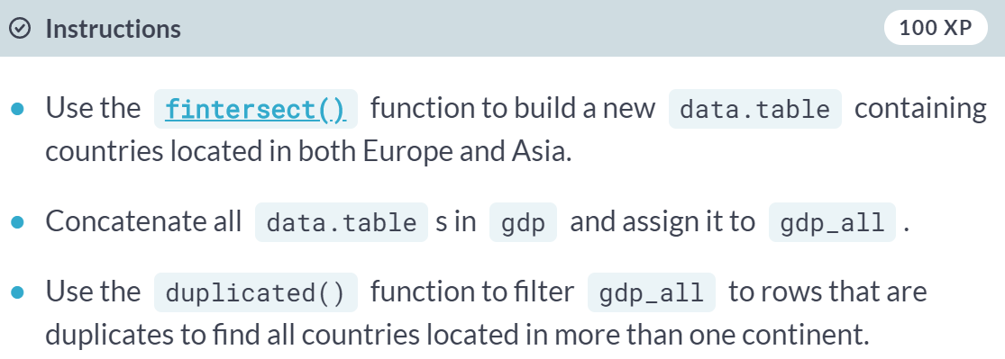  
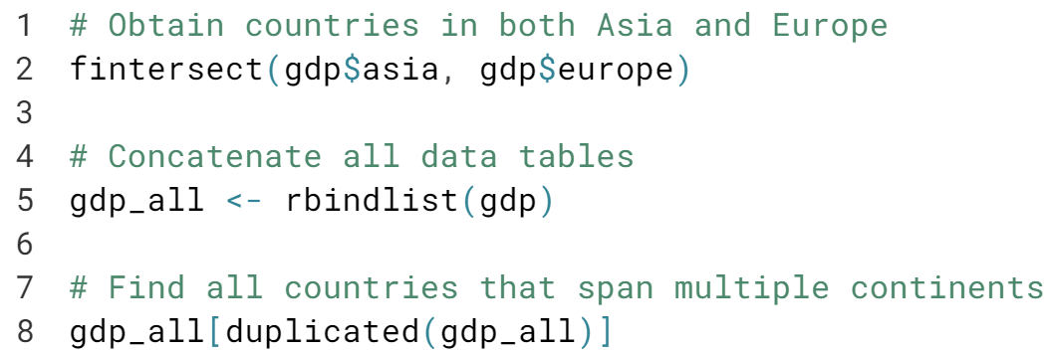  
  
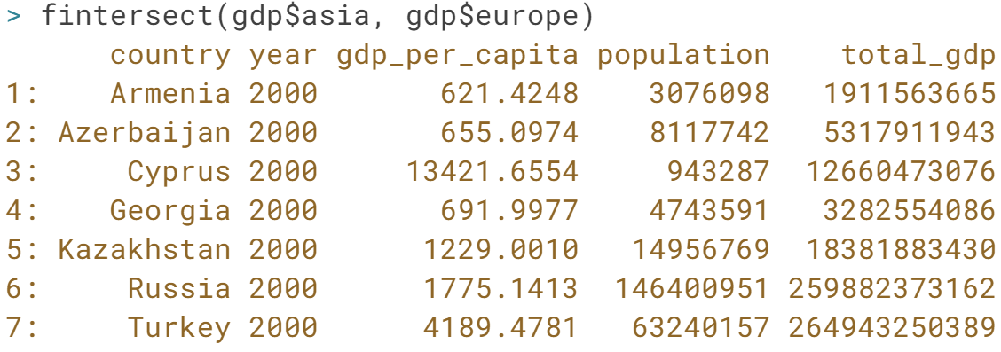  
  
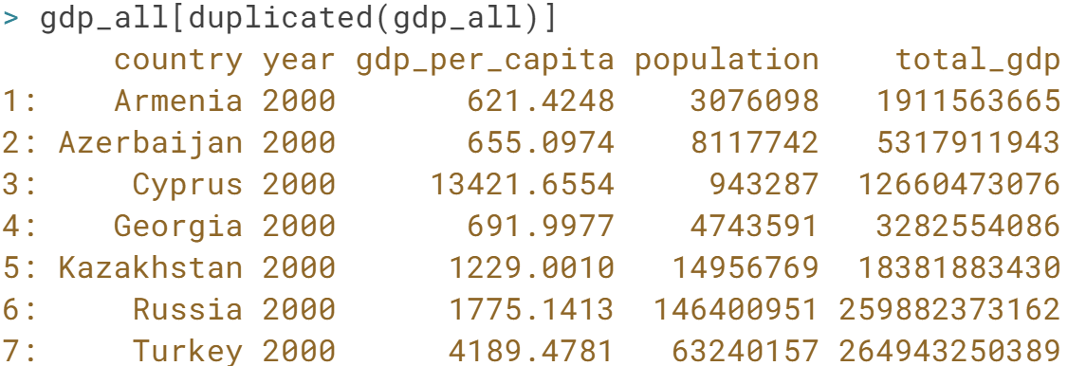  
  
Nicely done! Did you know base R provides set operation functions that work on vectors? For example, the ***intersect()*** function will find the common elements of two vectors.

# Removing duplicates while combining tables

The same list of data tables as the last exercise, gdp, is available in your workspace. Your goal this time is to build a data.table in which each country appears only once, even if it is located in more than one continent.

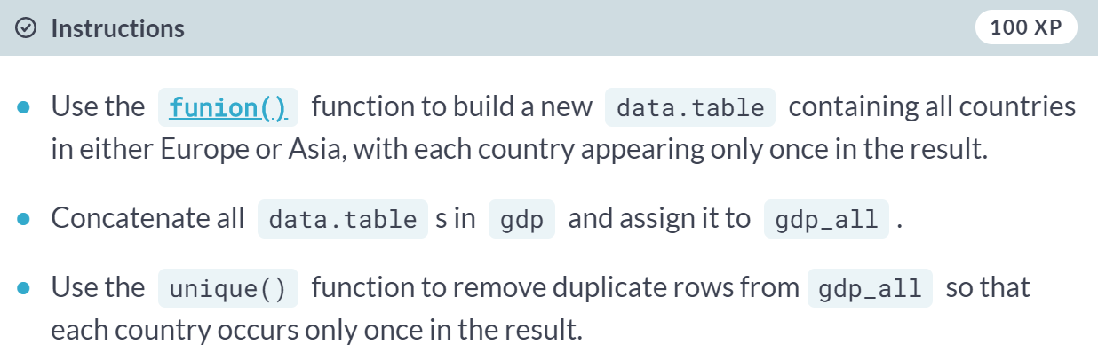  
  
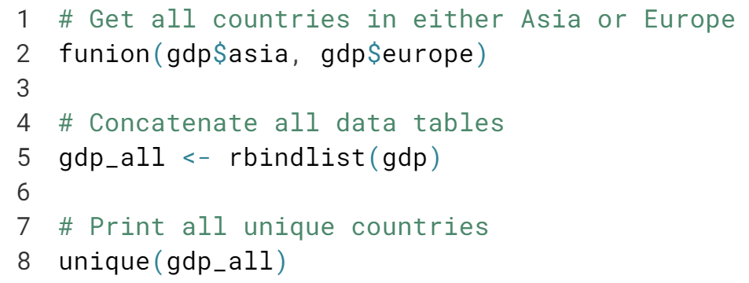  
  
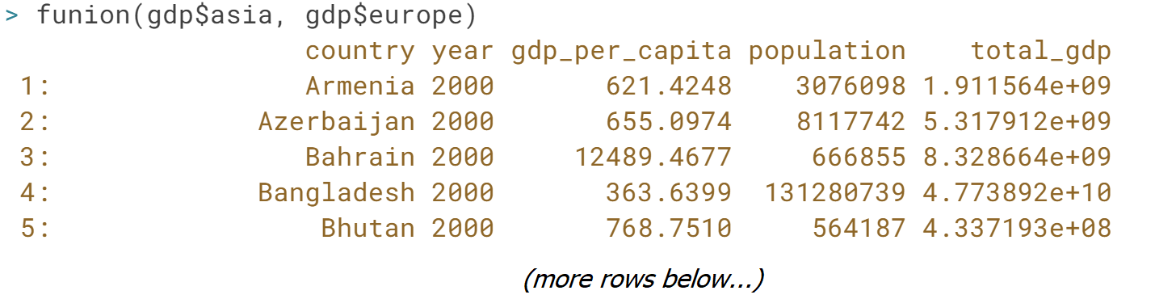  
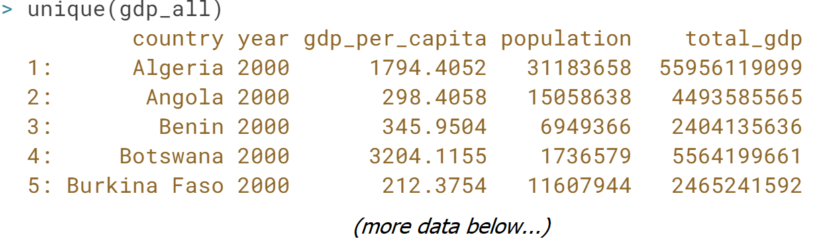  
  
Great job! Functions in R can be chained together in the same statement, for example,  
.

# Identifying observations unique to a table

An additional data.table has been loaded into your R session, middle_east, along with the gdp list of data tables from the previous exercise. The middle_east data table contains the set of countries in the [**Middle East**](https://en.wikipedia.org/wiki/Middle_East), a geopolitical region which spans parts of Europe, Africa, and Asia.

All countries in the middle_east data table appear in one or more data tables in the gdp list. Your goal is to print data tables containing all countries in Africa, Europe, and Asia, that are not found in the middle_east.

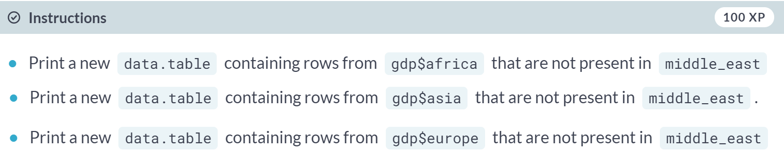

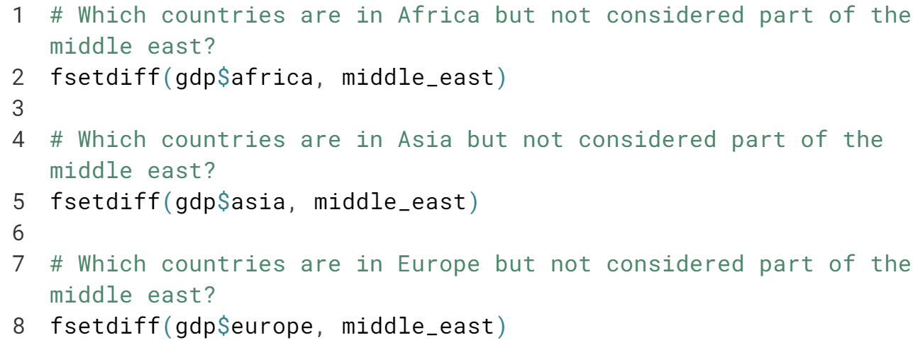

Nice work! You can do this in one line of code: ***lapply(gdp, fsetdiff, middle_east)***.



In this lesson, we will learn how to melt data tables from wide to long format.

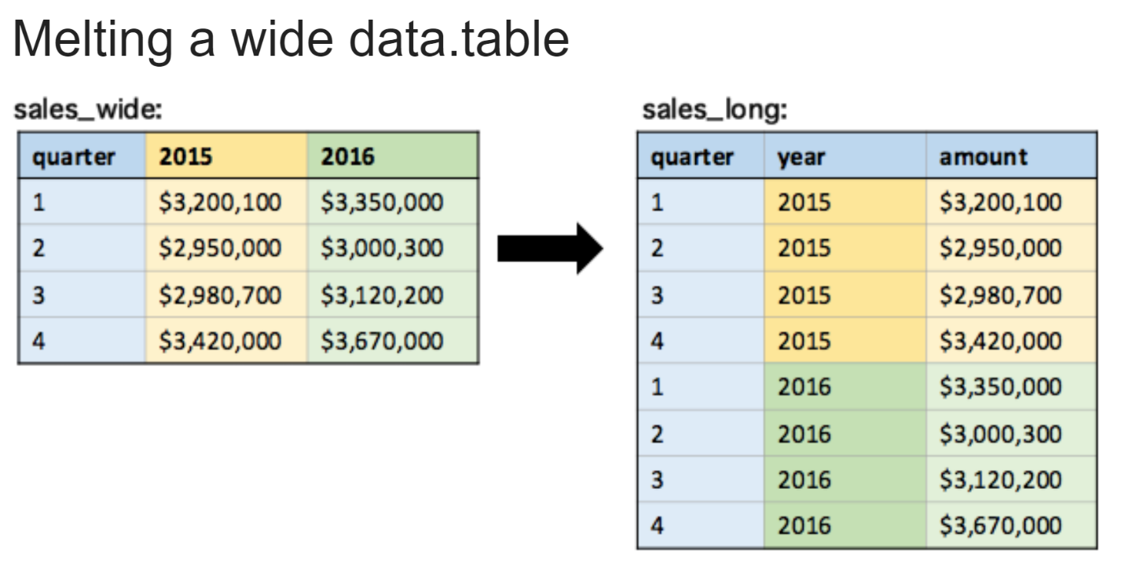  
A wide format data table is one where a single variable is spread across multiple columns corresponding to some grouping, such as in the example data table on the left. This type of layout is common when working with excel spreadsheets because it is a human-friendly way of organizing data with regular groupings.

However, when working with datasets in R, we will often want to reshape this data into a long format, shown on the right. In the long format, these values occupy a single column, with another column indicating group membership. This format allows us to take full advantage of the functionality in the data table syntax like grouping of calculations.

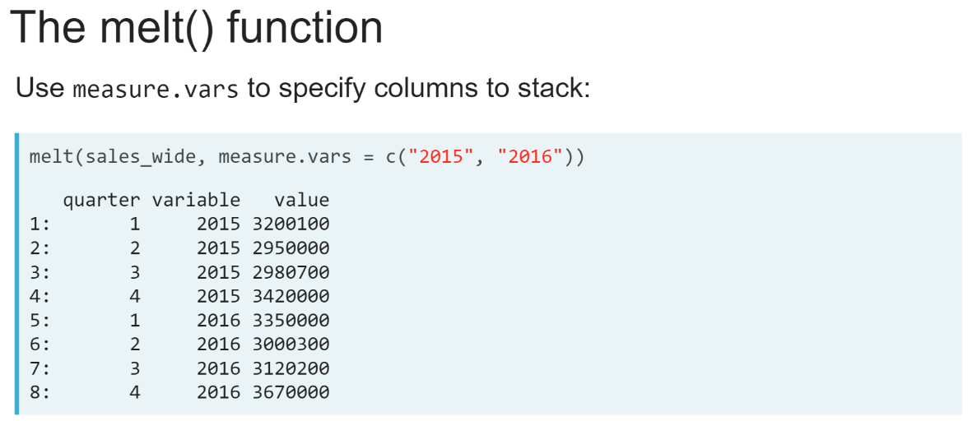  
We can use the ***melt()*** function to reshape a wide data table to a long data table. There are few different ways to use this function.

First, we can provide a vector of column names to the *measure.vars* argument. The ***melt()*** function will take these columns and stack them on top of each other to create two new columns: "*variable* " and "*value* ".

The "*value* " column will contain the values of these stacked columns while the "*variable* " column labels each row with the column name from the original wide data table.

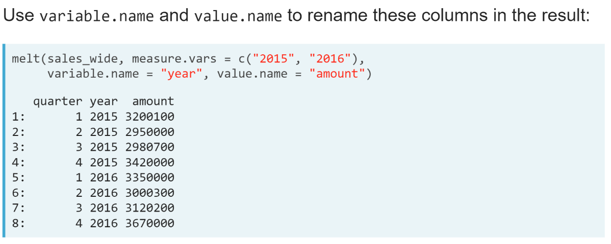  
We can give these new columns any name we like using the *variale.name* and *value.name* arguments.

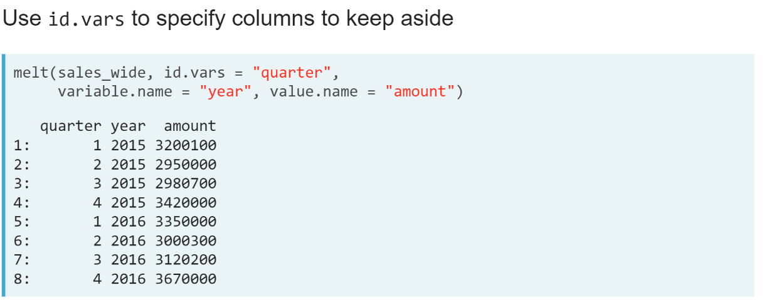  
We can also use the *id.vars* argument instead of *measure.vars* argument to tell the ***melt()*** function which columns we want to keep aside as row identifiers in the new data table. The ***melt()*** function will then stack all other columns into the new "*value*" column.

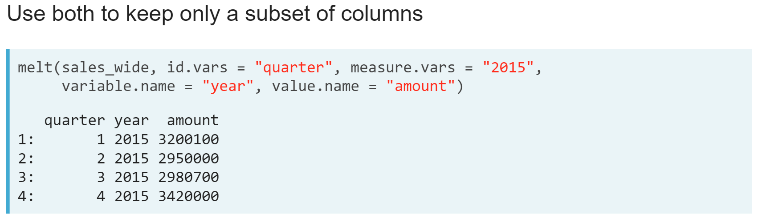  
We can use both the *id.vars* and *measure.vars* arguments at the same time. If we use both arguments, any columns we don't provide to either argument will be dropped in the result.

# Melting a wide table

A data table named gdp_per_capita containing the gross domestic product (GDP) per capita for countries in Oceania every five years from 1990 to 2010 sourced from the [**Gapminder foundation**](https://www.gapminder.org/) is available in your workspace. Your goal is to reshape this data table to the long format so that there is a single column containing all GDP per capita values for each country and year.

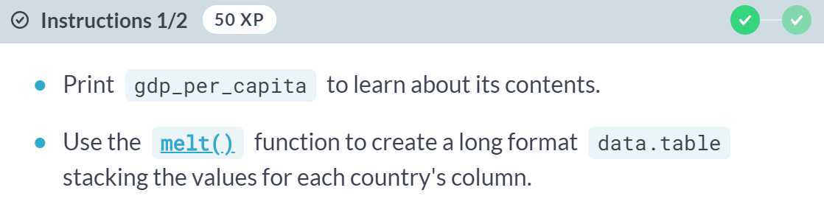

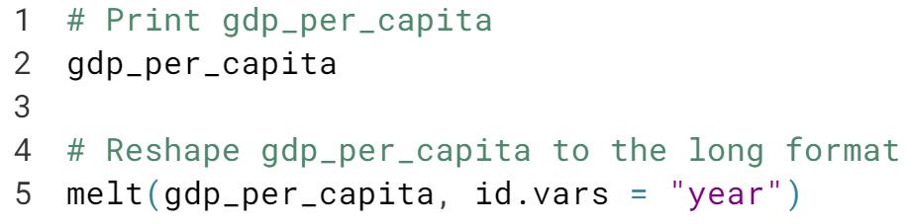  
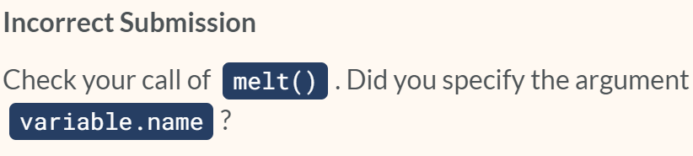  
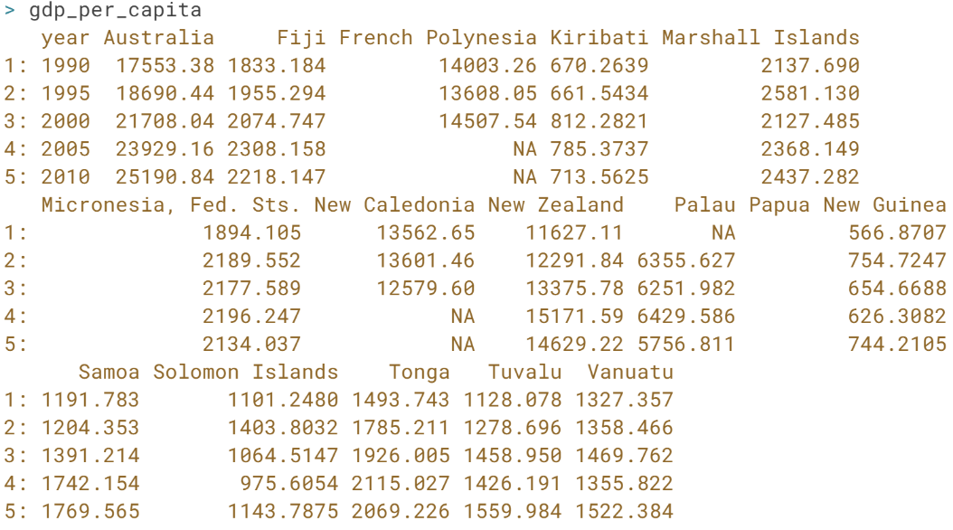  
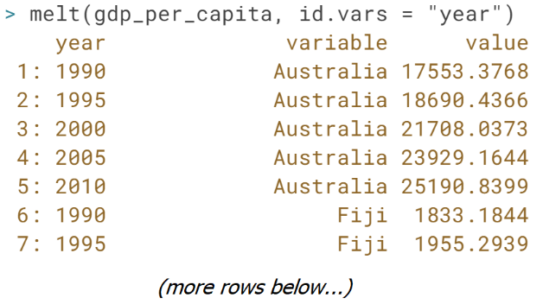

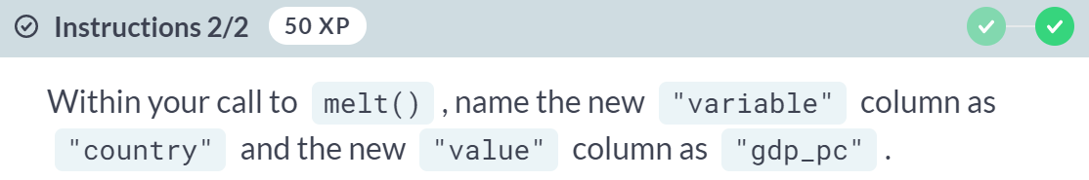  
  
  
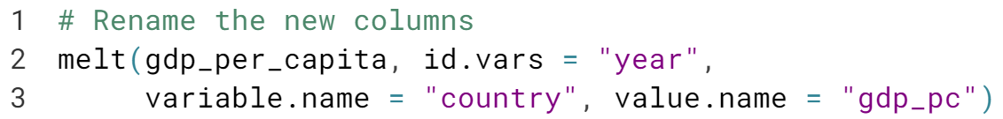

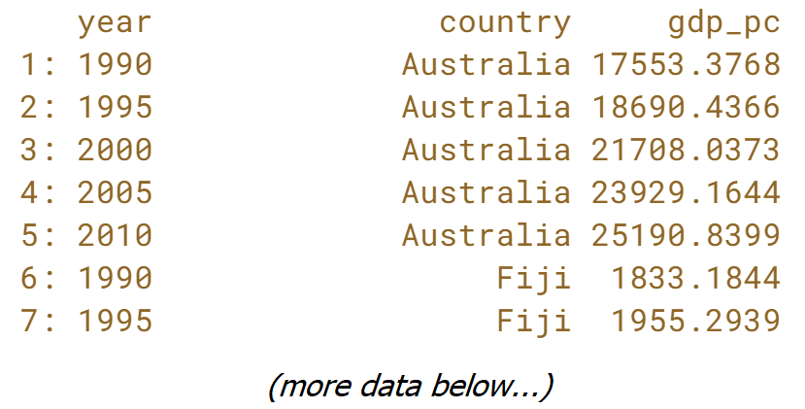

Excellent! By default, the "variable" column in the result will be a factor. You can change this by setting *variable.factor = FALSE*.

# More melts

A data table containing confirmed Ebola case numbers from Guinea in weeks 50 and 51 of the outbreak has been loaded into your R session. Your goal is to melt ebola_wide into a long format data table containing a single column for the case numbers variable.  
  
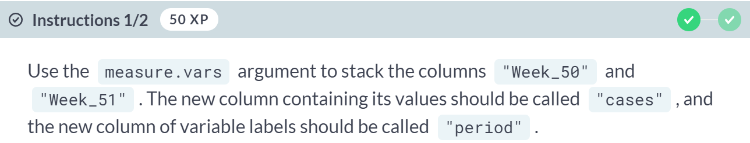

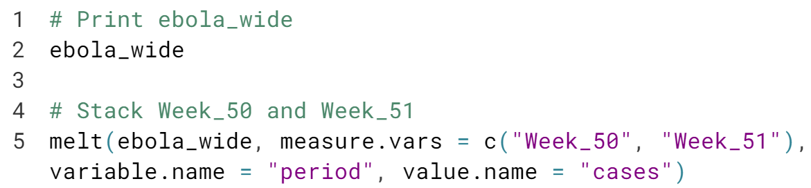  
  
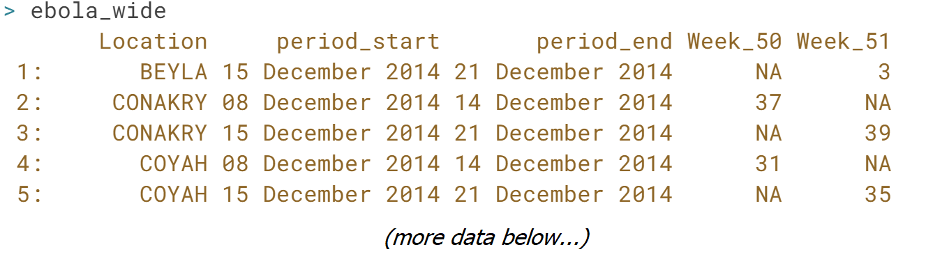  
  
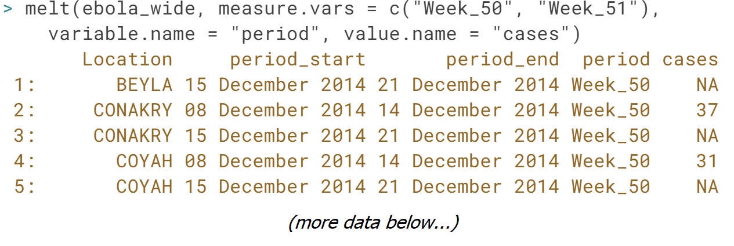

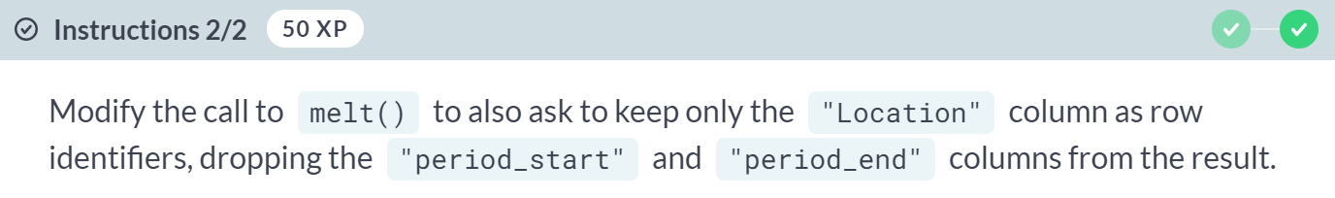

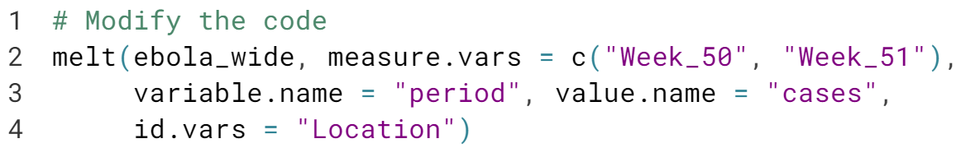

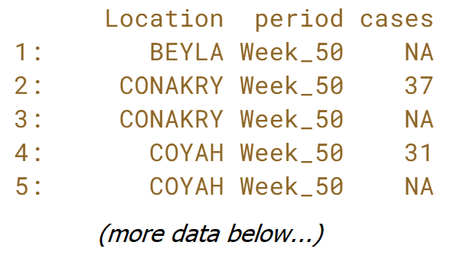  
  
Great job! Using *id.vars* together with *measure.vars* keeps only those columns in the result.



In this lesson, we will learn how to cast data tables from long to wide formats.

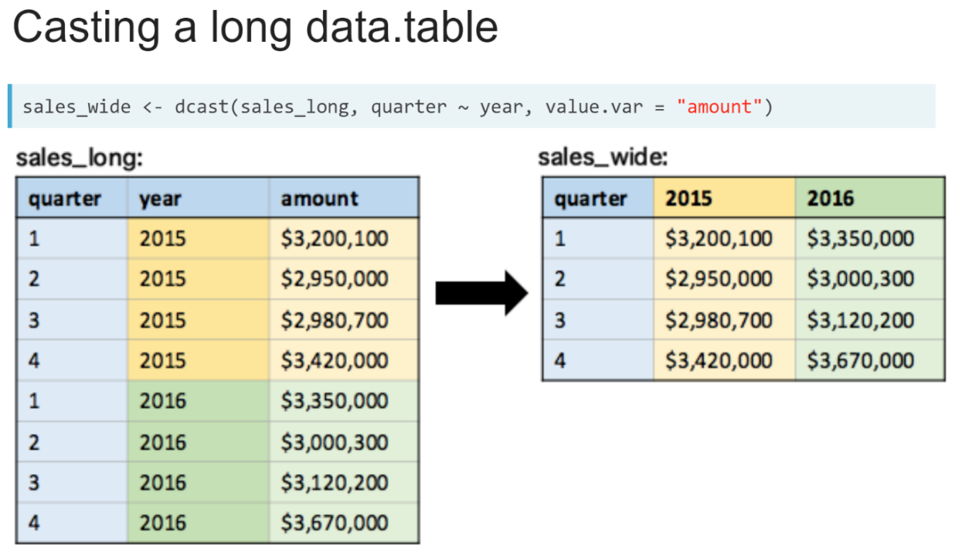  
In the previous lesson, we learned how to melt a wide format data (left) into a long format data table (right). The ***dcast()*** function will allows us to make the reverse transformation, reshaping a long format data table into a wide one.

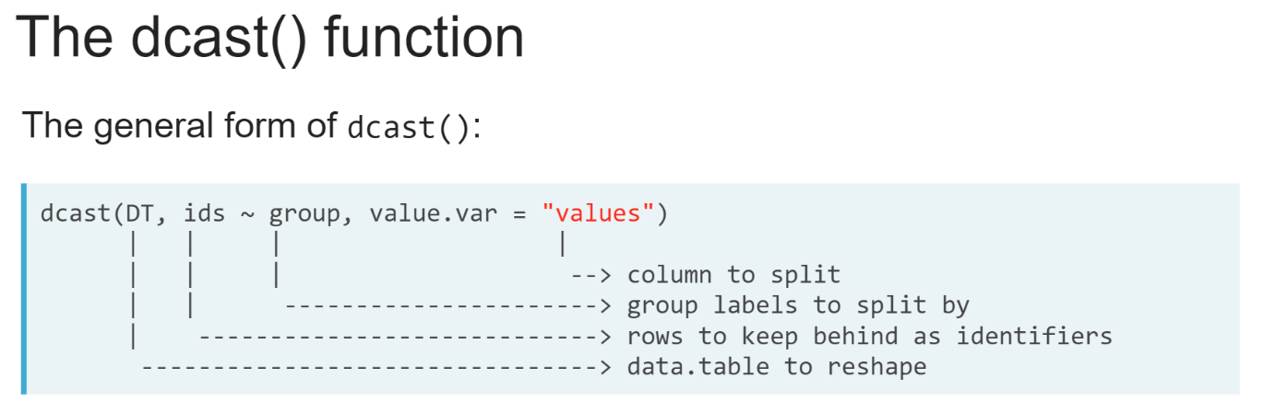  
The ***dcast()*** function takes three arguments. The first argument is the data table we want to reshape. The third argument, *value.var* takes the name of the column whose values we want to split into the multiple columns in the wide format result.

The second argument is a formula describing how to split this column and which columns to keep aside. It is composed of three parts: a left-hand side, a tilde (~), and a right-hand side, which takes the name of a column of group labels and each unique label will become a new column in the wide format containing the values of the column given to *value.var* for the rows with that group label.   
  
Basically, the left-hand side takes the name of the column containing the identifier labels for each observation that are repeated in each group.

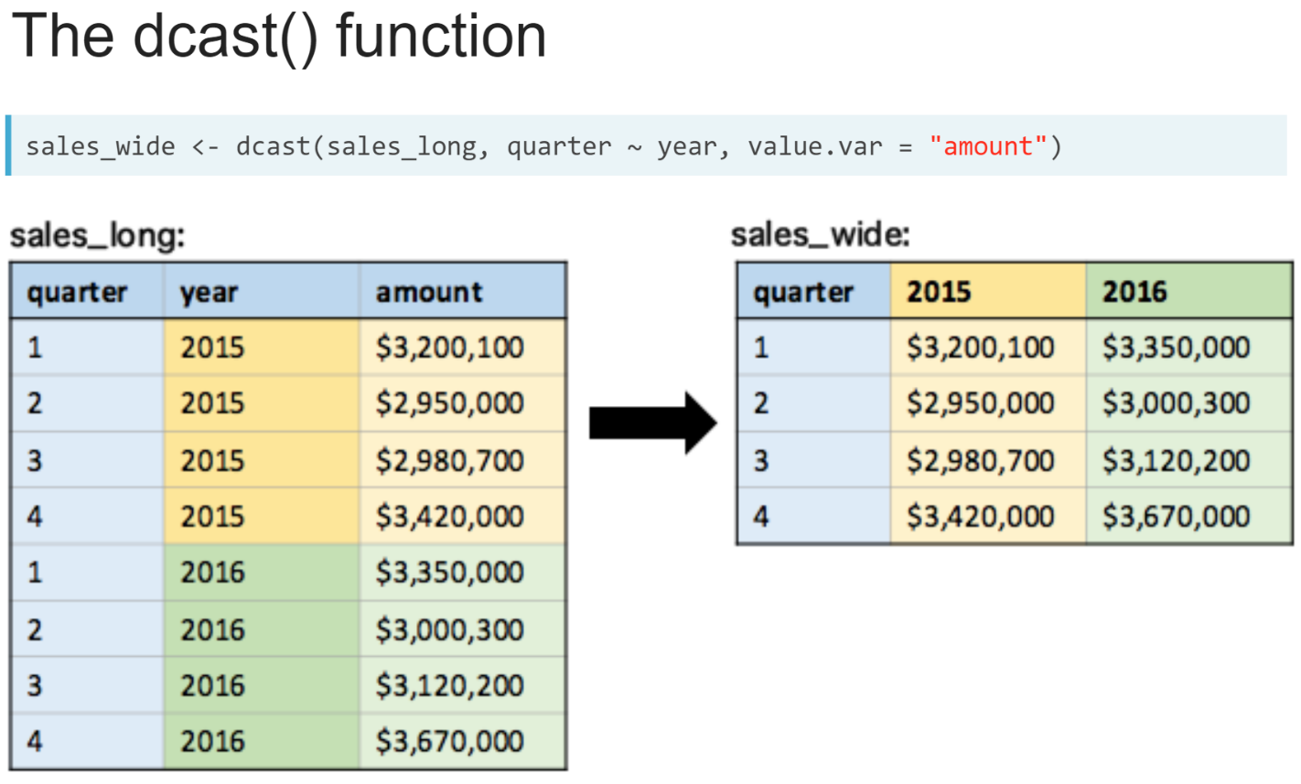  
Returning to our example, we can see the corresponding call to the ***dcast()*** function. Here, the amount column is split into two columns, based on the unique labels in the "*year*" column, which is given to the right-hand side of the *dcast()* formula.

The quarter column contains repeated identifiers, the values 1 to 4 repeated by each unique year label. This column is given to the left-hand side of the *dcast()* formula and is kept aside as row identifier in the result.

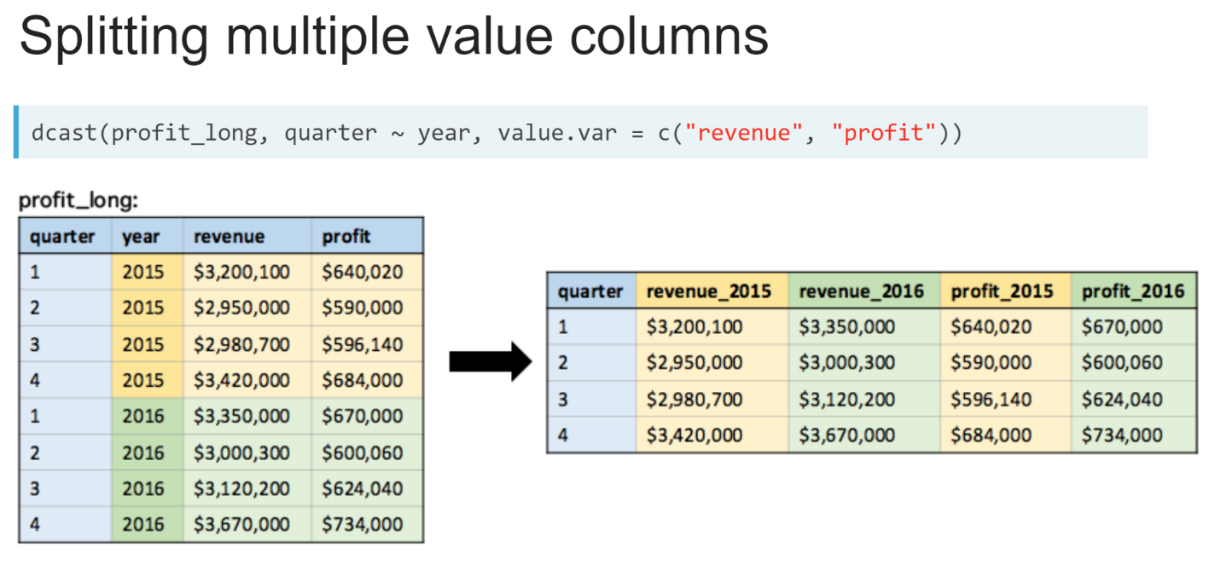  
We can split multiple columns at once by supplying a character vector of column names to the *value.var* argument. The columns in the result will be named after the value column followed by an underscore(_), then each group label.

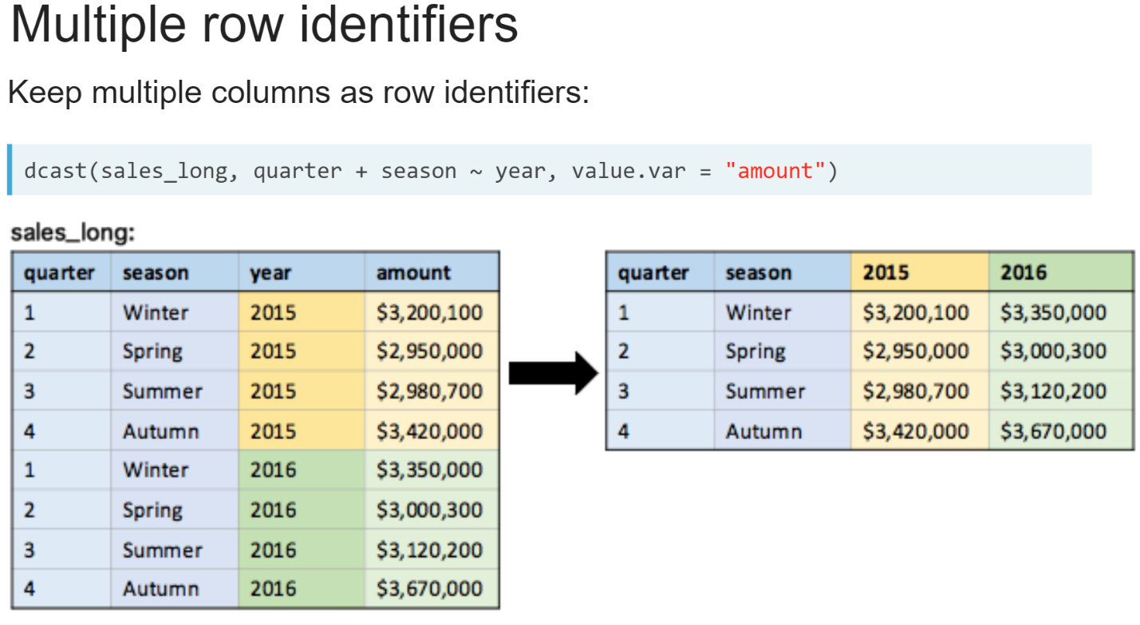  
We can keep multiple columns aside as the row identifiers by separating their names with a plus sign in the left-hand side of the formula.  
  
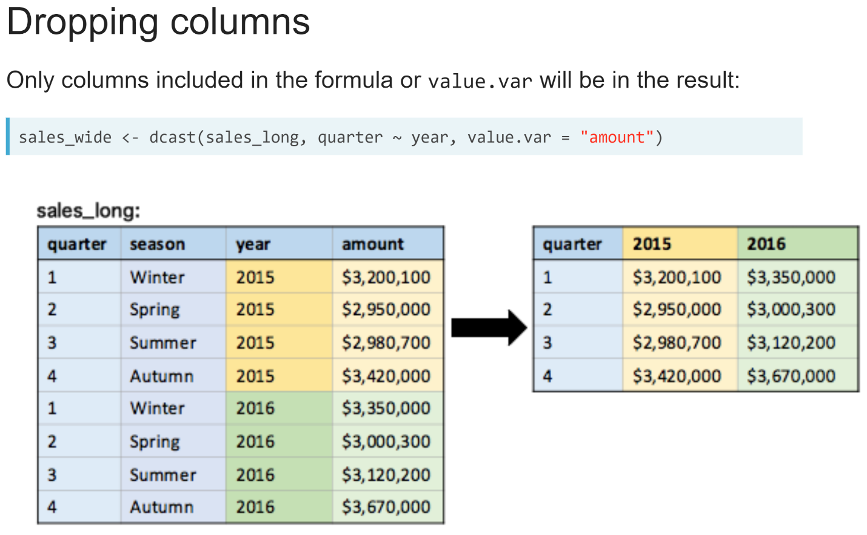  
Note that if you don't provide a column to the formula or the *value.var* argument, it won't be included in the result.

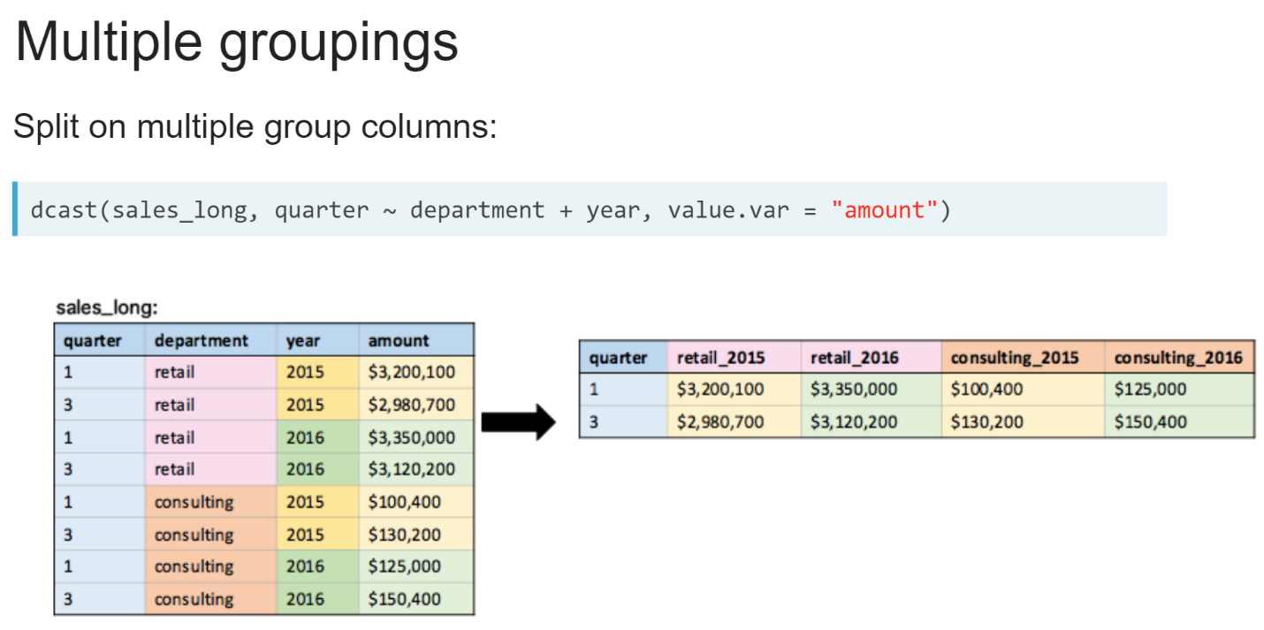  
We can also split on multiple group label columns using a plus sign in the right hand side of the formula.

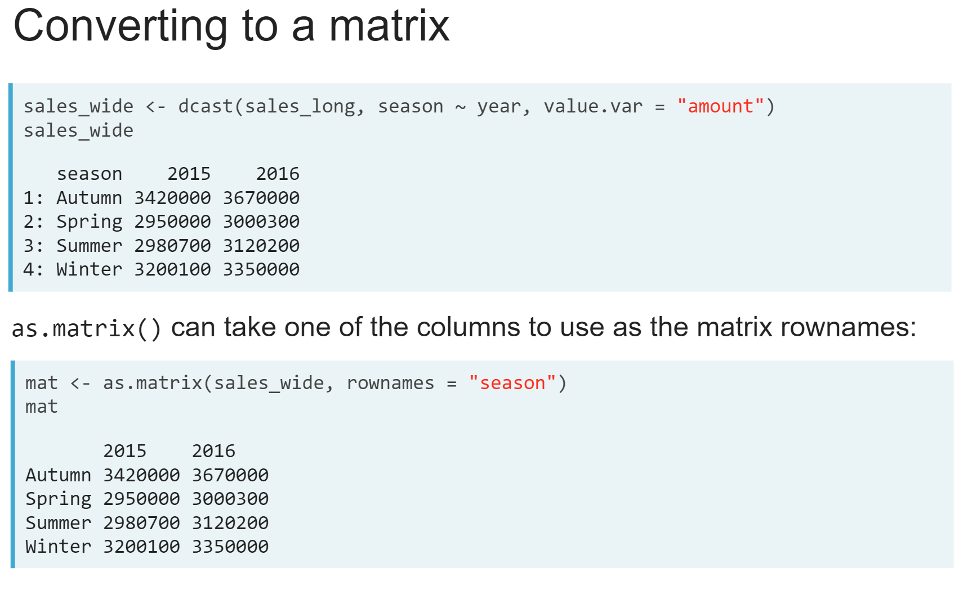  
One of the reasons we might want to cast a long data table to a wide one is if we want to create a matrix of values for another function to use.

We can do this with the ***as.matrix()*** function. When called on a data table, we can use an additional argument, *"rownames"*, to tell the function which column to use as the matrix row names.

# Casting a long table

gdp_oceania contains the population and GDP for every country in Oceania for every five years from 1990 to 2010 and is available in your workspace. Your goal is to create wide format data.tables containing the population and total GDP for each country with each year having its own column.

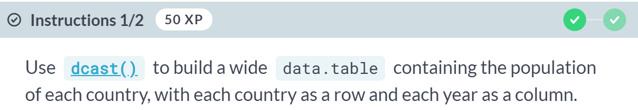  
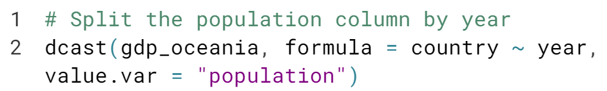  
  
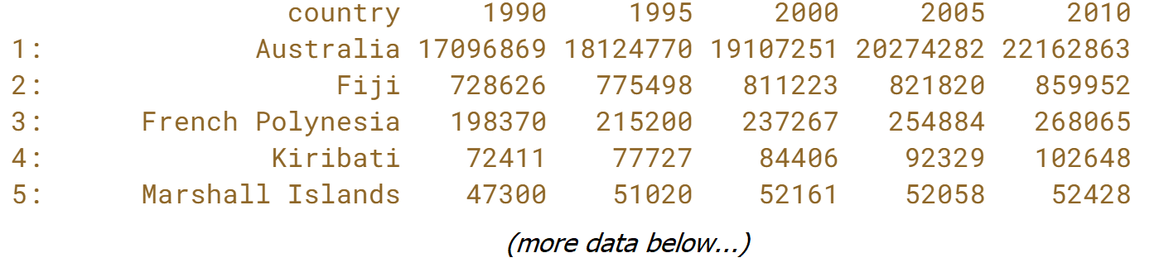

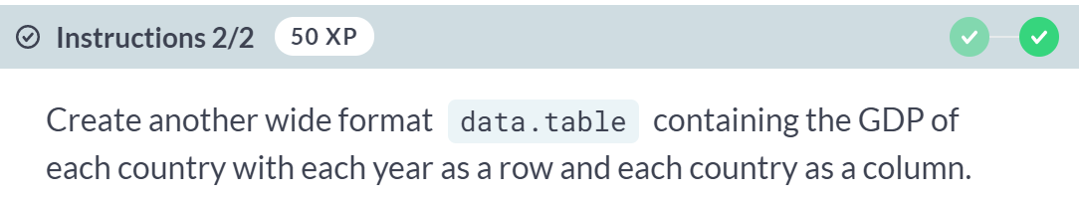  
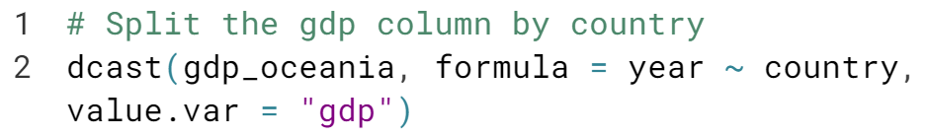  
  
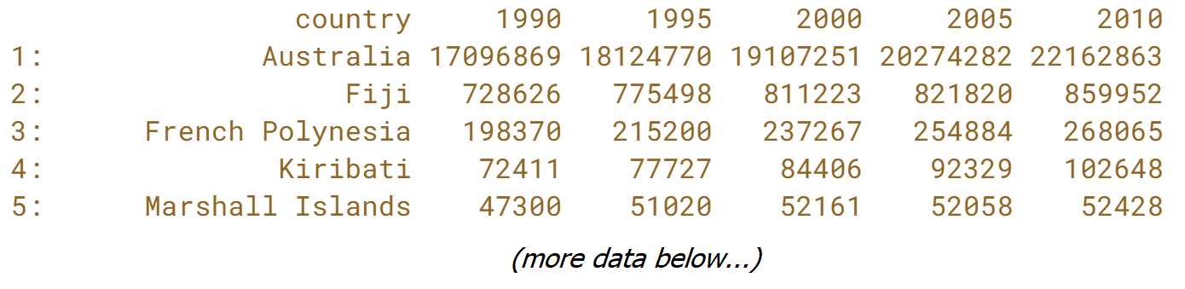  
Nice work! One way to remember the ***dcast()*** formula is that the column you give to the left-hand side will always be the left most column of row identifiers in the result.

# Casting multiple columns

The data table from the previous exercise, gdp_oceania, is available in your workspace. Your goal is to create a wide format data table, splitting both the "gdp" and "population" columns by the "year" column.

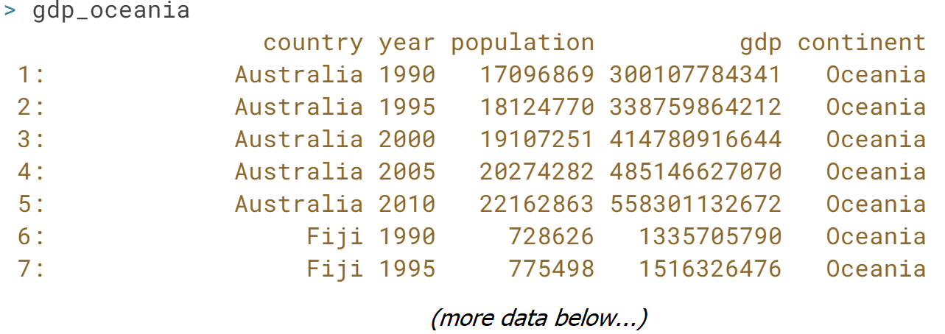

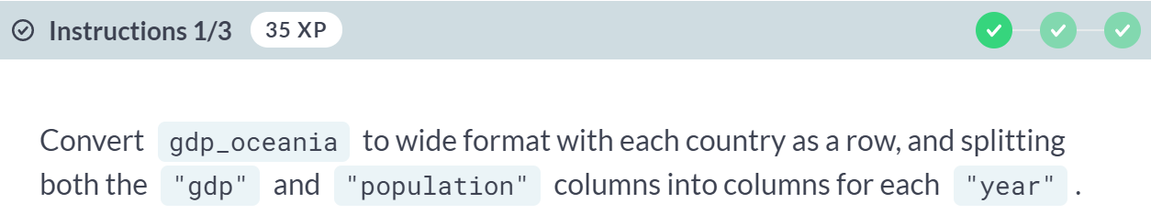

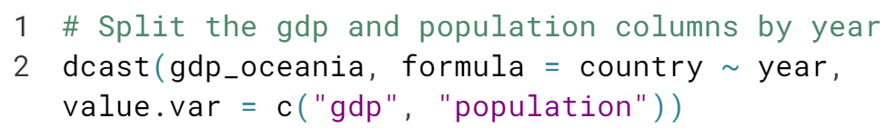

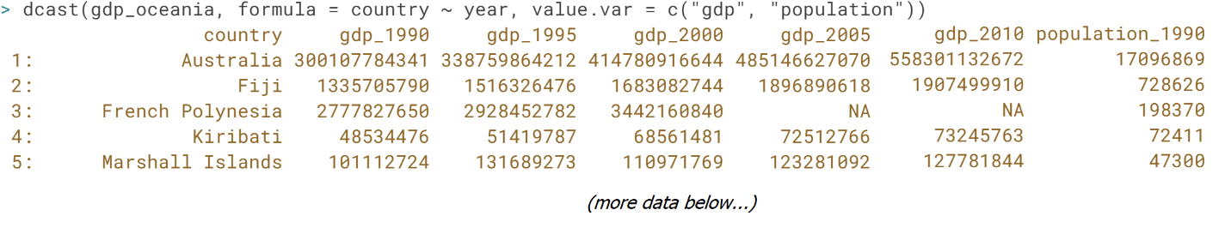

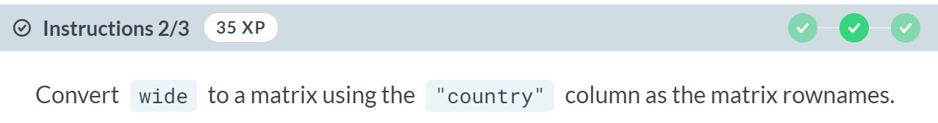

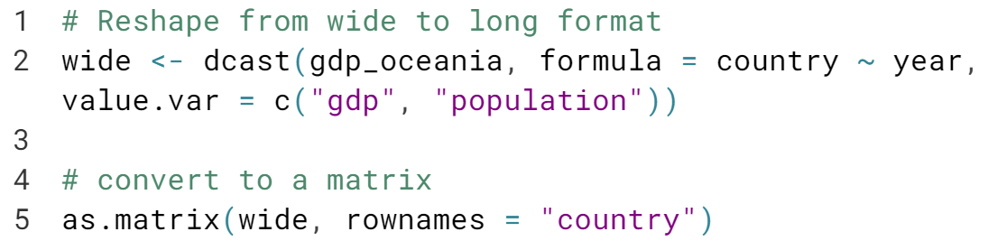

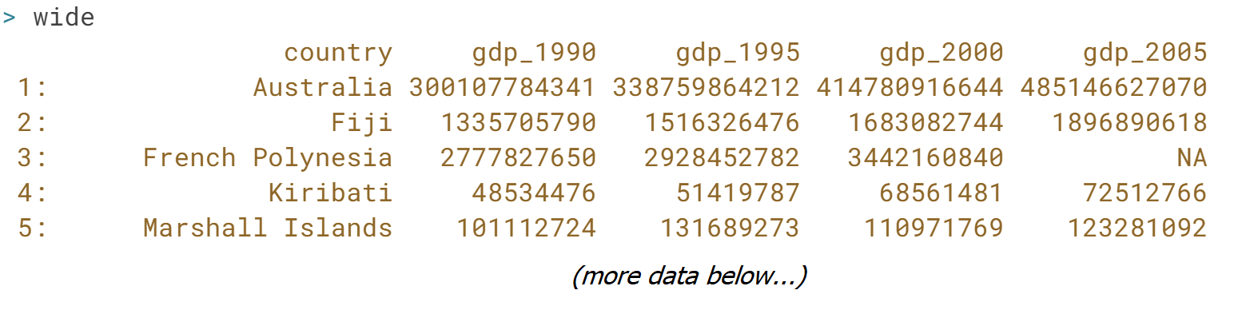

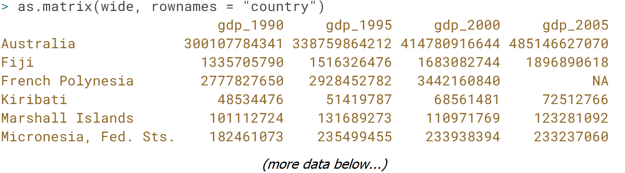

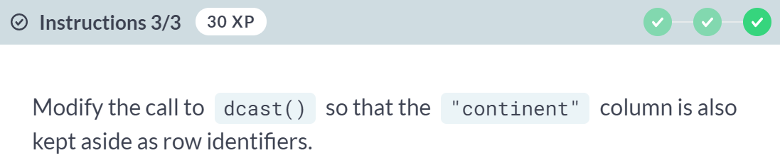  
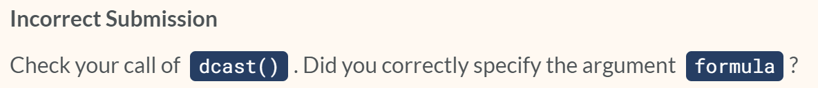  
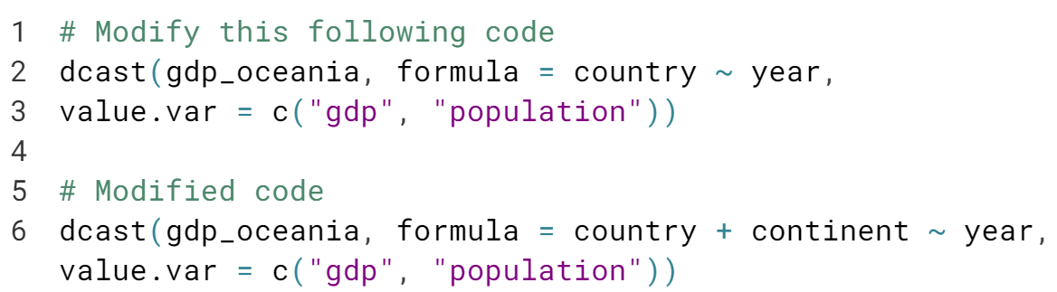  
  
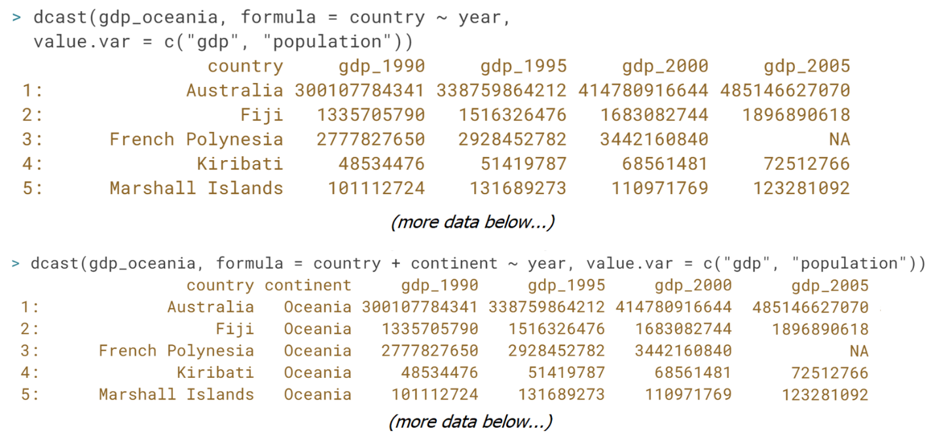  
Nicely done! If you don't want to keep any columns as row identifiers in the result, you can use the special symbol **.** in the formula.

# Splitting by multiple groups

gdp_by_industry_oceania contains the GDP generated by the agriculture and tourism industries in both 1995 and 2010. Your goal is to create a wide format data.table containing columns of GDP for each year and industry.

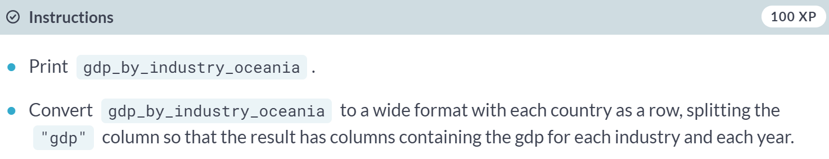

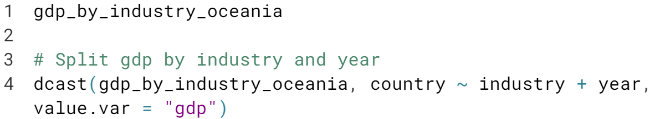

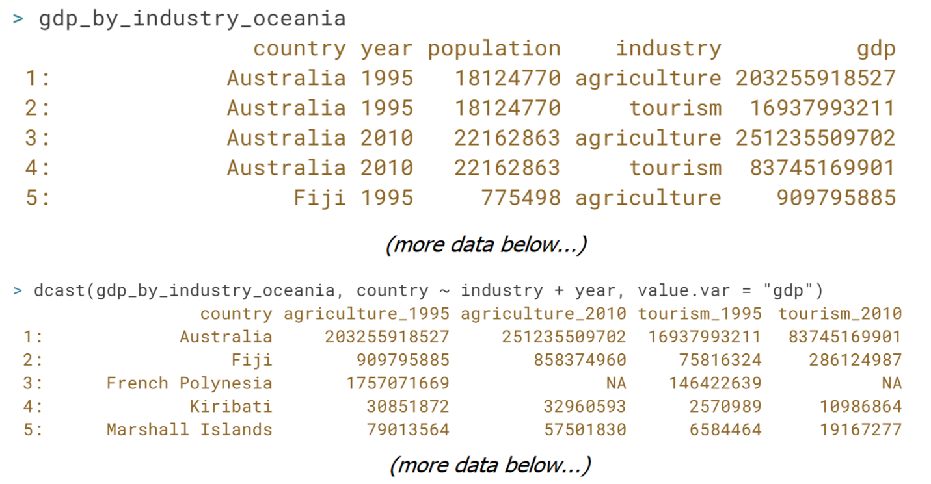  
  
Awesome job! For advanced use cases take a look at the *fill* argument which controls how ***dcast()*** handles group combinations that do not occur, and the *fun.aggregate* argument which controls how dcast handles cases where there are multiple values for different group combinations.